Coal kills – and sends climate bills – to our children.
How you can say NO to coal in your electric outlets.
Sir Per Ribbing, Licentiate of Technology in Engineering Physics, Uppsala University, Dept of Electrical Engineering

Abstract
In the old, physical, way of regarding the Product Electricity; as being similar to water flowing in pipes, the statement “All power mixes on the grid!” held true. However, from a market and consumer power point of view, from an economic view of the product that we purchase (i.e. the Product Electricity), that statement is false. Electricity which is audited; Production vs Consumption, does not mix with any other electricity. Only electricity which is not audited does mix. The anonymous agents which are the carriers of the purchased Product Electricity, i.e. the kWh:s, are mixed. The product itself (the electricity) is not mixed.
This new perspective is not intuitively easy to understand, especially not for electrical engineers or anyone working in the power sector. Nevertheless, it is the correct way to understand the new situation with deregulated power markets offering different “colours” of power, i.e. electricity with different environmental loads.
In this new situation the new perspective on the product electricity shows that there exists a possible choice of not consuming any coal power.
However, the power sector itself has obvious problems in accepting this new way of understanding the product they are selling. For instance, major power utilities do not know what Product Electricity they are supplying their electric charging stations with. When questioned they fall back to the “All power mixes on the grid” reply and that is just wrong.
Especially when charging your Electric Vehicle you do not want coal power to charge your batteries. That is an assumption I can assert very well after driving EVs since 1997.

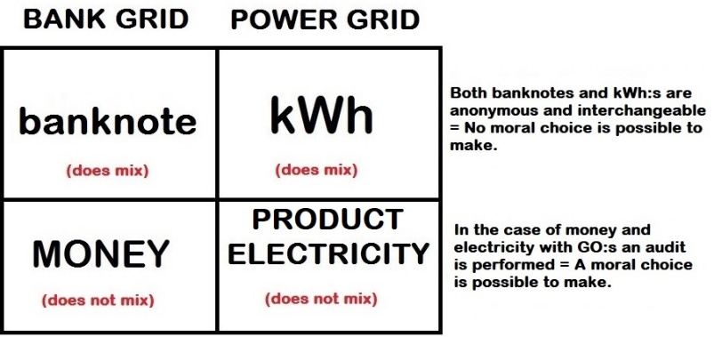

Recent Publications

Ribbing P (2018) “On the Analogy Between the Electric Grid and Our Banking System: Investigating "Consumer Power" in Deregulated Power Markets.” Int J Earth Environ Sci 3: 154.
doi: https://doi.org/10.15344/2456-351X/2018/154

Ribbing P, Leijon M (2020) “Historic Perspective on the Analogy between the Electric Grid and our Banking System.” J Nucl Ene Sci Power Generat Technol 9:2.
doi: 10.4172/2325-9809.1000194

Ribbing P (2020) “Reporting Purchased Product Electricity - A suggested Development of the Present EU Audit of Guarantees of Origin.” J Nucl Ene Sci Power Generat Technol 9:3.
doi: 10.37532/jnpgt.2020.9(3).198


Biography Sir PER RIBBING
Per Ribbing received his Licentiate degree in April 2019 after publishing his licentiate thesis: “Climate Change Leadership – the case for Electrification” and is currently writing his doctoral thesis on the same subject: Climate Change Leadership and the role of Green Power in the sustainable transition from fossil to renewable energy. As a Keynote Speaker on the New Paradigm on Electric Power, Ribbing has had a number of international missions. To all of these conferences he goes by train. “Use your brain – go by train”. In 2008 he was invited Keynote Speaker at TIEF-6 in Tsuruga, Japan. He took the train from Stockholm to Japan. Sir Per Ribbing has a Master of Science degree from Linköping Institute of Technology year 1989, but it was not until 1994 he became aware of the Climate Crisis and the imminent threats it is posing on his own children. He dedicated his licentiate thesis to his children.
“To Ebba, Gustaf, Safi & Elise;
I want to give you a world in peace.
But that won’t be, until it’s fossil free,
and that, dear reader, is the task for you and me. Email: per.ribbing@angstrom.uu.se

