Insights from Japan about Prospects of Renewable Energy
Younes Jalali, PhD, Schlumberger (retired), FRANCE

Abstract
Japan represents less than 2% of the world population, yet its energy usage is nearly 5% of global consumption. As the third largest economy in the world, and a highly industrialized one, this is not surprising. What is surprising is how modest is the use of renewable energy. Prior to Fukushima, renewables represented only 5% of the total energy mix. And today, nearly ten years on, it represents only 8%. Given that Japan is highly dependent on imports of primary energy resources, the expectation is that renewables would be far more developed. It is after all the best way to ensure security of supply. What can explain this paradox? And does it reveal causes that can help us understand the obstacles to the proliferation of renewables in Japan?

Three causes can be elucidated.

First is technical. The largest source of renewable energy in Japan is hydroelectricity. But this resource is fully utilized and there does not seem to be much scope for further development. Prior to Fukushima, 80% of Japan’s renewables was hydropower. Wind has also limited scope, since wind farms require vast space. It’s estimated 400 km2 is needed for a wind farm that can generate 1000 MW; but this sort of space allocation is not feasible in Japan. There is offshore wind, but there too the scarcity of unpopulated islands with shallow-water rims is a barrier. Floating offshore wind is at its infancy, and the region as a whole is prone to typhoons. Geothermal and biomass are also estimated to have modest scope for growth. This leaves solar as the resource with the least technical constraints (in favorable climate, 20 km2 is sufficient to harness 1000 MW). For this reason, solar has been the fastest growing renewable in Japan, post-Fukushima. But this growth is constrained by electricity storage and grid connectivity bottlenecks. This is the main reason behind the large gap between solar nameplate capacity (50 GW) and actual generation (8 GW).

Second is cost. Cost shows its impact even within the non-renewable energy sources. In terms of fuel cost, nuclear is the least expensive (eight times less than coal), and coal is less expensive than oil and gas. This can be seen when we examine the energy equivalence of these resources. To sustain a 1000 MW power plant for a year, we need 13 million barrels of oil, 60 billion cubic feet of gas, 4 million tons of coal, or 200 tons of Uranium Oxide. The price of these commodities reveals the large disparity between different fuel costs. However, power generated by the most expensive fuel (oil and gas) is still less expensive than power by renewables. Japan has introduced the Feed-in-Tariff (FIT) program to mandate power companies to purchase renewable energy from local producers at a premium. For now, this solves the issue of lack of cost-competitiveness.

Third is security policy. Japan is committed to nuclear energy, because it gives it the technical knowhow and stockpiles it considers it needs for purposes of national defense, and provides energy without greenhouse gases at a fuel cost that is much less than coal. This is significant for a country that is highly electrified (nearly 50% of Japan’s energy is consumed as electricity). If Japan were to exit from nuclear, it will see a rapid rise in renewable energy generation. That would be the only way for it to honor its targets to curb greenhouse gas emissions (2030 level at 25% below 2005, or 930 million tons energy-derived CO2). From this, it’s safe to conclude that the largest obstacle to the development of renewables in Japan is commitment to nuclear energy. The cost equation can be tilted in favor of renewables, if emissions are properly taxed and primary resources are realistically priced (Uranium Oxide is priced today like oil, pre-OPEC). Technical barriers can also be overcome to a large degree. The key barrier is Japan’s security policy. And this seems to be a common theme amongst leading industrialized nations.

Image

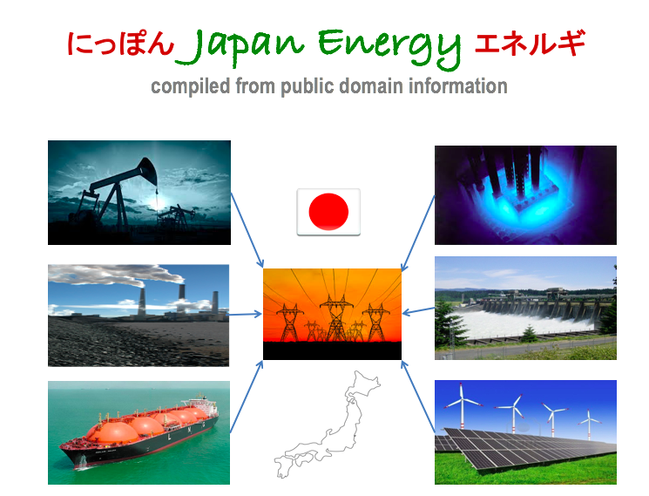
Recent Publications
- Jalali, Y., Haq, S.: “On Combined Use of Bed Boundary Logs and Formation Testing while Drilling to Predict Well Deliverability,” 19th Formation Evaluation Symposium of Japan, Chiba, Japan, September 26-27, 2013.
- Jalali, Y.: “Detecting Horizontal Intervals Prone to Production Problems by Novel LWD Measurements,” WSEOR, Xi’an, China, 25-28 April, 2012.
- Zhang, L, Jalali, Y.: “Well Productivity Estimation during Drilling,” extended abstract presented at the EAGE Workshop on Geosteering and Well Placement, Dubai, UAE, 7-10 November 2010.
- Huo, D., Jalali, Y.: “An Analysis of CO2 Storage Prospects in Deep Saline Reservoirs,” paper SPE 136077 presented at the SPE Production and Operations Conference and Exhibition, Tunis, Tunisia, 8-10 June 2010.
- Zhang, L., Jalali, Y.: “Estimation and Utility of Well Productivity during Drilling,” paper SPE 130811 presented at the International Oil and Gas Conference and Exhibition, Beijing, China, 8-10 June 2010.

Biography
Younes Jalali is a former faculty of Stanford University (School of Earth Sciences, 1987-1990), Scientific Advisor at Schlumberger (1990-2017), Distinguished Lecturer of SPE (Society of Petroleum Engineers, 2009-2010), and worked in Japan in the aftermath of Fukushima (2013-2017).
Email: Younes.Jalali@gmail.com

