Green Nanotechnology: aims and expedients
Oleg Figovsky,Prof.,PhD,
Dmitry Beilin, Dr.,PhD
Polymate Ltd.-International Nanotechnology Center (Israel)

Abstract
Green nanotechnology aims to develop clean technologies to minimize potential environmental and human health risks associated with the manufacture and use of nanotechnology products, and to encourage replacement of existing products with new nanomaterials that are more environmentally friendly. The most important component of nanotechnology is nanomaterials, i.e. materials with the ordered structure of their nanofragments having size from 1 to 100 nm. The production and process aspects of green nanotechnology involve both making nanomaterials in a more environmentally benign fashion and using nanomaterials to make current chemical processes more environmentally acceptable. The paper contains information about advanced nanomaterials can be produced without harming the environment or human health. This encompasses the production of nanomaterials without environmental toxicity, at room temperature and with the use of renewable energy sources. The paper contains the descriptions and results of theoretical and experimental researches in the field of environment friendly nanotechnology carried out over the past decade by scientific team of company Polymate Ltd.-International Nanotechnology Center (www.polymateltd.com, Israel)

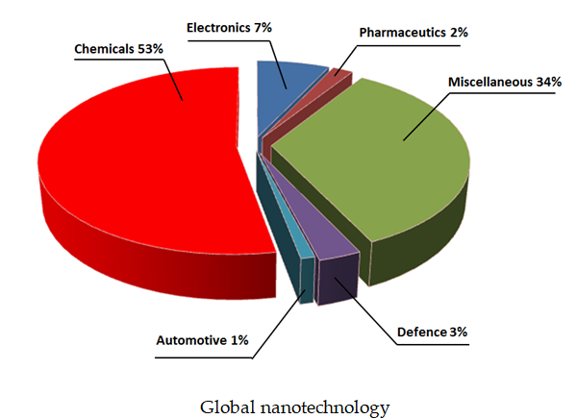

Prof. Oleg Figovsky is director of R&D of the Polymate Ltd.-International Nanotechnology Research Centre. He is a member of the European Academy of sciences. Novel nanotechnologies suggested by him were the basis for establishing industrial production in the US and other countries. Prof. O. Figovsky has 18 authored books, more than 300 scientific articles and 500 patents.

Dr. Dmitry Beilin is head of the laboratory at the Polymate Ltd.-International Nanotechnology Research Center. His fields of interest include structural theory, thin-walled space structures, NDT diagnostics in industry and construction, and the strength of polymer composite materials. Dr. Beilin has authored books, more than 100 scientific articles and holds 5 patents.
Email: sitapolymate@gmail.com

