Synthesis of Activated Carbon Materials From Rice Husk For The Enhancement of Microporosity and Carbon Dioxide Adsorption
Dr. Kishor Palle, Assistant Professor of Chemistry, Department of Basic Science & Humanities, Muffakham Jah College of Engineering & Technology, Hyderabad, India.
ABSTRACT

Microporous carbons synthesized from Rice husk activated carbon (RHAC) by KOH and/or ZnCl₂ treatment were examined as adsorbents for CO₂ capture. The specific surface area and micropore volume of the resulting carbons varied from 1187 m²/g (0.52cm³/g) to 1802 m²/g (0.72 cm³/g), respectively.The acquired microporous carbon materials showed high CO₂ adsorption capacities at 40 bar pressure reaching 16.4 mmol/g. The objectives of this work were to develop a modified method to produce activated carbon from rice husk and to compare its physical and morphological characteristics with the activated carbon obtained at different temperature. The internal structure of the carbon was analysed with scanning electronic microscopy (SEM). The results of FTIR (Fourier-Transform Infrared Spectroscopy) strongly support significant chemical and spectral changes occurring with the activation of the rice husk with potassium hydroxide and ZnCl₂ treatment.
KEYWORDS: Activated carbon, RHAC, Microporous materials, CO₂ adsorption.
Effective utilization of useful components present in agricultural bio-waste material for CO₂ adsorption is very important. Activated carbons prepared from agricultural bio wastes are very pure with tailor made textural properties which suits for adsorption reactions. Rice husks are subjected to calcination at different temperatures under different atmospheres. Activated carbons and silica will be prepared by different chemical treatment which will be used as supports for carbon dioxide adsorption from environment.The existing Carbon dioxide adsorption methods are environmental unfriendly procedures hence forth researchers are in search for new materials and technologies., that are both ecologically safe, inexpensive and able to fulfill its role with little pre-processing is growing.
IMAGE
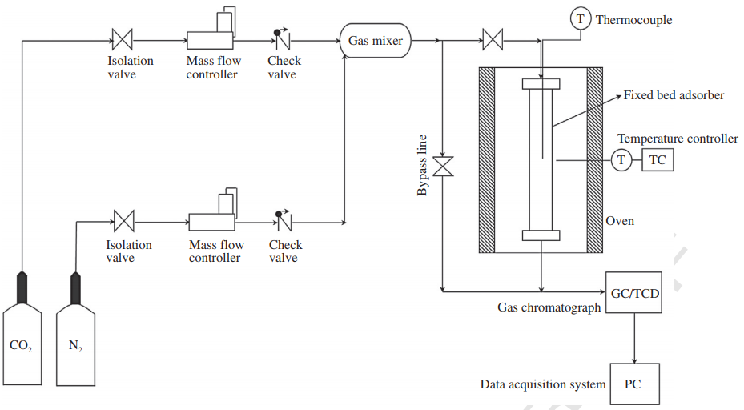
Figure: Schematic diagram of the experimental setup
New adsorbents prepared from rice husk as low-cost activated carbon using chemical activating reagents, to find out the surface changes occurring in rice husk during activation with KOH and ZnCl₂. Metal salt impregnations were carried out on Rice Husk activated carbons by using KOH, ZnCl₂ and mixture of both for CO₂ adsorption studies. Effect of temperature on adsorption of CO₂ was carried out on all modified activated carbons.
Carbons with high volume of surface area and pores and micropores were obtained by chemical modification of RHAC. The modifications significantly improve adsorption properties of RHAC essential for enlarging the CO₂ uptake up to 40 bar.
This work shows that the modification of commercial activated carbon RHAC impregnated with Potassium Hydroxide followed by treatment with ZnCl₂ for the enhancement of Carbon Dioxide Adsorption capacity.
Recent Publications:
[1]. A. S. Ello, J. A. Yapo, A. Trokourey, N-doped carbon aerogels for carbon dioxide (CO₂) capture,Afr. J. Pure Appl. Chem. 7 ,61-66, 2013.
[2]. A. S. Ello, L. K.C. de Souza, A. Trokourey, M. Jaroniec, Development of microporous carbons for CO₂ capture by KOH activation of African palm shells,J.CO₂Utilization 2,35–38, 2013.
[3]. C. Wang, Y. Guo, X. Zhu, G. Cui, H. Lia, S. Dai, Highly efficient CO₂ capture by tunable alkanolamine-based ionic liquids Chem. Commun., 48, 6526–6528, 2012.
[4]. D. P. Vargas, L. Giraldo, J. Silvestre-Albero, J. C. Moreno-Piraján, CO₂ adsorption on binderless activated carbon monoliths, Adsorption 17 ,497–504, 2011.
[5]. C. Shena, C. A. Grande, P. Li, Jianguo Yu, A. E. Rodrigues, Adsorption equilibria and kinetics of CO₂ and N₂ on activated carbon beads. Chem. Eng. J. 160 ,398–407, 2010.

Biography

Dr. Kishor Palle Ph.D., Working as an Assistant Professor of Chemistry in the Department of Basic Science & Humanities, Muffakham Jah College of Engineering & Technology (MJCET), Banjara Hills, Hyderabad. He has 15 years of experience in teaching. He received his Ph.D in the area of research in Catalysis & Green Chemistry from Jawaharlal Nehru Technological University, Anantapur. He has published 15 research and technical papers in National/International journals as well as conferences.

e-mail: drkishorepalle@gmail.com

