Global Warming
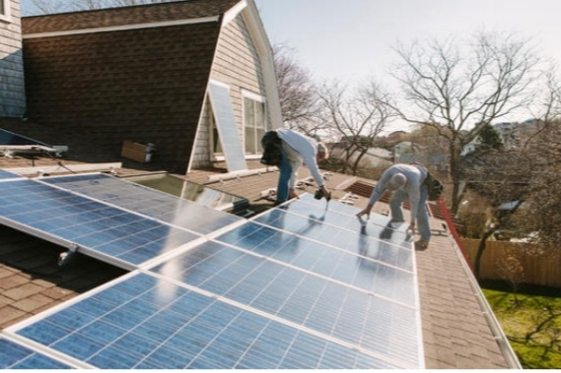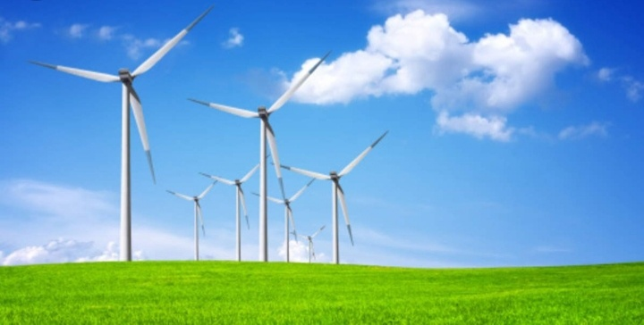

Research Author By Ms. Howida
Eltayeb Alian
Zulfa for Community
Development Services Company
Email:howida.alian@yahoo.com

Introduction :-
2019 - 2021 until now was the warmest decades recorded with global average of temperature reaching 1.5 temperature degree above pre – industrial levels in 2019 Human - induced global warming is presently increasing at a rate of 0.2 temperature degree per decade with serious negative impacts on to the natural environment & human health & wellbeing including a much higher risk that dangerous possibly catastrophic changes in the global environment will accour . For this reasons international Community accour has recognized the need to keep global warning well blew 2 temperature degree & purse efforts to limit it to 1.5 temperature degree . Global warming the increase the average of the world temperature as result of what is known as the green houses effect , gases build upon atmosphere the earth gets better .This process is leading to rapid change climate also known as change Climate change & global warming are often used interchangeable but have distinct meanings , similarly the terms weather & climate are sometime confused , through they are refer to events with broadly different spatial - and timescales.

Methods:-
Four method used to study climate change ice cores , sea – floor sediment , framings , all show climate change from a far period of time climatologist can collect any one these sample to see if our earth now is changing by global warming. Methodology refers to the over arching strategy & rationale of research. It involves studying the method used in your field & theorises or principles behind them , in order to develop an approach that matches your objectives.
Results:-
Impacts :-
Rising scale level & move frequent & intense storm will see more erosion of coastline wearing away & inundating
community & residential properties , health increasing severe frequent heat , waves may lead to death & illness especially among people & animals .Also increase drought of lands & wilde fires & burning petroleum oil fuel produce carbon dioxide & nitrous oxide & intense floods are rising oceans , sees & rivers & green lands strong ice have melted & ice water flow into sees & oceans landslides across the countries are destruction . Global warming is causing in huge social & economic negative impacts inrecently & in several states across the countries causing death & destruction & will continue the over coming decades in the world according to mitigation measure of experts warn for the report of researches.

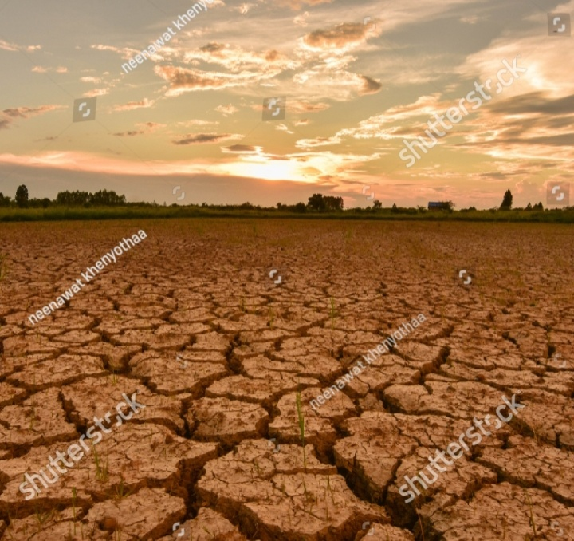
Drought Lands Impact
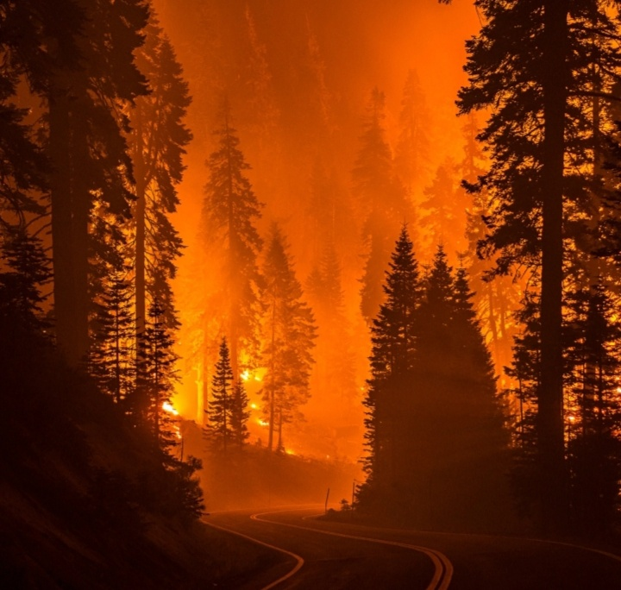
Wildfires Impact
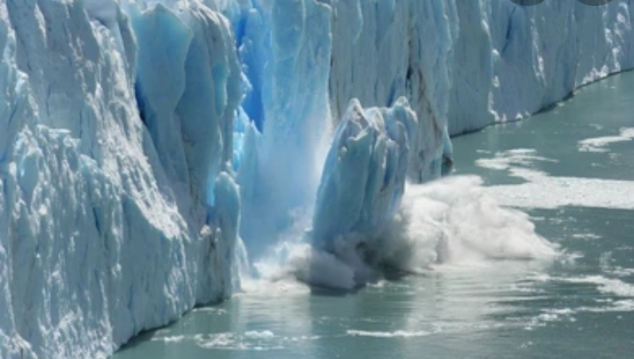
Oceans Melting Impact
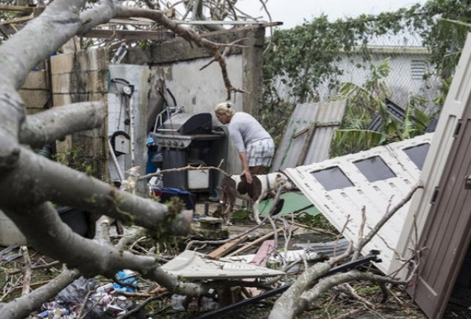
Hurricanes Damaging Impact

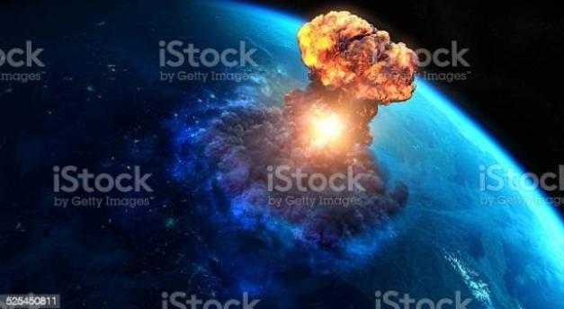
Nuclear Weapons Risk Produce
Poison Nitrogen Oxide Has Created Atmosphere Mushroom
Nuke & Damage to The Environment Infrastructure & Socio – Economic Development
Impacts

Causes:-
Cause No.1
Burning Fossils :-
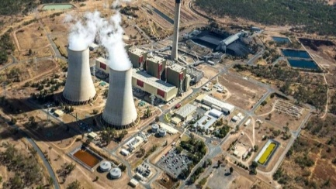
Burning fossils when people burn fossil fuels like oil , coal & gas to create electricity or power their gas , they release Co2 & nitrous oxide pollution into atmosphere are a big Co2 pollution producers in the world.
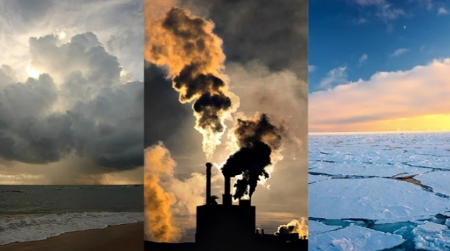
Fossils Fuels Hydrocarbon &Co2
Cause No.2
Culture & Farming :-
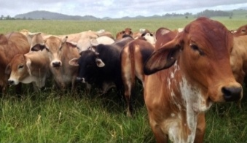
Animals & livestock like sheep & cattle produce methane green house gas when livestock grazed at a large scale , the amount of methane produce is a big contributor to global warming , some of farmers use also to release nitrous dioxide which another a greenhouse gas . Farming contribute 16% of their total greenhouse gas emission.
Cause No.3
Deforestation &Trees Cleaning :-
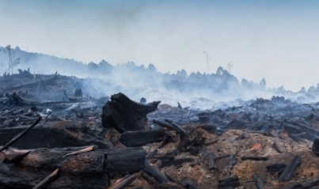
Plants & trees play an important role in regulating the climate because they absorb carbon dioxide from the air & release oxygen to the air & release oxygen back to into forests. A bushland uses carbon sinks . They are a valuable means of keeping global warming to 1.5 temperature degree . But humans clear vast green of vegetation around the world for farming urban infrastructure development or to sell tree products such as timber & palm oil . When vegetation is removed or burnt , the stored carbon is released back into the atmosphere as Co2 temperature contributing to global warming up to one - fifth of global greenhouse gas pollution or come from deforestation & forest degradation .
Solutions :-
Solution of Cause No.1
1)Reducing the amount of electricity generated from oil , coal & gas
2) Increasing the amount of electricity from clean ,renewable energy sources like solar energy & wind energy .
3)Join the movement for a stronger action on climate change & urge key politicians to get back on track to meeting Paris - agreement target .
Solution of Cause No.2
1)Use different stock feeds can help to reduce framings contribution to climate change
2)World Wide for Nature is working with leading beef producers through project - pioneer to develope , trial & validate improved livestock & pasture management that can deliver & significant economic , social & environmental gain out more .
Solution of Cause No.3 :
1)Prevent reforestation
2)Plant more trees through forestration & afferstration
3)Shop sustainably
4)Call on our leader to introduce strong laws to stop excessive tree - cleaning .

Conclusions:-
The conclusion that confirms global warming is the major challenge for our global society . Global warming will change our climate in the next century . The solution of global an warming are : Frist There must be international political solution - Second Funding to developing cheap & clean energy ( solar energy & wind energy ) production must be increased - Third Economic development must be based on clean energy usage.& all our hopes on global politics & clean technology & a lot of costs & damage that caused by changing climate can be mitigated - Fourth The nation’s of environmental laws or rules must take action not words only against global warming has made climate change in the world - Fifth Future trend an electricity of solar energy to operation all cars & trains & ships & air planes & a peaceful rockets due to change atitude positively of national community & international community how to fight global warming negative impacts now until future in the world

References :-
*Zulfa for Community Development Services Company
*World Wide for Nature ( WWF )
*Green Climate Change Fund
*United Nations Evironmental Program( UNEP )
*World Methodological Organization
*Food Agriculture Organization
( FAO )

* European Union Bank
*Universal Postal Union
*UN Climate Change

*United Nations Institute for Disarmament Research

*International Red Cross. Committee

*United Nations Security Council Parmenat Members

