Smart Solar Canals Grid (Hybrid Power Generation, Water Conservation and Green Hydrogen)

Prepared By: SHEIKHALDEEN NASRALDIN SHEIKHALDEEN ABAAS
Email: sheekho6969@gmail.com Mob:9908980466

ABSTRACT:
Solar energy is one of the most abundant sources of renewable energy for the future. This solar energy can be extracted by PV system. Many methods for PV installation are carried out, such as roof top PV system, dam top PV system; floating PV, canal top PV system etc. In canal top system, PV panels are placed above the water canal which saves installation area and reduces evaporation loss. The performance of any PV system depends mainly on the light intensity, so by a concentrating PV system power output can be increased. The usage of concentrated PV system can bring down the investment cost per kWh. In this paper canal top PV system with reflectors in the inter array spacing are studied. The expected advantage of such a system is that the evaporation loss can be further reduced and additional cooling system may not be required. To get uniform availability of light and to avoid shading on the panels, tilt angle of the panel, inter array spacing and orientation of the reflectors are calculated optimally.
At the entrance to the water channels exploit the water rush by Installing micro hydropower turbines, It has certain characteristics that allow fish to pass through without being harmed , This hybrid system generates electric energy shared between solar panels and hydropower , This large energy can be exploited in designing a smart system for solar channels that saves water by the shade formed by the solar system and reflectors, as well as exploiting the surplus energy in making green hydrogen by using Electrolysis .

Introduction:
Recently, renewable energy systems have undergone rapid developments around the world, and certain renewable energy industries, such as solar and wind, have attained annual growth rates of 20% or more . Renewable energy is an important alternative source of energy that promotes sustainable development in energy sector. Solar photovoltaic (PV) technology is the most common renewable energy option for clean energy generation. Since the power generation from solar is very expensive, it is not very popularly used. To overcome this problem there are number of methods, which includes the concentration of solar radiation and electrical thermal co-generation. The electrical current produced in a solar cell is, in principle, proportional to the solar radiation intensity on the surface of the cell. Solar concentrators are used to increase the irradiance on the cell surface, and thus the electricity production. So concentrating systems has the potential for reduced cost of solar electricity due to a smaller cell area. When a solar cell is exposed to concentrated sunlight, its temperature increases and this reduces the cell efficiency and this in turn reduces power output. In this way few benefits of concentrating the sunlight may be lost. The simple, straight forward method to this problem is to cool the solar cells. The cooling can be passive by means of cooling fins, or active by means of a cooling medium. If water is used as the coolant, the thermal energy can be utilized for heating applications. Taylor Briglio discussed a feasibility analysis of installing solar photovoltaic panels over California water canals. In this proposal a canal top solar system is studied with plane reflectors for the concentration of the sunlight. The main parameters affecting the PV performance is irradiation, temperature and shading which is optimized. Additional cooling is not required due to the presence of water in the canal which condenses to give a cooling effect. The evaporation loss of water may further reduce and an additional solar radiation falls on the panel by the use of reflector, Micro hydropower can be one of the most simple and consistent forms or renewable energy on your property. If you have water flowing through your property, you might consider building a small hydropower system to generate electricity. Micro hydro power systems usually generate up to 100 kilowatts of electricity. Most of the hydropower systems used by homeowners and small business owners, including farmers and ranchers, would qualify as micro hydropower systems. A micro hydropower system needs a turbine, pump, or waterwheel to transform the energy of flowing water into rotational energy, which is converted into electricity. Micro hydro turbine is using in the Entrance of the Canal , the number and size of the turbines depend on the water rush, Green hydrogen is hydrogen that is produced using renewable energy through electrolysis. This method uses an electrical current to separate hydrogen from oxygen in water. If the electricity needed for electrolysis is generated from renewable sources such as solar or wind, the production of hydrogen in this way emits no greenhouse gasses.

Picture1,2,3 shows:
Micro hydro Power, Solar canal system and smart meters
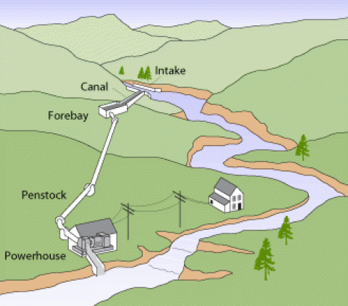

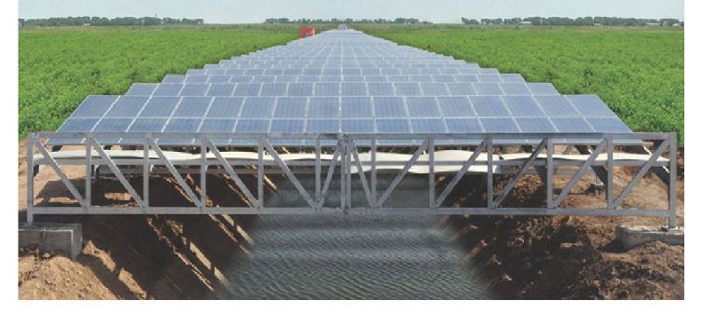
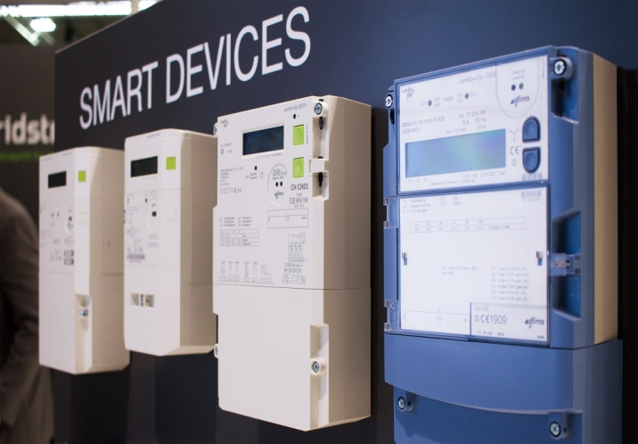

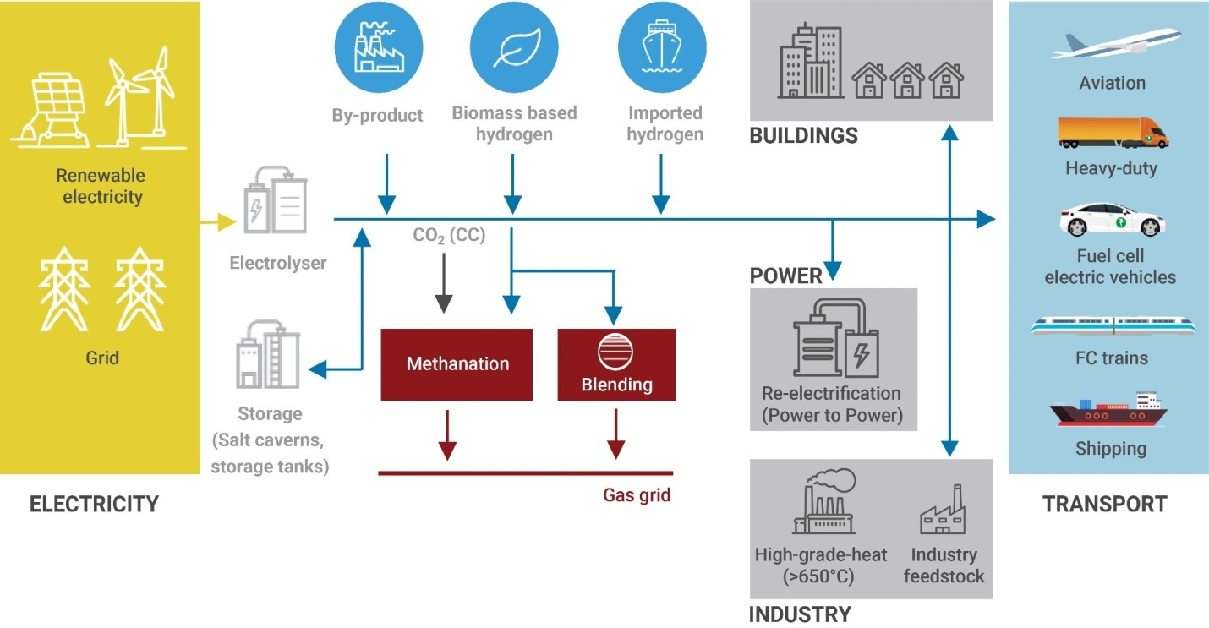

Pic3 green hydrogen from renewable energy

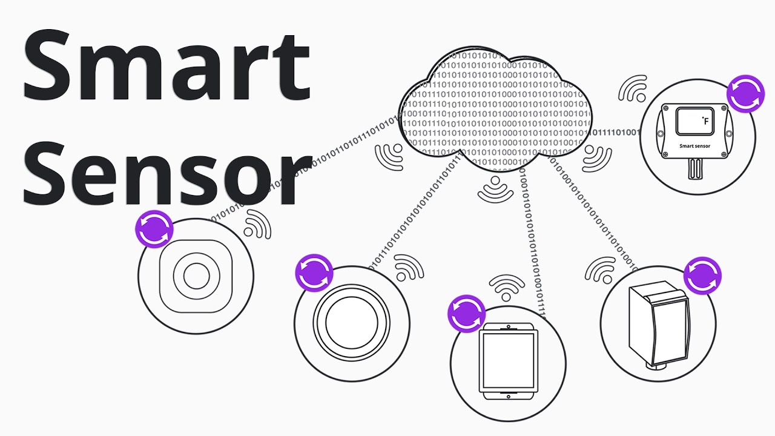

LITREATURE REVIEW:
Actually there is no previews study combined those Elements together (solar canals, micro hydro turbine, green hydrogen generation and smart system). But at 2012 the American professor Brandi Makuen with the help of Sun Edison company start the project of solar canals in Gujarat state west of India with 1 km , and the approximate project is 532 km with estimate prevent evaporate of 9000000 liters of water .
Now California solar canal is under process.

OBJECTIVE:
- Generate Renewable Energy
- Water conservation
- Uses less Area
- Generate green hydrogen
- Smart solar canal system

METHDOLOGY:
- By using mathematical equation and simulation program I will be able to Design solar canal system. Will becomes the basis for the establishment of an integrated system of smart solar channels in the world.
- I will seek financing from companies to implement this project on the ground in the future

REFRENCES:
- “Now,Gujarat to cover Narmanda canals with solar“(https://web.archive.org/web/20120425024336/http://www.thehindubusinessline.com/industry-and-economy/government-and-policy/article3346191.ece
- Effect of Solar Canals on Evaporation, Water Quality, and Power Production: An Optimization Study Sherine El Baradei * and Mai Al Sadeq

