Decarbonisation of the Road Transport with Renewable Energy
Amela Ajanovic, PhD, Energy Economics Group,
Vienna University of Technology, Austria

Abstract
Globally, transport accounts for about one quarter of the total carbon dioxide emissions. Energy consumption in the transport sector, which is dominated by fossil fuels, is continuously increasing causing various environmental problems. To cope with these problems alternative automotive technologies and alternative fuels are widely supported by different policy measures. It is of high priority to increase use of renewable energy sources in the transport sector. Currently, biofuels are mostly used alternative to conventional fossil fuels. However, with the increasing use of electric vehicles also electricity and hydrogen produced from renewable energy sources are becoming an important means in the decarbonization of the transport sector. Over the last years, biofuels have been supported worldwide. Yet, with the increasing use of biofuels we are facing new challenges, such as to ensure their sustainability and to avoid their competitions with food production. These challenges as well as changeable policy framework resulted in reduction of investment in biofuel technologies over the last decade. Currently, focus is put on electrification of mobility, although, in spite of the different supporting policies implemented worldwide, the amount of electricity used in the transport sector is still negligible, especially use of electricity from renewable energy sources. The purpose of this paper is to analyze existing policies, prospects and barriers for the increasing use of renewable energy sources in the road transport. Our method is based on the economic and environmental assessment of alternative fuels and alternative vehicles. Although, they could provide better environmental performance than conventional vehicles and fuels, alternative solutions are still more expensive. However, with technological learning and economics of scale costs could be reduced in the future. The major conclusion is that future use of renewable energy in the transport sector is very dependent on the development of the corresponding total mobility costs and environmental performances. For environmental performance of e-mobility, the priority is to increase use of renewable energy in electricity generation. Appropriate policy measures should ensure increasing use of renewable energy sources and faster decarbonization of the road transport.

Image
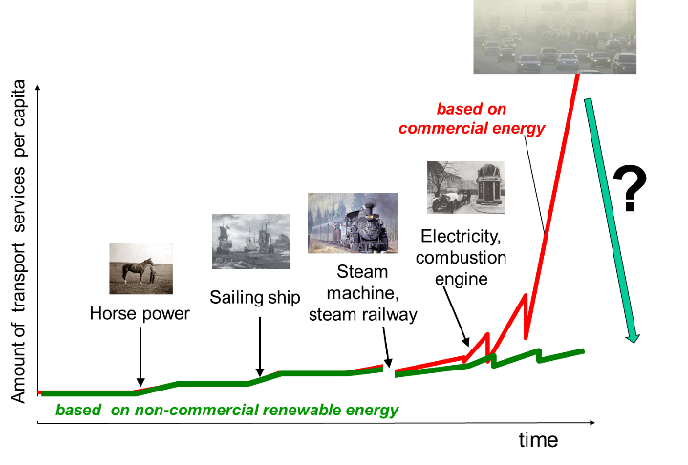
Figure 1. Development of the transport sector
Recent Publications
- Ajanovic A., Haas R., Schrödl M (2021) On the Historical Development and Future Prospects of Various Types of Electric Mobility. Energies 2021, 14, 1070.
- Ajanovic A., Haas R (2020) Prospects and impediments for hydrogen and fuel cell vehicles in the transport sector, International Journal of Hydrogen Energy. Volume 46, Issue 16, 3 March 2021, Pages 10049-10058
- Ajanovic A., Haas R (2020) On the economics and the future prospects of battery electric vehicles, Greenhouse Gases: Science and Technology. https://doi.org/10.1002/ghg.1985
- Ajanovic A, M.Siebenhofer, R. Haas, (2021): Electric Mobility in Cities: The Case of Vienna. Energies 2021,14, 217.
- Ajanovic A., Hiesl A., Haas R (2020) On the role of storage for electricity in smart energy systems, Energy. Volume 200, 1 June 2020.
- Siebenhofer M., A. Ajanovic, R. Haas (2021) How policies affect the dissemination of electric passenger cars worldwide. Energies 2021, 14(8), 2093;
- Haas R., A. Ajanovic, J. Ramsebner, T. Perger, J. Knápek, J. W. Bleyl (2021) Financing the future infrastructure of sustainable energy systems. Green Finance, 3(1): 90–118. DOI: 10.3934/GF.2021006


Amela Ajanovic is Asst. Professor at TU Wien. She is a lecture and faculty member of the postgraduate MSc Program “Renewable Energy Systems”. She holds a master degree in electrical engineering and a PhD in energy economics at TU Wien. Her main research interests are alternative fuels and alternative automotive technologies as well as sustainable energy system and long-term energy scenarios. She has been guest researcher at the Energy Research Centre of the Netherlands (ECN) in Amsterdam and at the International Energy Agency (IEA) in Paris, as well as a guest lecturer at the Technical University of Prague. She has been involved in many national and international research projects, and has published more than 30 papers in peer- reviewed international journals.
Email: ajanovic@eeg.tuwien.ac.at

