Fluid Natural Energy Fractal Dimension for Characterizing Shajara Reservoirs of the Permo-Carboniferous Shajara Formation, Saudi Arabia
Name: Professor / Doctor Khalid Elyas Mohamed Elameen Alkhidir, Ph.D
Affiliation: Department of Petroleum and Natural Gas Engineering, College of Engineering, King Saud University, Saudi Arabia, kalkhidir@ksu.edu.sa

Abstract
The quality and assessment of a reservoir can be documented in details by the application of fluid natural energy. This research aims to calculate fractal dimension from the relationship among fluid natural energy, maximum fluid natural energy and wetting phase saturation and to approve it by the fractal dimension derived from the relationship among inverse pressure head * pressure head and wetting phase saturation. Two equations for calculating the fractal dimensions have been employed. The first one describes the functional relationship between wetting phase saturation, fluid natural energy, maximum fluid natural energy and fractal dimension. The second equation implies to the wetting phase saturation as a function of pressure head and the fractal dimension. Two procedures for obtaining the fractal dimension have been utilized. The first procedure was done by plotting the logarithm of the ratio between fluid natural energy and maximum fluid natural energy versus logarithm wetting phase saturation. The slope of the first procedure = 3- Df (fractal dimension). The second procedure for obtaining the fractal dimension was determined by plotting the logarithm (inverse of pressure head and pressure head ) versus the logarithm of wetting phase saturation. The slope of the second procedure = Df -3. On the basis of the obtained results of the fabricated stratigraphic column and the attained values of the fractal dimension, the sandstones of the Shajara reservoirs of the Shajara Formation were divided here into three units.

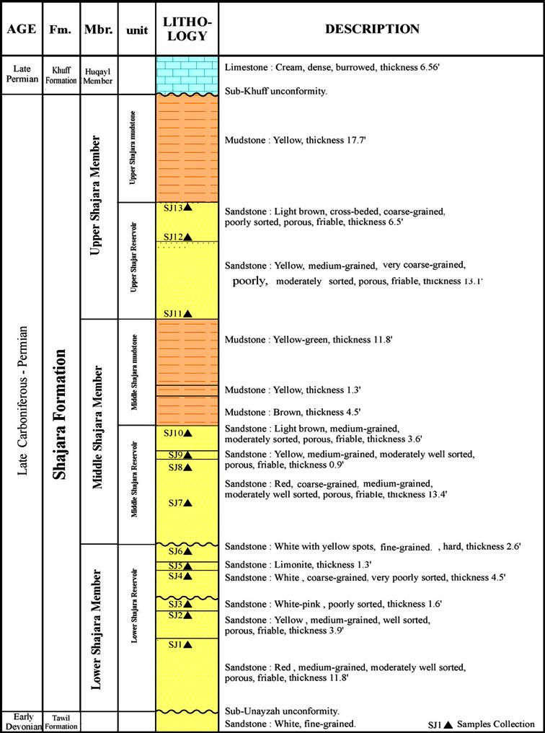
Image
Figure 1 Surface type section of the Shajara Reservoirs of the Permo-Carboniferous Shajara Formation at latitude 26° 52' 17.4" longitude 43° 36' 18
Recent Publications
- Khalid Elyas Mohamed Elameen Alkhidir (2020) Seismo Mechanical Energy Fractal Dimension for Characterizing Shajara Reservoirs of the Permo-Carboniferous Shajara Formation, Saudi Arabia. International Journal of Petroleum and Petrochemical Engineering. 6:14-23
- Khalid Elyas Mohamed Elameen Alkhidir (2020) Specific Enthalpy Fractal Dimension for Characterizing Shajara Reservoirs of the Permo-Carboniferous Shajara Formation, Saudi Arabia. Journal of Agriulture and Aquaculture. 2:1-9
- Khalid Elyas Mohamed Elameen Alkhidir (2020) On Similarity of Seismo Diffusion Coefficient and Pressure Head Fractal Dimension for Characterizing Shajara Reservoirs of the Permo-Carboniferous Shajara Formation, Saudi Arabia. Journal of Biogeneric Science and Research. 2: 1-7.
- Khalid Elyas Mohamed Elameen Alkhidir (2020) On Similarity of Seismo Magentic Field and Pressure Head Fractal Dimension for Characterizing Shajara Reservoirs of the Permo-Carboniferous Shajara Formation, Saudi Arabia, Saudi Arabia. Earth & Environmental Science Research & Reviews. 3: 23-28
- Khalid Elyas Mohamed Elameen Alkhidir (2020) Seismo Radial Grain Velocity Fractal Dimension for Characterizing Shajara Reservoirs of the Permo-Carboniferous Shajara Formation, Saudi Arabia. Journal of Chemistry: Education Research and Practice. 4: 1-16.

Biography
Khalid Elyas Mohamed Elameen AlKhidir is professor at king Saud University. He did his postdoctoral research at King Saud University, College of Engineering, Department of Petroleum and Natural Gas Engineering, Al-Amoudi Research Chair in Petroleum, Enhanced Oil Recovery. He published papers in sandstone reservoirs characterization, tight carbonate reservoirs characterization, and in an enhanced oil recovery

Email: kalkhidir@ksu.edu.sa

Notes/Comments:

