Incidence of Isospora belli in leukemic children in Erbil city.

Summary:
This study was conducted in Erbil city to investigate the incidence of Isospora belli infection among leukemic children, by laboratory examination of stool samples obtained from 26 children suffering from leukemia using different methods like N. saline, Iodine fecal smears, Sheathers flotation and modified Ziel-Neelson techniques. Isospora belli was detected in only one out of 26 (3.8%) ill children.
Objective: to investigate the rate of infection with Isospora belli in children suffering from diarrhea especially the immunocompromised and leukemic group.
Key words: Isospora belli, Leukemic Children, Isosporiasis

Introduction:

Isospora belli is a coccidian protozoan parasite related to the phylum Apicomplexa that parasitizes epithelium of upper small intestine of humans and causes diarrheal disease (1). It is taxonomically related to Cryptosporidium spp., Cyclospora spp. and Toxoplasma (2). Infections of this parasite are cosmopolitan in distribution, but more common in tropical, subtropical regions, Middle East, and areas with poor sanitation (3), it is associated with outbreaks of diarrhea in mental wards and daycare centers (2). This organism is the only member of the genus that infect human, and transmitted through contaminated water and food (4).
Most of the infections are asymptomatic. Symptomatic isosporiasis is mainly characterized by watery diarrhea, abdominal pain, vomiting, dehydration, malabsorption, weight loss, and peripheral eosinophilia. Although, chronic and sever illness in infants, young children, and healthy adults has been reported (5), in healthy hosts the illness is typically self-limiting. However, in patients with immunodeficient states and acute lymphoblastic leukemia, the illness is chronic and may be associated with severe dehydration and debilitation (3).
As with other Coccidian, I. belli has both sexual and asexual life cycle. The infection is acquired through the ingestion of sporulated oocysts. Sporozoites were released in the intestinal lumen and invade intestinal epithelial cells, within the epithelial cells the parasite undergoes a round of merogony process (asexual stage) leading to the production of merozoites. The released merozoites reinvade intestinal epithelial cells and can undergo additional rounds of merogony or develop into either micro- or macrogamonts (sexual stage). Microgametes will fertilize the macrogametes to form a zygote which develops into the oocyst. Immature oocysts are passed in the feces and maturation to the infectious sporulated oocysts occurs in the environment. Recognizable stages during this maturation (i.e., sporogony) include oocysts with a single sporoblast, oocysts with two sporoblasts, and the mature oocyst with two sporocysts, each with four sporozoites (2,3).
Detection of Isospora is made by direct or concentrated wet smears of fresh or preserved stool specimens, rather than permanent stained smears. In wet smears, oocysts are pale transparent, oval, measures 20 to 33 µm by 10 to 19 µm, and generally contain only one or two immature sporoblasts (6). The acid-fast stain is another detection method, by which the oocyst stained red (7).
For the treatment of isosporiasis, trimethoprim-sulfamethoxazole is the drug of choice. ciprofloxacin also used but it is less effective (8).

Patients and method:
This study was conducted among 26 leukemic child from Nanakali hospital of Malignant diseases in Erbil City, during June 2010. Ten of them had acute myeloid leukemia (AML) and 16 had acute lymphocytic leukemia (ALL).
Stool specimens were collected from ill children in a tightly covered wide mouth, disposable plastic containers. These were labeled with a number, date and name of each subject. Macroscopic examination was done for evaluating the consistency, color, presence of pus, mucus or blood in the stool samples.

Direct saline and iodine mount
A drop of N. saline was placed in the left half, and another drop of lugols iodine was placed in the right half of the slide.
With an applicator stick a small portion of stool specimen was picked up and mixed with N. saline, and another small amount was picked up and mixed with iodine.
The two smears(saline and iodine) were covered with cover slip .
Preparation was examined under microscope using objective lens 10X then 40X magnification power.
In iodine mount Isospora oocysts appear light brown ovoidal bodies with dark brown wall. Sheathers sugar flotation technique were also used as a concentration method in scanty infection (Fig. 1).
Modified Ziehl-Neelson technique was used in the positive sample to confirm diagnosis.(Fig. 2).

Result:
Isospora belli was detected only in one (3.8%) out of 26 leukemic children, which was mixed with G. lamblia.

Discussion:
For the first time in Erbil city Isospora belli was detected in one case (3.4%) among children suffering from leukemia which was mixed with Giardia infection. This finding is similar to that recorded in Ethiopia, in a study done by adamu et.al., whom found (2.3%) of children under five years of age suffering from diarrhea (9).
Isospora belli is known to be a rare cause of childhood diarrhea (10). For example, in India, Mirdha et al. (2002) detected only (0.17%) of the symptomatic isosporiasis among children with diarrhea (11), and in Iran Nahravanian and Assmer (2008) detected only one case among 23 AIDS patients 4.3% (12).

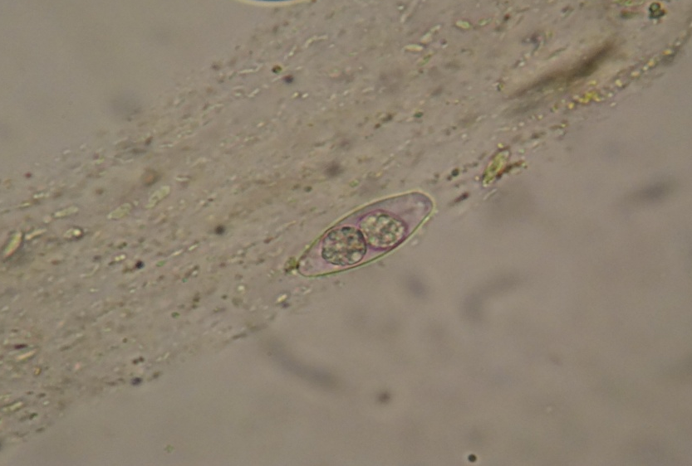
(Fig. 1):Isospora belli (mature oocyst containing two sporocysts) using Sheather´s sugar flotation technique (40X)

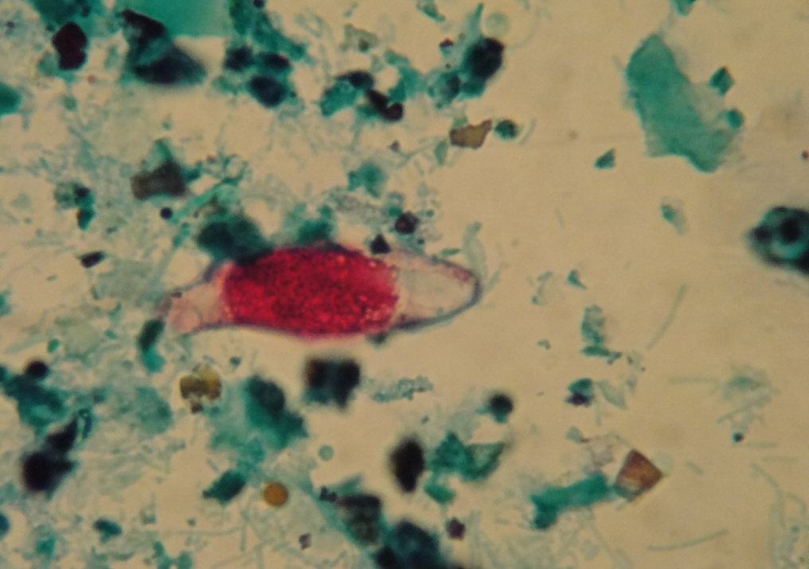
(Fig. 2):Isospora belli (immature oocyst containing a sporoblast)

Stained with modified Ziehl-Neelson stain.

References:
- Singh, A.; Houpt, E. and Petri, W.A. (2009). Rapid diagnosis of intestinal parasitic protozoa, with a focus on Entamoeba histolytica. Hindawi publishing corporation. Vol. 2009. P 1-8.
- Marshal, M.M.; Noumovtz, D.; Ortega, Y. and Sterling, C.R. (1997). Waterborne protozoan pathogens. Clin. Microbiol.Rev. 10(1): 67-85.
- Lindsay, D.S.; Dubey, J.P. and Blagburn, B.L. (1997). Biology of Isospora spp. from humans, nonhuman primates, and domestic animals. Clin. Microbiol. Rev. 10(10): 19-34.
- Escobedo, A.A.; Almiral, P.; Alfonso, M.; Cimerman, S.; Rey, S. and Terry, S.S. (2009). Treatment of intestinal protozoan infections in children. Arch. Dis. Child. (Published online) p: 1-20.
- - Meamar, A.R.; Rezaian, M.; Zare-Mirzaei, A.; Zahabiun, F.; Faghihi, A.H.; Oormazdi, H.; et al. (2009). Severe diarrhea due to Isospora belli in a patient with thymoma. J. Microbiol. Immunol. Infect. 42: 526-29.
- Wittner, M.; Tanowitz, H.B. and Weiss, L.M. (1993). Parasitic infectin in AIDS patients. Cryptosporidiosis, isosporiasis, microsporidiosis, cyclosporiasis. Infect. Dis. Clin. North. Am. 7: 569-86.
- Mannheimer, S.B. and Soave, R. (1994). Protozoal infections in patients with AIDS, Cryptosporidium, isosporiasis, cyclospoiasis and microsporidiosis, Dis. Clin. Nor. Am. 8: 483-85.
- Sears, C.L. and Kirkpatric, B.D. (2001). Cryptosporidiosis and Isosporiasis. In; Gillespie, S.H. and Pearson, R.D. (Eds) Priciples and practice of clinical parasitology. JohnWiley& Sons Ltd. England. PP: 139-64.
- 9- Adamu, H.; Endeshaw, T.; Teka. T.; Kifle, A. and Petros, B. (2006). The prevalence of intestinal parasites in pediatric diarrheal and non- diarrheal patients in Addis Ababa hospitals, with special emphasis on opportunistic parasitic infections and with insight into the demographic and socio-economic factors. Ethiop. J. Hlth. Dev. 20(1):39-46.
10- Al-Braiken, F.A.; Amin, A.; Beeching, N.J.; Hommel, M. and Hart, C.A. (2003). Detection of Cryptosporidium amongst diarrheic and asymptomatic children in Jeddah, Saudi Arabia. Annals. Trop. Med. & Parasitol. 97(5): 505-10.
11- Mirdha, B.R.; Kabra, S.K. and Samantray, J.C. (2002). Isosporiasis in children. Indian Peditr. 39: 941-44.
12- Nahravanian, H. and Assmar, M. (2008). Cryptosporidiosis in
immunocompromised patients in the Islamic Republic of Iran. J. Micribiol. Immunol. Infect. 41: 74-77.

