Thermal energy storage in phase change materials: Achievements so far and challenges ahead
Mahmood Mastani Joybari, PhD, Concordia University, Canada

Abstract
In recent years, mainly due to the environmental reasons, the share of renewable energy sources has been on the rise. A major challenge for such sources is their intermittent availability. To tackle the resulting time mismatch between energy supply and demand, energy storage especially in phase change materials (PCMs) received considerable attention. Nevertheless, PCMs are far from widespread commercialization due to some inherent shortcomings especially their low thermal conductivity. In addition, most of the existing studies considered one-time or consecutive phase change processes. In reality, however, PCMs might undergo simultaneous charging and discharging. Consequently, to tackle such shortcomings in the literature, comprehensive experimental and numerical investigations have been conducted by our team as part of the contribution to Annex 31 of International Energy Agency (IEA-ECES Annex 31). The major topics covered so far include:
(a) characterization of heat transfer mechanism in vertical storage units
(b) analysis of the effect of storage shape on vertical units (cylindrical vs. conical)
(c) analysis of the effect of orientation on storage units (vertical vs. horizontal)
(d) characterization of heat transfer mechanism under simultaneous charging and discharging
(e) analysis of the effect of geometrical properties on vertical units (shell to tube radius ratio)
(f) enhancement techniques in horizontal storage units (using multiple tubes, triplex tubes and/or fins).
It can be understood from the outcomes that PCMs need further research to be widely accepted. In addition, further optimization studies are needed to exploit their potential to the full.

Image
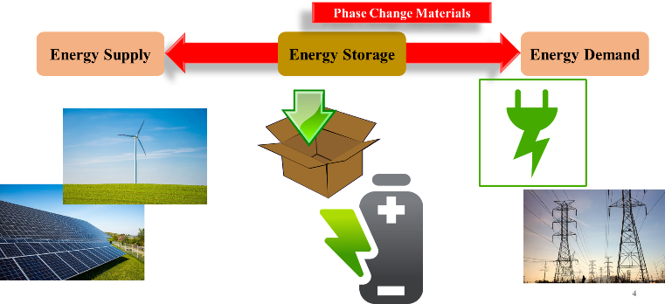
Recent Publications
- Joybari MM, Seddegh S, Wang X, Haghighat F (2019). Experimental investigation of multiple tube heat transfer enhancement in a vertical cylindrical latent heat thermal energy storage system. Renewable energy, 140: 234-244.
- Joybari MM, Haghighat F, Seddegh S, Yuan Y (2019). Simultaneous charging and discharging of phase change materials: Development of correlation for liquid fraction. Solar Energy, 188: 788-798.
- Joybari MM, Haghighat F, Seddegh S (2017). Natural convection characterization during melting of phase change materials: Development of a simplified front tracking method. Solar Energy, 158: 711-720.
- Joybari MM, Haghighat F, Seddegh S, Al-Abidi AA (2017). Heat transfer enhancement of phase change materials by fins under simultaneous charging and discharging. Energy Conversion and Management, 152: 136-156.
- Joybari MM, Haghighat F, Seddegh S (2017). Numerical investigation of a triplex tube heat exchanger with phase change material: Simultaneous charging and discharging. Energy and Buildings, 139: 426-438.

Biography
Mahmood Mastani Joybari has his expertise in thermal energy storage systems, especially phase change materials. He obtained his PhD in Building Engineering from Concordia University. He participated in the multinational team of Annex 31 of the International Energy Agency (IEA-ECES Annex 31) both in terms of contribution and preparation of the final report. His main research contributions are in terms of natural convection within PCMs where he developed a simplified PCM front tracking method under melting as well as simultaneous charging and discharging.
Email: m_masta@encs.concordia.ca

Notes/Comments:

