Abstract Image
Chemical pollution-free future involves a positive environment impact method is need such as microwave-assisted extraction with its variants. According to this statement, extraction techniques with reduce organic solvent consumption are greatly need; this technique must be able to eliminate chemical solvent, while ensuring a safe and high-quality extract with a good extraction yields and biological activities. This concept makes it possible to meet the challenge of the 21st century for protecting both our environment and human health. In this order of idea, we have therefore worked on the influence of Microwave assisted extraction (MAE) on biological activities of Trichilia roka MAE root bark.
Microwave-assisted process (MAP) technology, a reliable alternative method of extraction. offers some combination of the following advantages: Improved products, increased purity of crude extracts, improved stability of marker compounds, possibility to use less toxic solvents, reduced processing costs, increased recovery and purity of marker compounds, very fast extraction rates, reduced energy and solvent usage. As the matrix is also directly heated from the inside to the outside during microwave extraction, it improves the extraction and solubilisation of the root bark. Growing interest in medicinal plant include: rising costs of orthodox medications, low therapeutic index of synthetic compounds and the growing incidence of drug resistance among the pathogens especially in developing countries with weak economic indices. MAE proved to be the best for the extraction process of T. roka root bark with Inhibition Concentration (IC₅₀) of 2.10⁻² mg/.mL for conventional extraction method and 3.3.10⁻³ mg/.mL under MAE process and Total polyphenol content (TPPC) of 12.5 g GAE/100gDW and antioxidant activity (DPPH 90.1%; AOA 90.5%. MAE procedure is a promising technique in recovery efficientely secondary metabolites with interest biological activities from T. roka. root.
Keywords: Trichilia roka root bark; Microwave-assisted extraction, factors; antioxidant; antiplasmodial, total polyphenol content.
Image
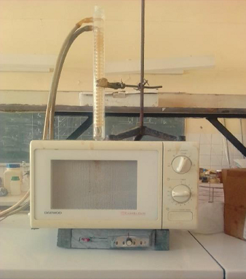
Domestic microwave oven (Daewoo, KOG-360, Combi Grill) adapted with a condenser.
Recent publications
- O.Nana. J.Momeni. F.F.Boyom. N.Y.Njitang and M.B.Ngassoum. Microwave assisted extraction as an advanced technique for optimisation of limonoids yields and antioxidant potential from Trichilia roka (Meliaceae). Current Research in Green and Sustainable Chemistry. 2021; (4) 100147. doi. Org/10. 1016/j.crgsc. 2021. 100147
- O.Nana. J.Momeni. F.F.Boyom. M.B.Ngassoum. Microwave assisted extraction of antiplasmodial and antioxidant limonoids from Trichilia roka (chiov). Journal of Phytopharmacology. 2021; 10(3) 185-191. doi:10.31254/phyto.(2021)10307.
- O. Nana, J. Momeni, T.R. Nzangue, M.B. Ngassoum, The inﬂuence of microwaveassisted extraction on Trichilia roka root bark, Int. J. Phytopharm. 2 (4) (2015) 22–29.
- O. Nana, J. Momeni, T.R. Nzangue, M.B. Ngassoum, Phytochemical screening,
antioxidant and antiplasmodial activities of extracts from Trichilia roka and Sapium
ellipticum, J. Phytopharm. 2 (4) (2013) 22–29
Biography.

I’m Dr Nana Ndounkeu Olga Minette, permanent lecturer of Organic Chemistry at the Faculty of Science of the University of Ngaoundere and at Department of Chemistry. Recently recruited (2 years) to higher education, I taught for 18 years in high school while being a temporary teacher in the Faculty of Sciences and at National Advanced School of Agro-Industrial Sciences (ENSAI) for 16 years.
My current status as a permanent lecturer gives me the latitude to formulate my own research directions. Green Chemistry is one of my main areas of research, the optimisation of extraction techniques and the maximisation of the biological activities such as antiplasmodial and antioxidant of secondary metabolites in general and of Limonoids, flavonoids and polyphenols in particular.

