Mechanistic Investigation Inspired Green Synthesis Strategies: From Theory to Experiments
Jingping Zhang, School of Chemistry, Northeast Normal University, Changchun 130024, China

Abstract (300 word limit)
Computational chemistry is especially important for understanding the structures and properties of compounds and for elucidating mechanisms of chemical reactions, in turn, helps in the design of new reactions and catalysts. To achieve green syntheses, we have explored the effects of assistant (catalyst), solvent, and counterion on the reactions to optimize the experimental conditions towards green synthesis.¹⁻⁷ A series of novel organic synthesis reactions with trace water-, water solvent-, self-catalyzed and water replacing organic toxic solvents have been achieved by DFT calculation with following findings. 1) The chairlike [3,3]-intramolecular shift was found to be the rate-limiting step for the water-catalyst mechanism with lower energy barrier in both gas-phase and QM/MM simulated bulk water, compared with those under neat condition for aromatic Claisen Rearrangement.¹ 2) Economic reaction approaches were designed for the reported domino cyclization between gem-dialkylthio vinylallenes and benzylamine in DMSO solvent, namely, this reaction can be improved under organic solvent-free conditions either catalyzed by trace water or self-catalyzed by BnNH₂.³ 3) [DBU-H]⁺-H₂O was found to be the effective catalyst form in the proton migration transition state rather than traditional suggestion [DBU-H]⁺-OH– for the synthesis of 2,3-dihydro-pyrido[2,3-d]pyrimidin-4(1H)-Ones.⁴ 4) We have found a green “On water” synthetic strategy for biphenol derivatives previously prepared in MeCN by β-Naphthol and Formaldehyde.⁵ 5) The mechanism of N-Bromosuccinimide (NBS) promoted synthesis of imidazo[1,2-a]pyridine can be altered and accelerated by solvent water and substrate. Water acts as solvent, reactant, anchoring, stabilizer, and catalyst in our explored reactions.⁶ Therefore, we open a new efficient and green strategy for the synthesis of previously reported reactions.

Image
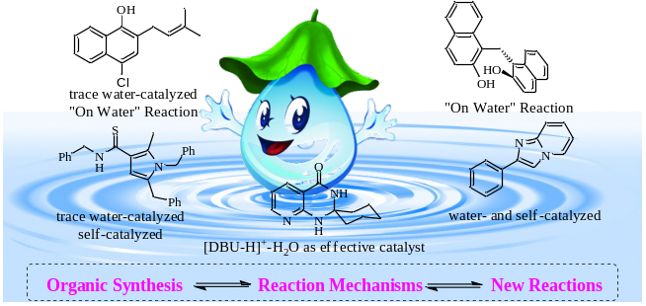
Recent Publications (minimum 5)
- Zheng Y, Zhang J P (2010) Catalysis in the Oil Droplet/Water Interface for Aromatic Claisen Rearrangement. The Journal of Physical Chemistry A 114: 4325-4333.
- Zheng Y, Zhang J P (2010) Interface Water Catalysis of the Epoxide Opening. ChemPhysChem 11:, 65-69.
- Yuan H Y, Zhang J P (2014) Mechanistic understanding of domino cyclization between gem-dialkylthio vinylallenes and benzylamine towards economic synthesis: a computational study. Green Chemistry 16:2653-2663.
- Yuan H Y, Zhang J P (2015) [DBU-H]⁺ and H₂O as Effective Catalyst form for 2,3-dihydropyrido[2,3-d]pyrimidin-4(1H)-Ones: A DFT Study. Journal of Computational Chemistry 36: 1295-1303.
- Cao S, Zhang J P (2017) Mechanistic Investigation Inspired “On Water” Reaction for Hydrobromic Acid-Catalyzed Friedel–Crafts–Type Reaction of β-Naphthol and Formaldehyde. Journal of Computational Chemistry 38: 2268-2275.
- Qian M, Zhang J P (2018) Mechanistic Insights Into N-Bromosuccinimide-Promoted Synthesis of Imidazo[1,2-a]pyridine in Water: Reactivity Mediated by Substrates and Solvent. Journal of Computational Chemistry 39: 2324-2332.
- Yuan H Y, Zhang J P (2018) Mechanistic Insight on Water and Substrate Catalyzed the Synthesis of 3-(1H-indol-3-yl)-2-(4-methoxybenzyl) isoindolin-1-one: Driving by Noncovalent Interactions. Journal of Computational Chemistry 39: 2316-2323.

Biography (150 word limit)
Jingping Zhang has completed her PhD at the age of 31 years from Northeast Normal University and postdoctoral studies from Kyushu University. She is currently the director of division of International Cooperation and Exchange. She is also the chief editor for Journal of Molecular Science. The research interests of Prof. Zhang are investigation of mechanism for novel organic reactions and design functional materials such as lithium ion battery (cathode & anode) materials. She has published more than 320 papers in J. Am. Chem. Soc, Angew. Chem., Int. Ed, Nano energy, ACS Catal, Green Chem, Chem. Commun, J. Mater. Chem. A, Adv. Synth. Catal, J. Org. Chem, J. Comput.Chem, etc
Email: jpzhang@nenu.edu.cn

