A nano hydrophobic task-specific room temperature ionic liquid as an adsorbent for discriminating of Cr (III) and Cr (VI)

Ghazale Daneshvar Tarigh, Masoumeh Bakhtiari,
Farzaneh Shemirani, Tehran, Iran

Abstract (300 word limit)

In this research hydrophobic task-specific room temperature ionic liquid (HTSRTIL) coated on the magnetic multi-wall carbon nanotube (MMWCNT) have been prepared by in-situ electrostatic immobilization. The as-sorbent has been successfully used for the speciation/extraction of chromium species. Total chromium was determined by oxidizing Cr (III) to Cr (VI) using KMnO₄ in acidic media. The adsorbent was characterized by scanning electron microscopy (SEM), X-ray diffraction (XRD), Energy dispersive x-ray spectrometry (EDS) and Fourier transform infrared spectrophotometer (FT-IR). The analyte being finally determined by UV-Vis spectrophotometry. The influence of several experimental variables (including pH, amount of adsorbent, sample volume, extraction time and desorption solvent) has been considered in depth in the optimization process. The developed method, which has been analytically characterized under its optimal operation conditions, allows linear range between 1-200 µg L⁻¹ and detection limits of 0.4 µg L⁻¹. The repeatability of the method expressed as the relative standard deviation (RSD) 4.9% (n = 5) while the enrichment factor is 300. The proposed procedure has been applied for the speciation of chromium from water (tap, spring, river, and well), vegetables (cabbage, broccoli, cress, and leek), soil (from coal mine), and fish with the recoveries in the range from 70 to 103%.
Image
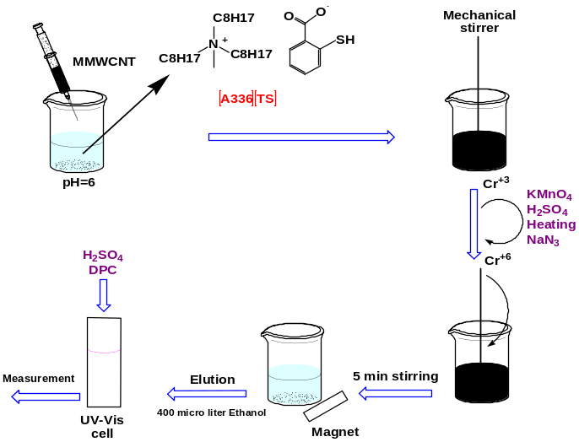
Schematic diagram of hydrophobic task-specific room temperature ionic liquid- dispersive magnetic solid phase extraction for speciation of Cr (III)/Cr (VI)

Recent Publications (minimum 5)
- Sadeghi, S., Moghaddam, A.Z., (2016) Chromium speciation using task specific ionic liquid/aqueous phase biphasic system combined with flame atomic absorption spectrometry. J. Mol. Liq. 221:798–804.
- Callao, M.P., Go, V., (2006) Chromium determination and speciation since 2000. 25:1006–1015.
- Wang, Q., Baker, G.A., Baker, S.N., Colón, L.A., (2006) Surface confined ionic liquid as a stationary phase for HPLC. Analyst. 131: 1000–1005
- Billard, I., Jobin, E., Ouadi, A., Gaillard, C., (2008) Task-specific ionic liquids for An and Ln extraction: unusual speciation and extraction mechanisms. Atalante 2008. 1–4.
5. H. Davis, Jr., J., (2004) Task-Specific Ionic Liquids. Chem. Lett. 33: 1072–1077.


Biography
Ghazale Daneshvar Tarigh received her PhD degree in analytical chemistry from University of Tehran, Iran in 2015. She received her bachelor's degree (B.Sc.) in pure chemistry at the University of Zanjan, in 2003. She got her master's degree (M.Sc.) under the direction of Prof. Yadollah Yamini at TMU and Prof. Ali Jabbari at KNTU in 2009. Her field of interest is the development of new extraction technologies, with an emphasis on miniaturized sample preparation methods and separation techniques. Now she works at University of Tehran as a teacher assistant. She works with master's students as an advisor.
Email:ghdaneshvartarigh@yahoo.com

