Techno-environmental feasibility analysis of CO₂ capture and reutilization from alcoholic fermentation processes: the CO₂-AFP Strategy.
Abdessamad Gueddari, PhD candidate, UCLM, Spain.
Santiago Garcia-Yuste, associate professor, UCLM, Spain.
Carlos Alonso-Moreno, associate professor, UCLM, Spain.
Jesús Canales-Vazquez, associate professor, UCLM, Spain.
Jorge E. Zafrilla, associate professor, UCLM, Spain.

Abstract
A novel Carbon Dioxide Utilisation approach is proposed based on the use of the emitted by-product biogenic CO₂ from Alcoholic Fermentation Processes to produce soda ash. This product is one of the most demanded commodities in the chemical industry. In global terms, researchers report that the implementation of this strategy will produce over 30,6 Mt of Na₂CO₃ by capturing 12,7 Mt of CO₂ and 56 Mt of CO₂ negative emissions per year, without generating any by-products. The chemical process selected to achieve this utilisation is based on a chemical reaction between gaseous CO₂ and saturated sodium hydroxide solution (NaOH 50% wt.). The feasibility of this approach was discussed following the CO₂ Chem network approach. In order to evaluate the possibility of implementing the CO₂-AFP Strategy, it has been analysed from a technical and environmental perspectives applied to a real business model. On one hand, the technical feasibility study is divided into three different phases: (1) Characterization of the CO₂ emissions, (2) CO₂ capture and design of the distribution system and (3) the chemical processing plant. On the other hand, the environmental feasibility is analysed on determining the footprint scope 1 and 2. Finally, global projection results are obtained based on the techno-environmental feasibility performance.

Image
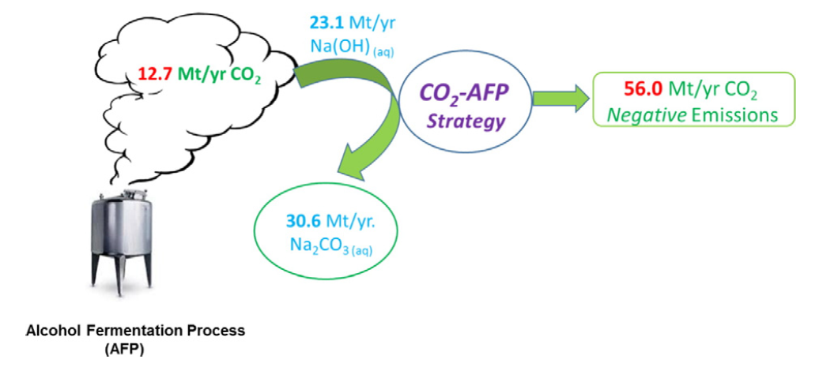
Recent Publications
- Alonso-Moreno, C. Garde, J.J., Zafrilla, J.E., Canales-Vázquez, J., Gueddari, A., García-Yuste S. (2018). The Carbon Dioxide-Rumen Fermentation Processes-strategy, a proposal to sustain environmentally friendly dairy farms. Journal of Cleaner Production. 204:735-743.
- Alonso-Moreno Carlos, García-Yuste Santiago (2016) Environmental potential of the use of CO₂ from alcoholic fermentation processes. The CO₂-AFP strategy. Science of The Total Environment. 568: 319-326.
- J. C. Ruiz-Morales, A. Tarancón, J. Canales-Vázquez, J. Méndez-Ramos, L. Hernández-Afonso, P. Acosta-Mora, J.R. Marín Rueda and R. Fernández-González (2017). Three-dimensional printing of components and functional devices for energy and environmental applications. Energy & Environmental Science. 10 (4): 846- 859.
- Alvarez, S., Tobarra, M.A. and Zafrilla, J.E. (2018). Corporate and Product Carbon Footprint under Compound Hybrid Analysis. Application to a Spanish Timber Company. Journal of Industrial Ecology.
- J. Martínez, J. A. Castro-Osma, C. Alonso-Moreno, A. Rodríguez-Dieguez. M. North, A. Otero, A. Lara-Sánchez (2017). One-component aluminium (heteroscorpionate) catalysts for the formation of cyclic carbonates from epoxides and carbon dioxide. ChemSusChem: 10: 1175-1185.


Biography
Abdessamad Gueddari is a Ph.D. candidate and research worker leading a pioneering business R&D project. His doctoral research investigates sciences and technologies applied to industrial engineering at the University of Castilla-La Mancha. Specifically, he is researching new engineering techniques and strategies to capture and transform carbon dioxide into value-add products. He earned a Bachelor of Mechanical Engineering, and a Master of Industrial Engineering. He belongs to the 3D Enermat Research Group at the Renewable Energy Research Institute. He is interested in improving the industry footprint by developing new sustainable processes and implementing new methodologies related to Carbon Dioxide Utilization strategies.
Email: abdessamad.gueddari@uclm.es
Notes/Comment

