New Vanillin bio-based epoxy monomers as Bisphenol A substitute for epoxy thermosetting resin.
Eric Desnoes, PhD candidate, UQTR, CA.
Dominic Thibeault, Pr, Oleotek, CA.
Lofti Toubal, Pr, UQTR, CA.
Daniel Montplaisir, Pr, UQTR, CA.

Abstract (300 word limit)
Thermosetting resins are synthetic polymeric materials used in composites, adhesives, and coatings. Epoxy resins are one of the major thermosetting polymers because of they have excellent adhesion, chemical and mechanical resistance. Nowadays, mostly all of epoxy resins are produced from bisphenol A (BPA) which is fully made from fossil fuels and have been proved to be a reprotoxic substance. Therefore, and due to increasing environmental concerns, access to bio-based and non-harmful aromatic monomers for industrial applications is needed. The main abundant resources of renewable aromatic compounds are polyphenols, cardanol and lignin, which lignin is the most abundant feedstock. Lignin is a cross-liked polymer that gives structural rigidity to plants, making up to 35% of biomass. Despite extensive research, there are few efficient pathways to obtain aromatic products at an industrial scale. However, vanillin can be produced from lignosulfonates contained in “brown liquor”, which is a by-product of pulp and paper industry. Today, up to 15% of the commercially available vanillin is produced by this method, and 85% are still obtained from fossil fuels. Vanillin has been used as a renewable building-block to develop a Schiff base compounds platform, using commercial and industrial hardener as a crosslinker, prior to their epoxidation. Bio-based epoxy monomers from vanillin Schiff base were synthesized and characterized. These monomers were cured with diethylenetriamine (DETA) employed as hardener. Vanillin-based thermosetting monomers were compared to petro-based monomers derived from BPA by mechanical characterization and thermal properties. Vanillin-based epoxy monomer platform thus appears to be a promising substitute to BPA.

Image
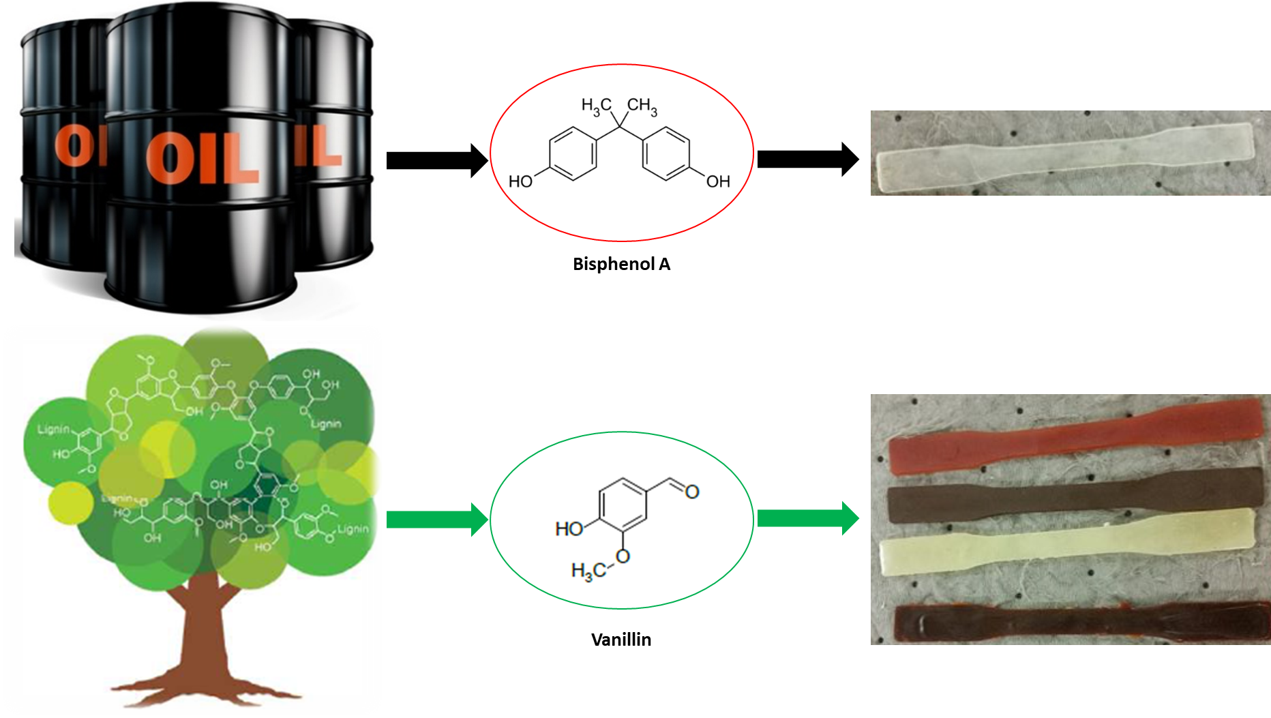
Recent Publications (minimum 5)
- Sudheer Kumar, Sushanta K. Samal, Smita Mohanty & Sanjay K. Nayak (2016): Recent Development of Bio-Based Epoxy Resins: A Review, Polymer-Plastics Technology and Engineering.
- Fache, Maxence & Boutevin, Bernard & Caillol, Sylvain. (2015). Vanillin Production from Lignin and Its Use as a Renewable Chemical. ACS Sustainable Chemistry & Engineering.
- Caillol Sylvain, Fache Maxence, Darroman Emilie, Besse Vincent, Auvergne Remi, and Boutevin Bernard. (2014). Vanillin, a promising biobased building block for monomer synthesis. Green Chemistry.
- Wang, Sheng & Ma, Songqi & Xu, Chenxiang & Liu, Yuan & Dai, Jinyue & Wang, Zongbao & Liu, Xiaoqing & Chen, Jing & Xiaobin, Shen & Wei, Jingjing & Zhu, Jin. (2017). Vanillin-Derived High-Performance Flame-Retardant Epoxy Resins: Facile Synthesis and Properties. Macromolecules.
5. Savonnet, Etienne & Grau, Etienne & Grelier, Stéphane & Defoort, Brigitte & Cramail, Henri. (2018). Divanillin-Based Epoxy Precursors as DGEBA Substitutes for Biobased Epoxy Thermosets. ACS Sustainable Chemistry & Engineering.

 Biography (150 word limit)

Eric Desnoes is a PhD student in his second year in applied chemistry at the “Université du Québec à Trois-Rivières” in Québec, Canada. Through his academic years, he developed skills in bio-based chemistry by using recycling industrial and agricultural wastes to produce sustainable thermosetting polymers. Eric also has a personal interest in the bio-based economy. He is currently involved in Algomega which is a start-up based on producing sustainable omega-3; in “Le BacVert” which is an environmental organization in his university, where he collect and recycle plastics directly in the university campus. He’s also involved in “Expérimentarium” which is a scientific popularization organization to promote researcher daily work to youth population.
Email: eric.desnoes@uqtr.ca

