Transition metal selenide- graphene nanohybrids as electrocatalyst for methanol fuel cells
Gopal K Mehrotra, PhD, MNNIT Allahabad, INDIA
Shiv K Pandey, MNNIT Allahabad, INDIA

Abstract

2D Transition metal selenides (TMDs), now a well established family of materials due to their excellent electronic, optical and magnetic properties, are at the forefront of their use in electrochemical cells, energy conversion and storage applications. Compositionally well defined two-dimensional hybrid nanocomposites of transition metal selenides (CoSe₂, NiSe_{2,} SnSe and Fe₂Se₃) grown onto graphene (G) for electrocatalytic applications have been been synthesized by in-situ hydrothermal process which is a convenient and efficient way to grow these materials with excellent crystallographic and morphological features. The TMD-G nanohybrid has shown a strong dependence on metal precursor concentration, ratio of solvent mixture, reaction temperature and time. Crystallographic features such as crystal phase, lattice orientation, defects, stacking faults and relevant vibrational phonon processes of the composites have been investigated by XRD and Raman Analysis. Morphological aspects such as surface assisted growth of TMDs onto graphene and their distribution throughout the surface dimensions have been explored using SEM followed by EDX analysis, TEM and HRTEM microscopy and SAED calculations. The catalytic efficiency of the composites for methanol fuel cells (DFMC) has been measured and analysed electrochemically through forward/ reverse scan under a given voltage from -0.2 V to 1.0 V versus Ag/ AgCl electrode in acidic medium. An oxidation mechanism for methanol has been proposed with respect to the heterostructures which have shown the formation of various intermediate species responsible for reducing catalytic activity. Thus, these graphene supported electro-catalysts can be potent materials for batteries with durable charge- discharge cycles under rigorous operating conditions.
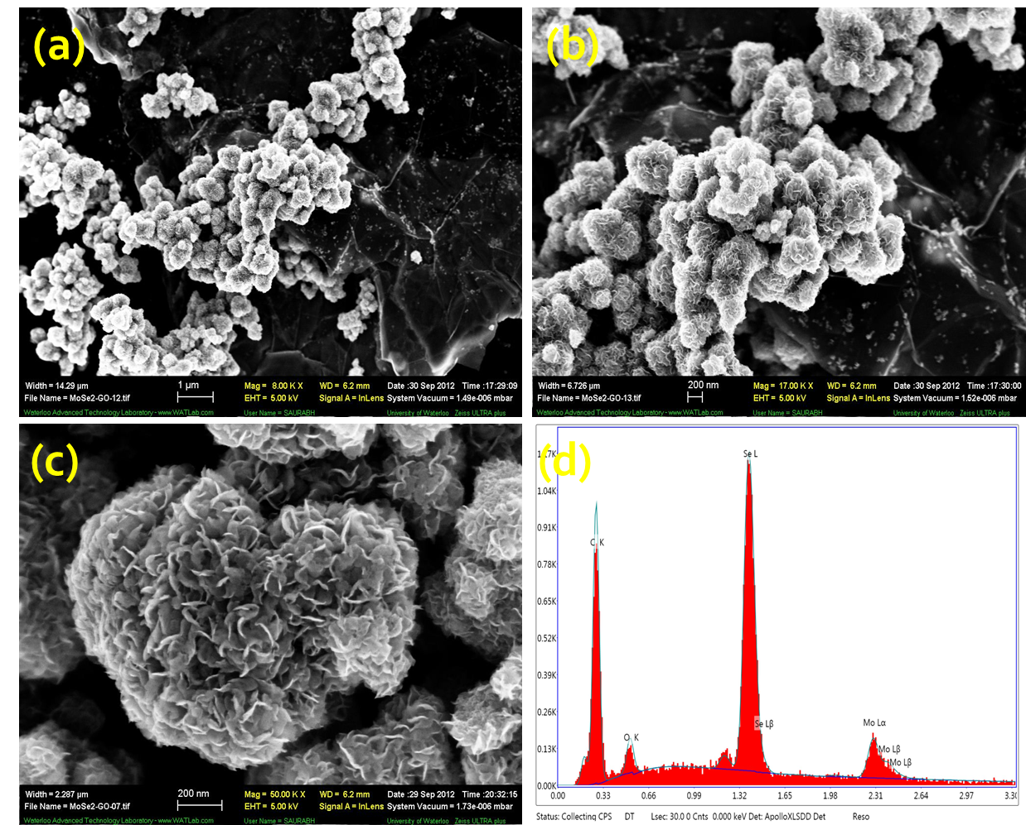
(a)Graphene exfoliated sheets are 5-6 µm in length. (b)At the areas of uniform MSe₂ concentration, these layered sheets cover the graphene sheets. (c) At large concentration of MoSe₂ layered structures are formed which arrange to form flower-like structures (d)EDX have shown the elemental composition of M, Se and C (Graphene) in the composite.

Recent Publications
- Bi, E. et al. Sci. Rep. 5, 13214; doi:10.1038/srep13214 (2015).
- Mao, S. et al. Small 11, 414-419 (2014).
- David L. et al. ACS Nano 8, 1759 (2014).
- Wang, H. et al. Nano Lett. 13, 3426- 3433 (2013).
- Rao, C. N. R. et al. J. Cluster Sci., 23, 929-937 (2012).
- Ma, Y. et al. J. Phys. Chem. C , 115, 20237- 20241, ( 2011).

Biography
Professor G. K. Mehrotra is involved in teaching and research at his current affiliation since last 30 years. His research areas include organometallic coordination chemistry, metal-organic frameworks, Inorganic –organic hybrid materials and nanobiocomposite materials . He has published about 75 research papers both in peer-reviewed international journals and conferences with over 1500 citations besides supervising several doctoral dissertations. He has collaborated in several international research programs both within India and abroad such as Russia, Poland, Germany, South Korea, Japan and USA and visited prestigious Korea Research Institute of Chemical Technology, Daejon, S. Korea as International Fellow (2004). Professor Mehrotra is also an expert reviewer for well known journals such as Green Chemistry, Journal of Molecular Structure, Inorganica Chimica Acta, Polyhedron, Materials Chemistry & Physics, ZAAC etc.
Email: gkmehrotra@mnnit.ac.in

Notes/Comments:

