Crystallographic Reactions in Formation of Dual Structural Transformations in Shape Memory Alloys
Osman Adiguzel, Firat University, Department of Physics, 23169 Elazig, Turkey

Abstract
Shape memory effect is a peculiar property exhibited a series of alloy system called shape memory alloys, which have dual characteristics called thermoelasticity and superelasticity, from view point of memory behavior. Two successive structural transformations, thermal and stress induced martensitic transformations govern shape memory phenomena in crystallographic basis. Thermal induced martensite occurs along with crystal twinning in self-accommodating manner on cooling, and ordered parent phase structures turn into twinned martensite structures. Stress induced martensitic transformations occur along with crystal or lattice detwinning reaction by stressing material in low temperature condition. Shape memory alloy exhibit another property called superelasticity, which is performed by stressing and releasing material at a constant temperature in parent phase region, and shape recovery is performed simultaneously upon releasing the applied stress. Superelasticity is performed in non-linear way; stressing and releasing paths are different in the stress-strain diagram, and hysteresis loop refers to energy dissipation.
The elementary processes involved in such martensitic transformations are lattice invariant shear, lattice twinning and detwinning. It is well known that crystal twinning and detwinning reactions play a considerable role in shape memory effect and superelasticity. Thermal induced martensitic transformation is a lattice-distorting phase transformation occurs with the cooperative movement of atoms by means of shear-like mechanism, and martensite variants occur. Martensitic transformations occur by two or more lattice invariant shears on a {110} -type plane of austenite matrix which is basal plane or stacking plane for martensite. Lattice invariant shear is not uniform in copper based shape memory alloys, and cause to the formation of long-period layered martensitic structures with lattice twinning on cooling.
In the present contribution, electron diffraction and x-ray diffraction studies performed on two copper based CuZnAl and CuAlMn alloys. Electron diffraction patterns and x-ray diffraction profiles show that these alloys exhibit super lattice reflections in martensitic condition. Specimens of these alloys aged at room temperature in martensitic condition, and a series of x-ray diffractions were taken duration aging at room temperature. Reached results show that diffraction angles and peak intensities change with aging time at room temperature. In particular, some of the successive peak pairs providing a special relation between Miller indices come close each other, and this result leads to the rearrangement of atoms in diffusive manner.
Keywords: Shape memory effect, martensitic transformation, thermoelasticity, superelasticity, lattice twinning, detwinning.

Recent Publications
- O. Adiguzel, Phase Transitions and Microstructural Processes in Shape Memory Alloys, Materials Science Forum Vol. 762 (2013) pp 483-486, (2013) Trans Tech Publications, Switzerland
- O. Adiguzel, Self-accommodating Nature of Martensite Formation in Shape Memory Alloys, Solid State Phenomena Vol. 213 (2014) pp 114-118, © (2014) Trans Tech Publications,
- O. Adiguzel, Nanoscale Aspects of Phase Transitions in Copper Based Shape Memory Alloys, Nanotechnology in the Security Systems, NATO Science for Peace and Security Series C: Environmental Security 2015, pp. 131-134
- O. Adiguzel, Phase Transitions and Elementary Processes in Shape Memory Alloys, Advanced Materials Research Vol. 1101 (2015) pp 124-128, Trans Tech Publications, Switzerland
- O. Adiguzel, Nano-Scale Mechanisms in the Formation of Displacive Transitions in Shape Memory Alloys, Physics, Chemistry and Applications of Nanostructures - Proceedings of the International Conference Nanomeeting - 2013. Edited by Borisenko Victor E et al. Published by World Scientific Publishing Co. Pte. Ltd
- O. Adiguzel, Ageing dependence and martensite stabilization in copper based shape memory alloys, IOP Conf. Series: Materials Science and Engineering 60 (2014) 012001, Proceedings of International Symposium on Advanced Materials(ISAM2013), 23-27, September 2013, Islamabad, Pakistan

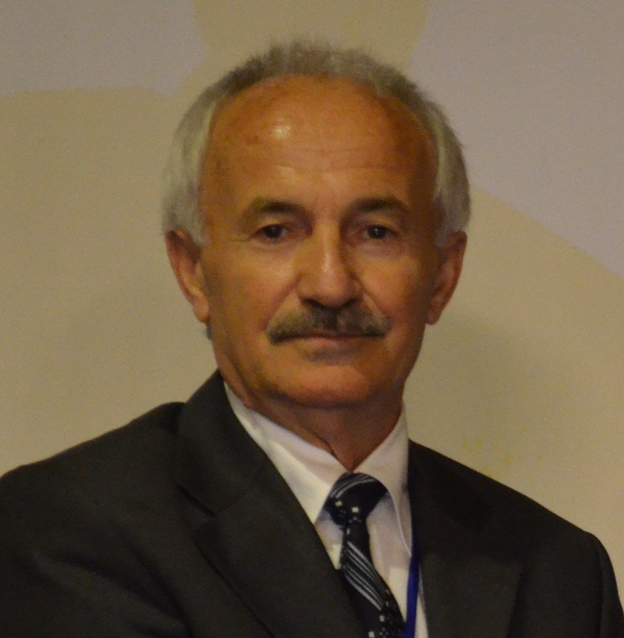Biography
Dr Adiguzel graduated from Department of Physics, Ankara University, Turkey in 1974 and received PhD- degree from Dicle University, Diyarbakir-Turkey. He has studied at Surrey University, Guildford, UK, as a post doctoral research scientist in 1986-1987, and studied on shape memory alloys. He worked as research assistant, 1975-80, at Dicle University and shifted to Firat University, Elazig, Turkey in 1980. He became professor in 1996, and he has already been working as professor. He published over 60 papers in international and national journals; He joined over 100 conferences and symposia in international and national level as participant, invited speaker or keynote speaker with contributions of oral or poster. He served the program chair or conference chair/co-chair in some of these activities. In particular, he joined in last five years (2014 - 2018) over 50 conferences as Keynote Speaker and Conference Co-Chair organized by different companies. He supervised 5 PhD- theses and 3 M.Sc- theses.
Dr. Adiguzel served his directorate of Graduate School of Natural and Applied Sciences, Firat University, in 1999-2004. He received a certificate awarded to him and his experimental group in recognition of significant contribution of 2 patterns to the Powder Diffraction File – Release 2000. The ICDD (International Centre for Diffraction Data) also appreciates cooperation of his group and interest in Powder Diffraction File.
Email: oadiguzel@firat.edu.tr

Notes/Comments:

