Enzymes for green and sustainable industrial processes: Example of the development of enzymatic cascades involving Transketolase for the synthesis of rare valuable (3S)-ketoses
Marion Lorillière, PhD, University of Clermont Auvergne, Institute of Chemistry of Clermont-Ferrand, France

Abstract
Nowadays, it is more essential than ever to develop sustainable and environmentally friendly industrial processes, that meet the 12 principles of Green Chemistry, stated in 1998 [1]. “White biotechnology” enables to fulfil these criteria, through the use of biological catalysts, i.e. whole microorganisms or isolated enzymes, to synthesize high added value compounds, at industrial scale. For more than 30 years, major advances have been made in the fields of genetic, bio-informatic, protein engineering, robotic, process engineering and materials science, allowing humans to adopt this revolutionary and diverse discipline, for the production of useful chemicals, including medicinal drugs, polymers, biofuels, cosmetics, detergents, but also in the textile and paper industries [2].
Pr. L. Hecquet and her team recently discovered and characterized the first thermostable Transketolase expressed from the thermophilic microorganism Geobacillus stearothermophilus (TK_{gst}, EC 2.2.1.1). Its robustness and its high synthetic potential allowed the efficient synthesis at high temperature of a large variety of (3S, 4R)-ketoses of interest, through the transfer of a two carbon ketol unit from lithium hydroxypyruvate (Li-HPA) as donor substrate to a wide range of aldehydes, as acceptor substrates, in irreversible reactions [3].
To improve the TK_{gst} reaction process, one-pot two-step and three-step enzymatic cascades were developed, through the in-situ generation of both donor and acceptor substrates, via Transaminase, d-Amino acid oxidase and Aldolases-catalyzed reactions. Various rare monosaccharides and analogues, widely used as pharmaceutical or nutraceutical products [4] were synthesized, from cheap and natural starting materials, through green and sustainable processes [5-7]. The discovery, the production and the characterization of each enzyme as well as the optimization of each cascade, will be presented.

Image

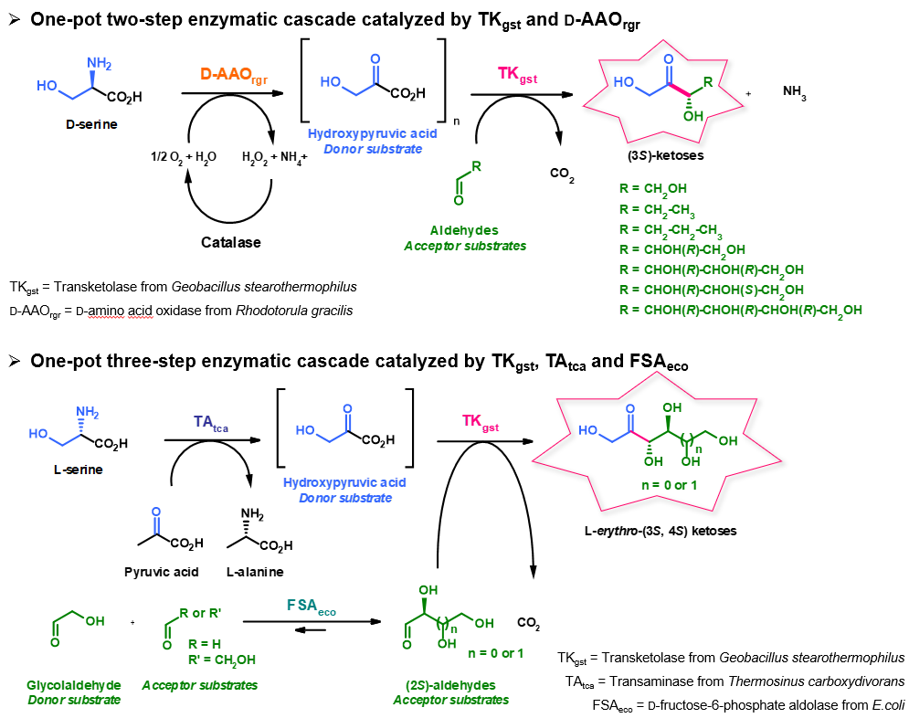
Recent Publications
- P.T. Anastas and J.C Warner. Green Chemistry: Theory and Practice; 1. paperback.; Oxford Univ. Press: Oxford, 2000
- a) R. A Sheldon and J. M. Woodley. Chemical Reviews, 2018, 118, 801-838 - b) S. Wu et al. Angew.Chem. Int. Ed. 2021, 60, 88-119 - c) J. P. Adams et al. Advanced Synthesis and Catalysis, 2019, 361, 2421-2432
- J. Abdoul Zabar and al. Thermostable Transketolase from Geobacillus stearothermophilus: Characterization and Catalytic Properties. Advanced Synthesis and Catalysis, 2013, 355, 116-128
- K. Beerens and al. Enzymes for the Biocatalytic Production of Rare Sugars. Journal of Industrial Microbiology & Biotechnology, 2012, 39, 823–834
- M. Lorillière et al. One-pot, two-step cascade synthesis of naturally rare l-erythro (3S, 4S) ketoses by coupling thermostable transaminase and transketolase, Green Chemistry, 2017, 19, 425-435
- M. L’Enfant et al. One-pot cascade synthesis of (3S)-hydroxyketones catalyzed by transketolase via hydroxypyruvate generated in situ from d-serine by d-amino acid oxidase, Advanced Synthesis and Catalysis, 2019, 361, 1-10
- M. Lorillière et al. Convergent in situ generation of both transketolase substrates via transaminase and aldolase reactions for sequential, one-pot, three-step cascade synthesis of ketoses, ChemCatChem, 2019, 12, 812-817

 Biography
Marion Lorillière completed her PhD in 2017 at the Institute of Chemistry of Clermont-Ferrand in France, in Pr. L. Hecquet’s group, in the field of Biocatalysis. Her research focused on the enzymatic synthesis of chiral compounds by stereoselective carboligation catalyzed by a novel thermostable transketolase (TK_{gst}), a robust thiamine diphosphate (ThDP) dependent enzyme, expressed from Geobacillus stearothermophilus. Her main objectives were to broaden TK_{gst} substrate spectrum by Directed Evolution, while improving TK_{gst} reaction process, through the development of one-pot enzymatic cascades. From 2018 to 2019, she completed postdoctoral research in the French pharmaceutical group Servier, in Croissy-sur-Seine, in France. She aimed at developing biocatalytic reactions catalyzed by isolated enzymes and whole cells, as well as the screening of fungal strains, for the discovery of new chemical entities. Since 2019, she is currently working in the international group PMC Isochem, in Vert-le-Petit, in France, in the field of protein engineering, fermentation and biocatalysis.

Email: marion.lorilliere@gmail.com

