Extending the reaction toolbox for C-C bond formation and cleavage : biocatalytic applications of Transketolase

Laurence Hecquet, Prof., PhD, University of Clermont Auvergne, Institute of Chemistry of Clermont-Ferrand, France.

Abstract (300 word limit)

Transketolase (TK), a thiamine diphosphate dependent enzyme, transfers a two carbon ketol unit from a donor to an aldehyde acceptor. While in vivo in the pentose phosphate pathway, this enzyme interconverts phosphorylated ketoses and aldoses in reversible reactions, numerous in vitro biocatalytic applications showed that this enzyme catalyzes the synthesis of various chiral hydroxyketones in irreversible reactions. Recently, we characterized the first thermostable TK from a thermophilic microorganism, Geobacillus stearothermophilus, offering robustness and broad synthetic potential.¹ Different ways are currently develop to improve the TK reaction process (immobilization, cascade reaction) and to broaden the TK substrate and product scope (engineering by directed evolution). The applications of wild-type and variant TKs for the synthesis of various chiral hydroxyketones, an important class of compounds in different fields (food, pharmaceuticals, fine chemicals) will be presented.¹⁻⁷

Image

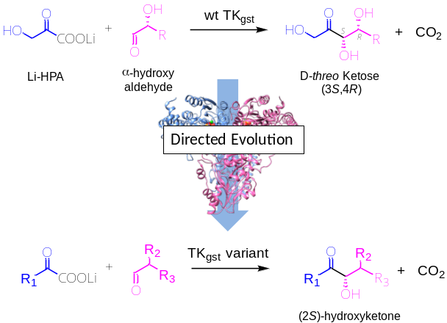
Recent Publications (minimum 5)

J. Abdoul-Zabar, I. Sorel, V. Hélaine, F. Charmantray, T. Devamani, D. Yi, V. de Berardinis, D. Louis, P. Marlière, W.-D. Fessner, L. Hecquet. Thermostable Transketolase from Geobacillus stearothermophilus: Characterization and Catalytic Properties. Adv. Synth. Catal. 2013, 355, 116-128.
2. M. Lorillière, M. De Sousa, F. Bruna, E. Heuson, T. Gefflaut, V. de Berardinis, T. Saravanan, D. Yi, W.-D. Fessner, F. Charmantray, L. Hecquet. One-pot, two-step cascade synthesis of naturally rare L-erythro (3S,4S) ketoses by coupling thermostable transaminase and transketolase. Green Chem. 2017, 19, 425 – 435.
3. T. Saravanan, S. Junker, M. Kickstein, J. Hegen S. Hein, M.-K; Link, S; Witt, M. Lorillière, L. Hecquet, and W.-D. Fessner. Donor promiscuity of a thermostable transketolase engineered by directed evolution - Efficient complementation of DXS activity Angew. Chem. Int. Ed., 2017, 56, 5358–5362.
4. M. Lolrillère, R. Dumoulin, M. L’enfant, A. Rambourdin, V. Thery, L. Nauton, W-D Fessner, F. Charmantray, L. Hecquet. Evolved Thermostable Transketolase for Stereoselective Two-Carbon Elongation of Non-Phosphorylated Aldoses to Naturally Rare Ketoses. ACS Catal., 2019, 9, 4754-4763.
5. H. Casajus, A. Lagarde, M. Leremboure, T. De Dios Miguel, L. Nauton, V. Thery, W-D Fessner, N. Duguet, F. Charmantray, L. Hecquet. Enzymatic Synthesis of Aliphatic Acyloins Catalyzed by Thermostable Transketolase. ChemCatChem, 2020, 12, 5772-5779.

Figure 1 : Broadenind of Transketolase substrate scope by directed

evolution

 Biography (150 word limit)
Laurence Hecquet (Full Professor since 2000, PhD) develops her research activities at the Institute of chemistry of Clermont-Ferrand (ICCF, UMR 6296), University Clermont Auvergne (UCA), France. Her research focuses on the enzymatic synthesis of chiral compounds particularly by stereoselective carboligation catalyzed by transketolase (TK), a thiamine diphosphate (ThDP) dependent enzyme. Her group has recently discovered and engineered by directed evolution a novel thermostable TK from Geobacillus stearothermophilus. The best TK variants efficiently improved wild type TK activity toward pyruvate and higher aliphatic homologues as nucleophiles and toward a large range of polyhydroxylated or aliphatic aldehydes as electophiles. The biocatalytic applications led to various chiral hydroxyketones with high stereocontrol. The long-term goals of her works are to broaden the substrate spectra of TK and of other ThDP enzymes and to optimize the biocatalytic processes in developping multienzymatic cascade reaction for obtaining new chiral compounds of biological interests.
Email: Laurence.hecquet@uca.fr

Notes/Comments:

