Establishment of N-glycan trimming pathway in the endoplasmic reticulum

Satoshi Ninagawa¹, Ginto George¹, Hirokazu Yagi², Takashi Yamamoto³, Koichi Kato^{2, 4}, Tetsuya Okada¹, Kazutoshi Mori¹
1. Grad. Sch. of Sci., Kyoto Univ., 2. Grad. Sch. of Pharma. Sci., Nagoya
City Univ 3. Grad. Sch. of Integ Sci, Hiroshima Univ., 4. ExCELLS

Abstract
Proteins misfolded in the endoplasmic reticulum (ER) are recognized, delivered to retrotranslocation channels, dislocated from the ER to the cytosol, and ubiquitinated and degraded by the proteasome: a pathway collectively termed ER-associated degradation (ERAD). In the glycoprotein ERAD (gpERAD) pathway, two-step mannose trimming from Man9GlcNAc2 (M9) produces oligosaccharides with the α1,6-mannose bond exposed, which is recognized by the lectin ERAD component for subsequent disposal (Ref. 1).
In mammals, how nine mannoses are trimmed in the ER had been discussed but unclear, especially concerning the enzymes that conduct the trimming. MAN1B1 (ER mannosidase I) with a mannosidase homology domain (MHD) was a primary candidate for the trimming from M9 to M8B, but it was clearly demonstrated that endogenous MAN1B1 localized in the Golgi (Pan et al., 2011 MBoC), not in the ER. Other candidates were EDEM1, EDEM2 and EDEM3 containing MHD, of which the enzymatic activities were ambiguous. To investigate functions of endogenous EDEM proteins, we constructed EDEM1, EDEM2 and EDEM3 KO cell lines for both in chicken and human. Comprehensive cellular N-glycan profiling showed strong enzymatic activities of EDEM family proteins, and suggested a new mannose trimming model: EDEM2 performs the trimming from M9 to M8B, and EDEM3 and EDEM1 from M8B (Ref.6) (Image).
However, it was reported that purified EDEM2 exhibited no (Mast et al., 2005 Glycob) or weak (Shenkman et al., 2018 Commu Biol) α1, 2-mannosidase activity in vitro, which contradicts our inference of strong EDEM2 mannosidase activity in cells. Demonstration of the mannosidase activity of EDEM2 toward M9 was therefore our primary goal. Then, we found that EDEM2 underwent stable disulfide bonding with TXNDC11, which was a prerequisite for the enzymatic activity of EDEM2 in cells. Purified EDEM2-TXNDC11 complex clearly converted free oligosaccharides from M9 to M8B (Ref. 2). Thus, our new N-glycan trimming model was strongly supported by the results obtained in cells and in vitro (Image).

Image

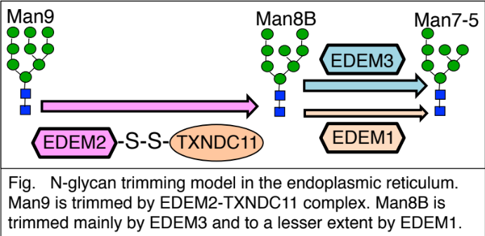

Recent Publications
- Ninagawa S, George G, Mori K (2020) Mechanisms of Productive Folding and Endoplasmic Reticulum-associated Degradation of Glycoproteins and Non-glycoproteins BBA Gen Sub under revision
- George G*, Ninagawa S*, et al., (2020) EDEM2 stably disulfide-bonded to TXNDC11 catalyzes the first mannose trimming step in mammalian glycoprotein ERAD eLife (2020) 9:e53455.
*Equal contribution
- Ninagawa S, et al., (2020) Antipsychotic olanzapine-induced misfolding of proinsulin in the ER accounts for atypical development of diabetes eLife (2020) in press
- Yagi H, 5 people, Ninagawa S, et al., (2020) Improved secretion of glycoproteins using an N-glycan-restricted passport sequence tag recognized by cargo receptor Nature Communications (2020) 11:1368
- Ninagawa S, et al., Forcible destruction of severely misfolded mammalian glycoproteins by the non-glycoprotein ERAD pathway. The Journal of Cell Biology (2015) 211:775-784.
- Ninagawa S, et al., EDEM2 initiates mammalian glycoprotein ERAD by catalyzing the first mannose trimming step. The Journal of Cell Biology (2014) 206:347-356.

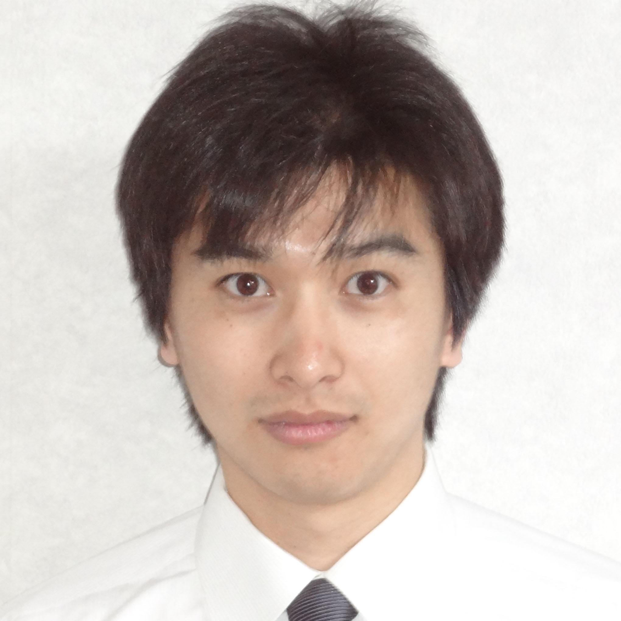 Biography
Dr. Satoshi Ninagawa is an assistant professor appointed in 2018 at Kyoto University in Japan. He received his M. S. (2007) and Ph. D. (2011) degrees in Dr. Kazutoshi Mori’s laboratory in the Graduate school of Science at Kyoto University. Except from 2014 to mid-2015 while he was a postdoctoral fellow in Dr. Koichi Kato’s laboratory in Okazaki Institute for Integrative Bioscience, he did most of his postdoctoral research as a fellow in Dr. Mori’s laboratory. He received the Japan Society of Carbohydrate Research Incentive Award and Young Investigator Award from The Japanese Biochemical Society in 2020, Cell Structure and Function Paper Award in 2017 and Japan Society for Cell Biology Young Scientist Award for Presentation in 2016.
Email: sninagawa@upr.biophys.kyoto-u.ac.jp

