Future warming shifts climatic suitability of native Himalayan tree species

Pramod Lamsal, School of Environmental and Rural Science, University of New England, NSW, Australia
Lalit Kumar, School of Environmental and Rural Science, University of New England, NSW, Australia
Farzin Shabani, School of Environmental and Rural Science, University of New England, NSW, Australia
Kishor Atreya, Asia Network for Sustainable Agriculture and Bioresources (ANSAB), Kathmandu, Nepal

Abstract (300 word limit)
Statement of the Problem: Climate change (CC) issue attracts attention of global community since the last couple of decades due to its detrimental consequences on social and ecological sectors. CC impacts are forecasted to disrupt most of the global ecosystems, with high altitude regions to become a worst sufferer. Mountains of such elevated regions are fragile ecosystem, and are subject to high impacts from the projected CC, that could affect distribution of existing native vegetation resulted from future unsuitable climate. As a result, vegetation can migrate or shift into areas having climate they can fully tolerate to maintain their growth and survival. The purpose of this study is to model nine native highland plants viz. Abies spectabilis, Betula utilis, Quercus semecarpifolia, Juniperus indica, Tsuga dumosa, Acer campbellii, Rohododendron campanulatum, Ephedra gerardiana, cassiope fastigiata so as to visualize the likely landscape of the Himalaya under future warming climate. Methodology & Theoretical Orientation: Analysis was done using CLIMEX niche modeling technique. Two global climate models, CSIRO-MK 3.0 (CS) and MIROCH-H (MR) were used under IPCC A1B and A2 emission scenarios for the year 2050 and 2100. Findings: Climatic suitability of the nine species contracts in areas that are currently suitable while expands in areas that are currently unsuitable. Currently around 1.09 million sq. km. area is climatically suitable. An addition of 0.68 and 0.35 million sq. km. will become suitable by 2050 and 2100 respectively. Cold stress is the main limiting factor for overall expansion of climatic suitability in the region. Conclusion & Significance: Existing climatic suitability of the nine high land native species will substantially shift towards north in the Tibetan Plateau. Such climatic suitability shift could impacts existing nature conservation activities and availability of water and food security in the region. Formulation and implementation of suitable adaptation strategies is necessary to offset such negative implications.

Image

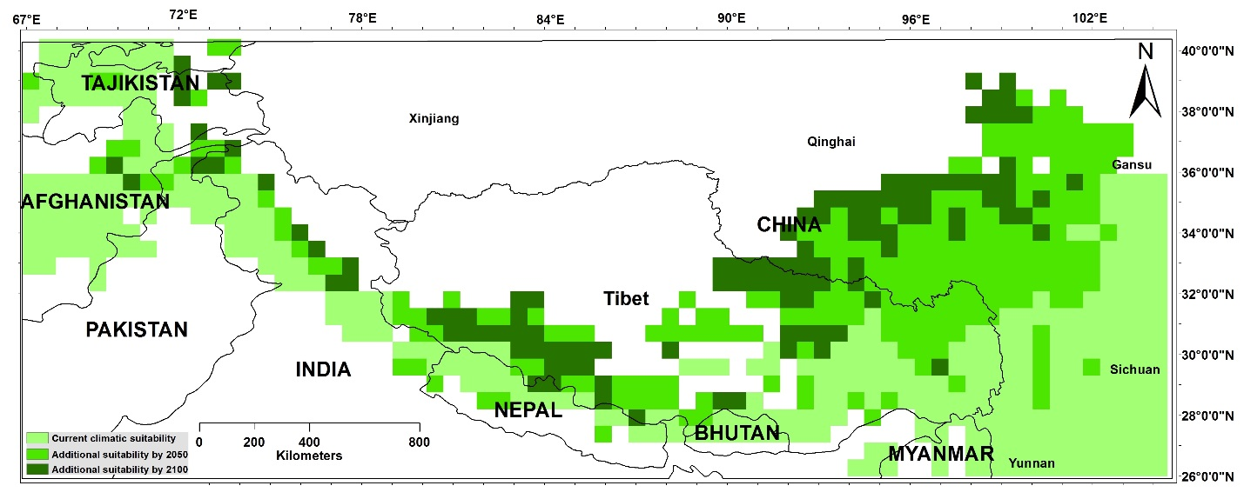
Recent Publications (minimum 5)

Lamsal P, Pant KP, Kumar L, Atreya K (2014) Diversity, Uses and Threats to Biodiversity in the Ghodaghodi Lake Complex, a Ramsar Site in Western Lowland Nepal. ISRN Biodiversity. Vol 2014. 12p. Volume 2014, Article ID 680102: 12.

Lamsal P, Pant KP, Kumar L, Atreya, K (2015) Sustainable Livelihood through the Conservation of Wetland Resources – A Case of Economic Benefits from Ghodaghodi Lake, Western Nepal. Ecology and Society, 20(1): 10.

Lamsal P, Atreya K, Pant KP, Kumar L (2015) An Analysis of Willingness to Pay for Community Based Conservation Activities at the Ghodaghodi Lake Complex, Nepal. International Journal of Biodiversity Science, Ecosystem Services & Management, 11 (4): 341-348.

Lamsal P, Atreya K, Pant KP, Kumar L (2016). Tourism and wetland conservation: Application of travel cost and willingness to pay an entry fee at Ghodaghodi Lake Complex, Nepal. Natural Resources Forum, Vol 40: 51-61.

Lamsal P, Kumar L, Atreya K (2016) Historical evidence of climatic variability and changes, and effects on high altitude regions: insights from Rara and Langtang, Nepal. International Journal of Sustainable Development and World Ecology

Lamsal P, Pant KP, Bhatta DR (2017) Forest based micro and small enterprises in Nepal: review of status, constraints, scope, and approach effectiveness. International Forestry Review

Lamsal P, Kumar, L, Atreya K, Pant KP (2017). Vulnerability and impacts of climate change on forest and freshwater wetland ecosystems in Nepal: A review. Ambio, DOI: 10.1007/s13280-017-0923-9

Biography
Pramod Lamsal is currently undertaking PhD degree at University of New England, NSW, Australia, focusing on climate change modeling on high altitude ecosystem of the Himalaya region. He completed his BSc (Hons) in forestry and MSc in Environmental Science specializing in natural resource management. He has published few peer reviewed journal articles on wetland biodiversity and management as well as in climatic variability and change perception. Currently he is involved in the climate change impact modeling of flora and fauna of the Himalayan ecosystem.
Email: plamsal@myune.edu.au; pramod_lamsal@yahoo.com

