Phase Displacements Assessment in Temporal Analysis of the Transboundary Islands of Tiran and Sanafir, Egypt-Saudi Arabia

Mohamed Elhag 1,2,3, *, Jarbou Bahrawi 1, Mohammed H Aljahdali 4, Georgios Eleftheriou 5, Char-iton Kalaitzidis 6, Abdulhaleem H Labban 7 and Abdulaziz Alqarawy 1

¹ Department of Hydrology and Water Resources Management, Faculty of Meteorology, Environment and Arid Land Agriculture, King Abdulaziz University, Jeddah 21589, Saudi Arabia.
² Institute of Remote Sensing and Digital Earth (RADI), Chinese Academy of Science (CAS), Beijing 100094, China.
³ Department of Applied Geosciences, Faculty of Science, German University of Technology in Oman, Muscat 1816, Oman.
⁴ Marine Geology Department, Faculty of Marine Sciences, King Abdulaziz University, P.O. Box 80200, Jeddah 21589, Saudi Arabia.
⁵ Hellenic Centre for Marine Research, Institute of Oceanography, P.O. Box 712, GR-19013, Anavyssos, Greece.
⁶ Department of Geoinformation in Environmental Management, CIHEAM/Mediterranean Agronomic Institute of Chania, Chania 73100, Greece.
⁷ Department of Meteorology, Faculty of Meteorology, Environment and Arid Land Agriculture, King Abdulaziz University, Jeddah 21589, Saudi Arabia.
* Correspondence: melhag@kau.edu.sa

Abstract
Tiran and Sanafir islands are coastal ecosystem islands located in the fragile environment of the Red Sea. The importance of the islands has always been bordering security for Egypt and Saudi Arabia. In the last decade, an economic value has been added to the border islands and grown significantly to be the focal point between the two countries' trade lines. The study is aiming at the temporal analysis of the SAR data phase estimation to map the island vertical displacement for the last 5 years. Temporal datasets of SAR images were collected from the European Space Agency, dataset collection started from November 2016 until May 2020 to comprehend the objectives of the research study. The SAR interferometry techniques were implemented to estimate the phase displacement for 15 SAR datasets of the border islands. Consequently, the temporal analysis demonstrated the trend of the phase displacement during the study timeframe. Results indicated that the maximum islands subsidence (-0.417 m) was estimated from the scene ac-quired in 21Feb2018. While the maximum uplift (0.708 m) value was estimated from the scene acquired in 17Nov2017. Moreover, the trend analysis showed an instability behavior among the successive SAR datasets. The findings of the current study are crucial to the decision-makers from Egypt and Saudi Arabia to realize the predictability of the island's displacement mitigations to ensure the sustainability of the incoming socioeconomic activities.

Image
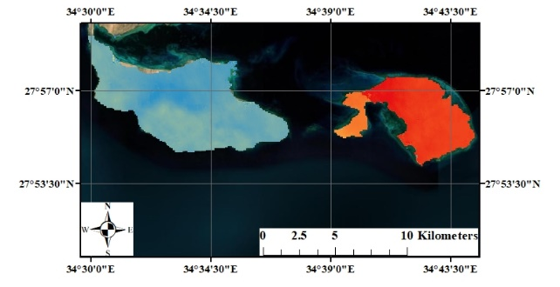7. Temporal vertical displacement (m) of the designated Islands from November 2016 until May 2020
Recent Publications (minimum 5)
- Bahrawi, J., Alqarawy,A., Chabaani, A., Elfeki, A. and Elhag, M. (2021). Spatiotemporal analysis of the annual rainfall in the Kingdom of Saudi Arabia: predictions to 2030 with different confidence levels. Theoretical and Applied Climatology, https://doi.org/10.1007/s00704-021-03778-8.
- Yilmaz, N., Yardimci, R.E., Haghighi, A.T., Elhag, M. and Celebi, A. (2021). Water quality determination by using phytoplankton composition in sea bass (Dicentrarchus labrax, L., 1758) aquaculture ponds in Turkey. Desalination and Water Treatment, 234, 392-398.
- Bahrawi,J., Al-Amri, N. and Elhag, M. (2021). Microwave versus Optical Remote Sensing Data in Urban Footprint Mapping of the Coastal City of Jeddah, Saudi Arabia. Journal of the Indian Society of Remote Sensing, 49, 2451–2466.
- Rabeea,M. A., Al-Heety, A. J.R., Mohammed, M. I., Fayydh, A. M. and Elhag, M. (2021). Impact of Hijlan Creek springs on water quality of the Euphrates River and the Hydrochemical characterization of the contamination plumes. Environmental Earth Sciences 80(15),1-15.
- Elhag,M., Gitas,I., Othman,A., Bahrawi, J., Psilovikos, A. and Al-Amri, N. (2021). Time series analysis of remotely sensed water quality parameters in arid environments, Saudi Arabia. Environment, Development and Sustainability 23 (2), 1392-1410.

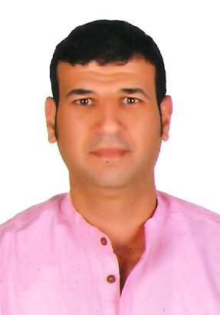

Biography
Prof. Dr. Mohamed Elhag obtained his Ph.D. degree from an Interdepartmental Program, School of Agricultural Sciences, University of Thessaly, Greece in Water Resources Management. Professor Elhag is currently a tenured professor of Remote Sensing at the Department of Water Resources, Faculty of Environmental Sciences, King Abdulaziz University, Saudi Arabia. Professor Elhag is a vising professor at the Institute of Remote Sensing and Digital Earth (RADI), Chinese Academy of Science (CAS), China, also a visiting professor at the Department of Applied Geosciences, Faculty of Science, German University of Technology, Oman. He is the author of several articles published in reputed journals and is a member of different international working groups related to his background. Prof. Elhag teaches a wide variety of Remote Sensing courses for under and postgraduate students.
Email: melhag@kau.edu.sa

Notes/Comments:

