Global Warming
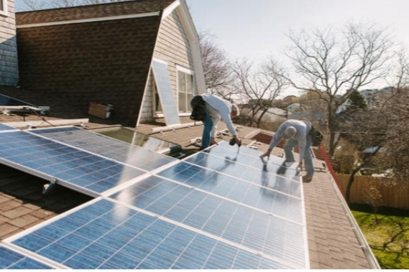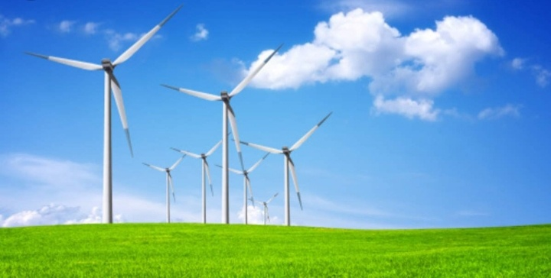

Research Author By Ms. Howida
Eltayeb Alian
Zulfa for Community
Development Services Company
Email:howida.alian@yahoo.com

Introduction :-
2019 - 2021 until now was the warmest decades recorded with global average of temperature reaching 1.5 *C temperature degree above pre – industrial levels in 2019 Human - induced global warming i s presently increasing at a rate of 0.2 *C degree per decade with serious negative impacts on to the natural environment & human health & wellbeing including a much higher risk that dangerous possibly catastrophic changes in the global environment will accour . For this reason international Community accour has recognized the need to keep global warning well blew 2 *C degree temperature & purse efforts to limit it to 1.5 *C temperature degree . Global warming the increase the average of the world temperature as result of what is known as the green houses effect , gases build upon atmosphere the earth gets better . This process is leading to rapid change climate also known as change Climate change & global warming are .often used interchangeable but have distinct meanings , similarly the terms weather & climate are sometime confused , through they are refer to events with broadly different spatial - and timescales.

Methods:-
Four method used to study climate change ice cores , sea – floor sediment , framings , all show climate change from a far period of time climatologist can collect any one these sample to see if our earth now is changing by global warming. Methodology refers to the over arching strategy & rationale of research research . It involves studying the method used in your field & theorises or principles behind them , in order to develop an approach that matches your objectives.
Results:-
Impacts :-
Rising scale level & move frequent & intense storm will see more erosion of coastline wearing away & inundating
community & residential properties , health increasing severe frequent heat , waves may lead to death & illness e1qspecially among people & animals .Also increase drought of lands & wilde fires & burning petroleum oil fuel produce carbon dexcide & nitrous oxide & intense floods are rising oceans , sees & rivers & green lands strong ice have melted & ice water flow into sees & oceans landslides across the countries are destruction . Global warming is causing in huge social & economic negative impacts inrecently & in several states across the countries causing death & destruction & will continue the over coming decades in the world according to mitigation measure of experts warn for the report of researches .

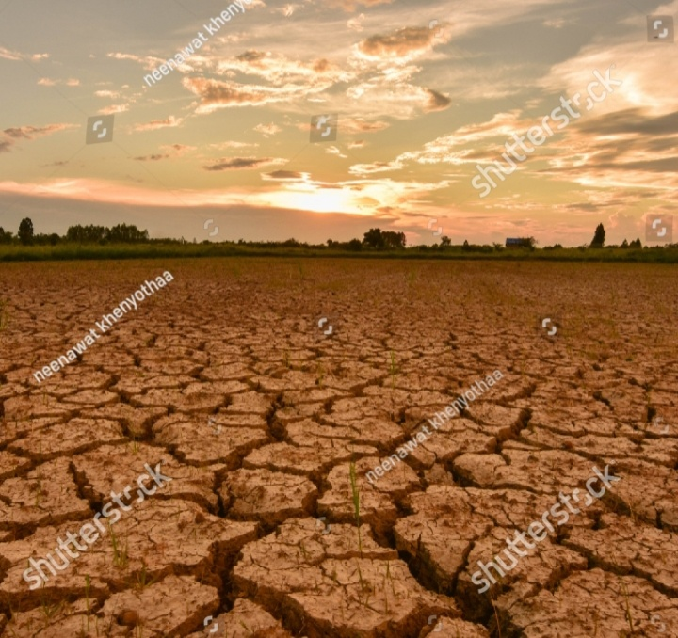
Drought Lands Impact
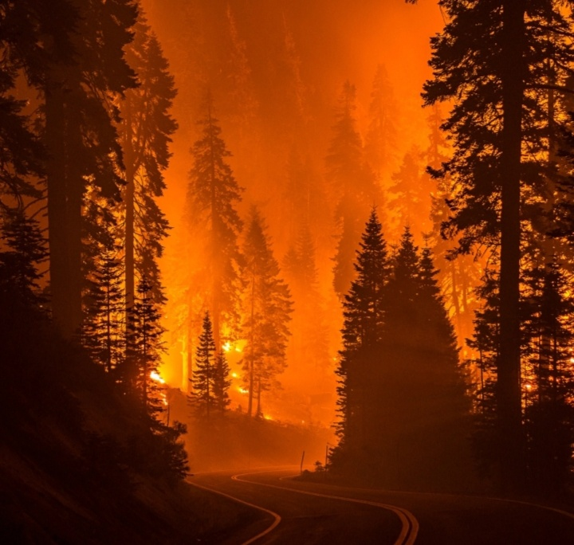
Wildfires Impact
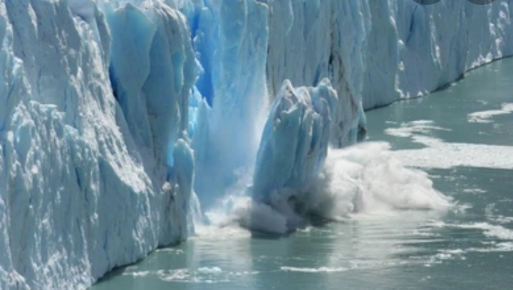
Oceans Melting Impact
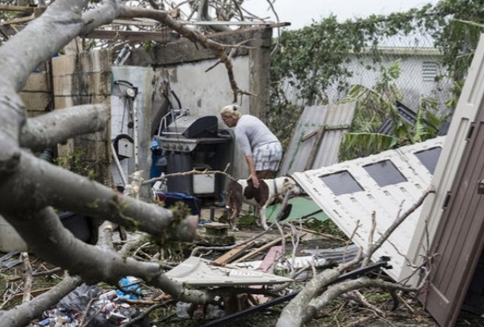
Hurricanes Damaging Impact

Causes:-
Cause No.1
Burning Fessiols:-
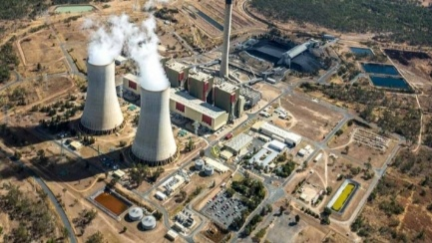
Burning fessiols when people burn fossil fuels like oil ,coal & gas to create electricity or power their gas , they release Co2 & nutitrus oxide pollution into atmosphere are a big Co2 pollution producers in the world.
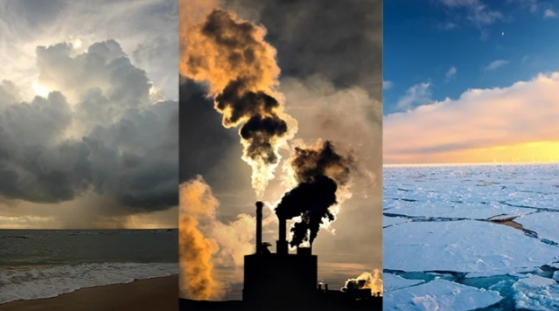
Fossils Fuels Hydrocarbon & Co2
Cause No.2
Culture & Farming :-
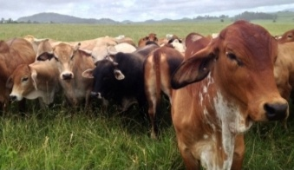
Animals & livestock like sheep & cattle produce mathane , a green house gas when livestock grazed at a large scale , the amount of methane produce is a big contributor to global warming , some of farmers use also to release nitrous dexcide which another a greenhouse gas . Farming contribute 16% of their total greenhouse gas emission.
Cause No.3
Deforestation &Trees Cleaning :-
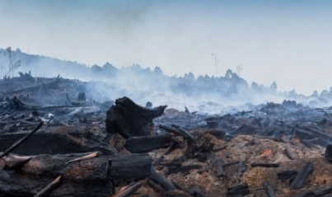
Plants & trees play a important role in regulating the climate because they absorb carbon dioxide from the air & release oxygen to the air & release oxygen back to into forests. A bushland uses carbon sinks . They are a valuable means of keeping global warming to 1.5 *C temperature . But humans clear vast green of vegetation around the world for farming urban infrastructure development or to sell tree products such as timber & palm oil . When vegetation is removed or burnt , the stored carbon is released back into the atmosphere as Co2 temperature contributing to global warming up to one - fifth of global greenhouse gas pollution or come from deforestation & forest degradation .
Solutions :-
Solution of Cause No.1
1)Reducing the amount of electricity generated from oil , coal & gas
2) Increasing the amount of electricity from clean ,renewable energy sources like solar energy & wind energy .
3)Join the movement for a stronger action on climate change & urge key politicians to get back on track to meeting Paris -. agreement target .
Solution of Cause No.3
1)Use different stock feeds can help to
reduce framings contribution to climate
change
2)World Wide for Nature is working with leading beef producers through project - pioneer to develope , trial & validate improved livestock & pasture management that can deliver & significant economic , social & environmental gain out more .
Solution No.3 :
1)Prevent reforestation
2)Plant more trees through forestration & afferstration
3)Shop sustainably
4)Call on our leader to introduce strong to stop excessive tree - cleaning .

Conclusions:-
The conclusion that confirms global warming is the major challenge for our global society . Global warming will change our climate in the next century . The solution of global an warming are : Frist There must be international political solution - Second Funding to developing cheap & clean energy ( solar energy energy wind energy ) production must be increased - Third Economic development must be based on clean energy usage.& all our hopes on global politics & clean technology & a lot of costs & damage that caused by changing climate can be mitigated - Fourth The nation’s of environmental laws or rules must take action not words only against global warming has made climate change in the world.

References :-
#Zulfa for Community Development Services Company
#World Wide for Nature ( WWF )
#Green Climate Change Fund
#United Nations Evironmental Program( UNEP )
#World Methodological . Org
#Food Agriculture . Org ( FAO )
#Universal Postal Union
# UN Climate Change

