Global Warming
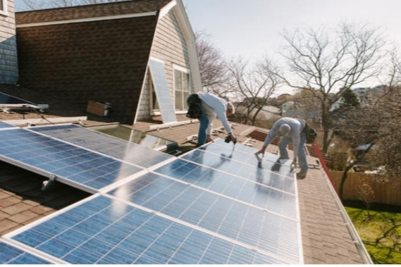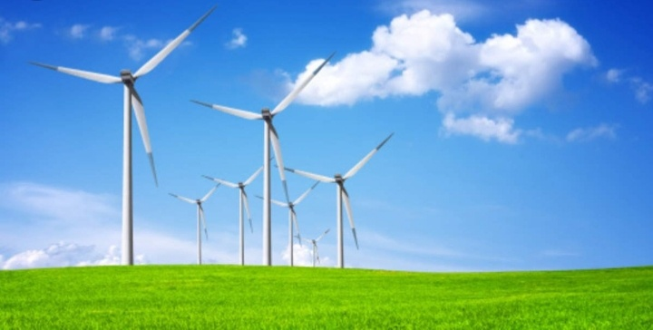
Researcher By Ms. Howida
Eltayeb Alian
Zulfa for Community Development for Community Development Services
Company
Email:howida.alia@yahoo.com
Introduction :-
2019 - 2021 until now was the warmest decades recorded with global average of temperature reaching 1.5 *C temperature degree above pre – industrial levels in 2019 Human - induced global warming is presently increasing at a rate of 0.2 *C degree per decade with serious negative impacts on to the natural environment & human health & wellbeing including a much higher risk that dangerous possibly catastrophic changes in the global environment will accour. For this reason international Community accour has recognized the need to keep global warning well blew 2 *C degree temperature & purse efforts to limit it to 1.5 *C temperature degree . Global warming the increase the average of the world temperature as result of what is known as the green houses effect, gases build upon atmosphere the earth gets better . This process is leading to rapid change climate also known as change . Climate change & global warming are often used interchangeable but have distinct meanings , similarly the terms weather & climate are sometime confused , through they are refer to events with broadly different spatial - and timescales.
Impacts :-
Rising scale level & move frequent & intense storm will see more erosion
of coastline wearing away & inundating
community & residential properties ,
health increasing severe frequent heat,
waves may lead to death & illness e1qspecially among people & animals .
Also increase drought of lands & wilde fires & burning petroleum oil fuel produce carbon dexcide & nitrous oxide & intense floods are rising oceans , sees & rivers & green lands strong ice have melted & ice water flow into sees & oceans & landslides across the countries are destruction . Global warming is causing in huge social & economic negative impacts inrecently & in several states across the countries causing death & destruction & will continue the over coming decades in the world according to mitigation measure of experts warn for the report of researches .
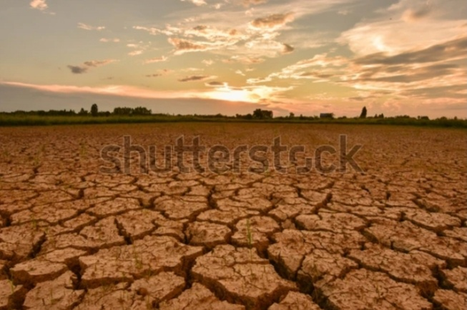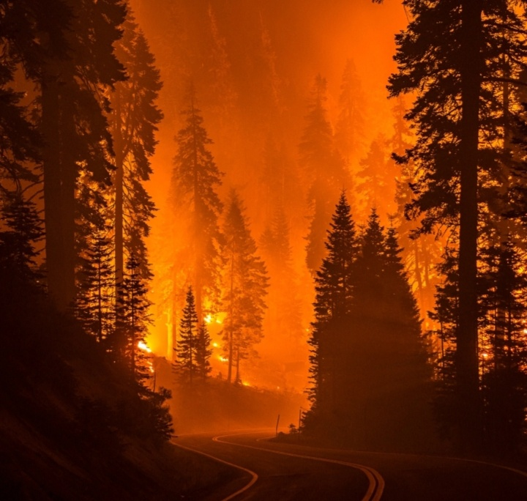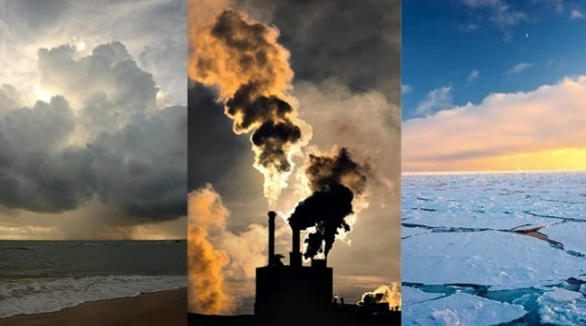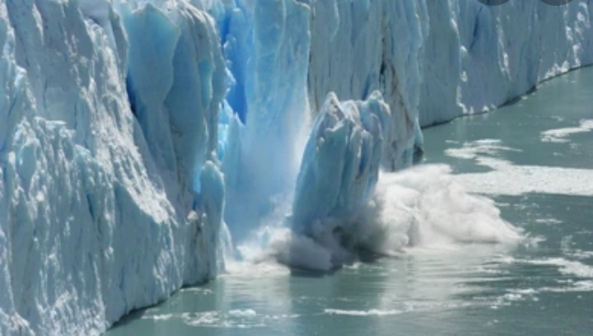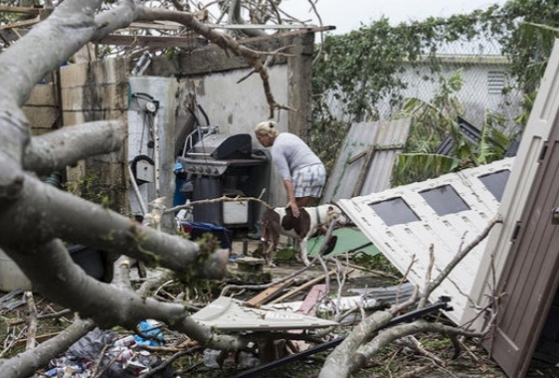
Causes:-
Cause No.1
Burning Fessiols:-
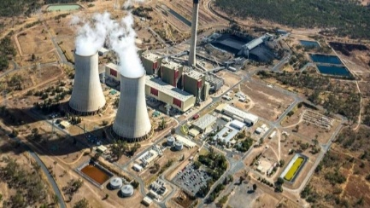
Burning fessiols when people burn fossil fuels like oil ,coal & gas to create electricity or power their gas , they release Co2 & nutitrus oxide pollution into atmosphere are a big Co2 pollution producers in the world.
Cause No.2
Culture & Farming :-
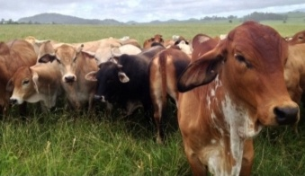
Animals & livestock like sheep & cattle produce mathane , a green house gas when livestock grazed at a large scale , the amount of methane produce is .a big contributor to global warming , some of farmers use also to release nitrous dexcide which another a green house gas . Farming contribute 16% of their total greenhouse gas emission.
Cause No.3
Deforestation &Trees Cleaning :-
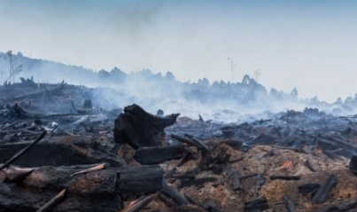
Plants & trees play a important role in
regulating the climate because they absorb carbon dioxide from the air & release oxygen the air & release oxygen
back to into forests . A bushland uses
carbon sinks . They are a valuable means of keeping global warming to 1.5 *C temperature . But humans clear vast green of vegetation around the world for farming urban infrastructure development or to sell tree products such as timber & palm oil . When vegetation is removed or burnt , the
stored carbon is released .back into the atmosphere as Co2 temperature contributing to global warming up to one - fifth of global green house gas pollution or come from deforestation & forest degradation .
Solutions :-
Solution of Cause No.1
1)Reducing the amount of electricity generated from oil , coal & gas
2) Increasing the amount of electricity from clean ,renewable energy sources like solar energy & wind energy .
3)Join the movement for a stronger action on climate change & urge key politicians to get back on track to meeting Paris -. agreement target .
Solution of Cause No.3
1)Use different stock feeds can help to
reduce framings contribution to climate
change
2)World Wide for Nature is working with leading beef producers through project - pioneer to develope , trial & validate improved livestock & pasture management that can deliver & significant economic , social & environmental gain out more .
Solution No.3 :
1)Prevent reforestation
2)Plant more trees through forestration & afferstration
3)Shop sustainably
4)Call on our leader to introduce strong to stop excessive tree - cleaning
References :-
#Zulfa for Community Development Services Company
#World Wide for Nature ( WWF )
#Green Climate Change Fund
#United Nations Evironmental Program( UNEP )
#World Methodological . Org
#Food Agriculture . Org ( FAO )
#Universal Postal Union
# UN Climate Change

