Optimize your Documentation to Improve Medicare Reimbursement

Ecler Jaqua, MD, DipABLM, DipABOM, FAAFP, Loma Linda University Health, USA

Abstract
Introduction: The geriatric patient is complex in many ways. The typical older adult is more likely to suffer from severe end stages of diseases, increased side effects from polypharmacy, and decreased social support resulting in poorer overall outcomes. The goal of the primary care physician is to address as many of these complaints in an efficient matter, all while documenting and billing appropriately for procedures to insure that taking care of the geriatric population remains a cost-effective endeavor.
Geriatric Billing: Determining the visit type. It is important to classify geriatric visits into two separate categories. The new wellness visit, and the standard office visit. This is essential, because while a large portion of preventative services (depression screening, advanced care planning, smoking cessation, sexual transmitted diseases screening, alcohol counseling, weight counseling and heart disease counseling) can be administered at both visits, the cognitive assessment is only billable during a wellness visit or a specific visit for cognitive assessment.
Geriatric Billing: Maximizing preventative services. In order to optimize potential for billable preventable services, annual wellness screening paperwork should include questions regarding depression, alcohol use, tobacco use, sexual transmitted diseases (STD) risk factors, and cardiovascular risk factors. A positive on any of these screens should prompt a brief discussion during the encounter with the appropriate billing code and time documented (Table 1).
Conclusion: The role of the primary physician is to provide comprehensive care to the individual, and often times the care provided is not reflected in the Medicare reimbursement as a result of incomplete or inadequate documentation. While initially daunting, with proper optimization of the clinic visits to include pre-visit screening questions, increased time slots for wellness visits, and note templates with prebuilt preventative coding can dramatically increase the RVUs generated for services that most physicians already provide.

Image

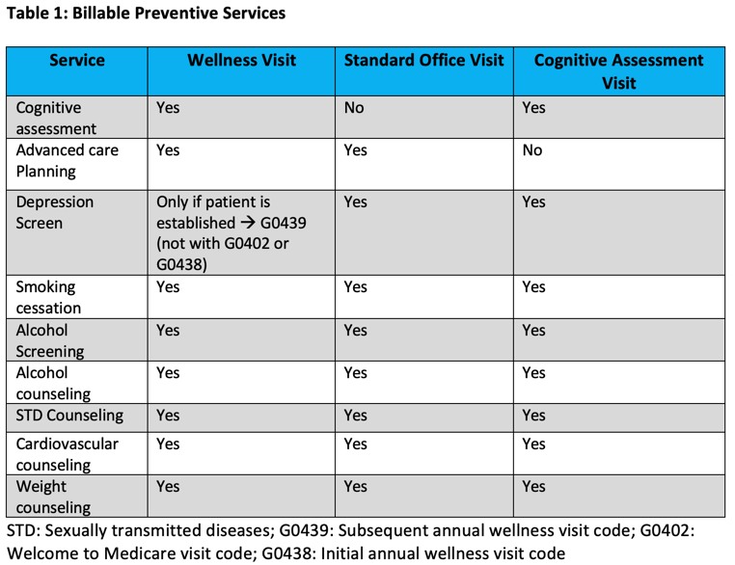
Recent Publications (minimum 5)
- Jaqua E, Jaqua T (2021) Integration Methods and Strategies to Expand a Physician's Practice. Adv Pub Health Com Trop Med: APCTM-121.
- Jaqua E (2021) Obesity Myths and Facts. RAS Nursing and Health Care. Volume 1 Issue 1.
- Jaqua E, Jaqua T, Nguyen V (2021) Managerial Economics – Family Medicine Care. RAS Medical Science. Volume 1 Issue 2. DOI: 10.51520/2766-5240-9
- Jaqua EE, Hanna M, Lee H. How to Identify and Treat Common Bites and Stings. J Fam Pract. 2020 December;69(10). doi:10.12788/jfp.0111
- Jaqua EE, Chi R, Labib W, Uribe M, Najarro J, Hanna M. Optimize your documentation to improve Medicare reimbursement. Cleveland Clinic Journal of Medicine.

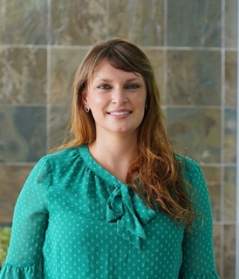
Biography (150-word limit)
Ecler Jaqua began at only age 17 her medical school at The Lutheran University of Brazil. Fascinated with the comprehensive care of all ages, and the continuing care of the individual and family, she naturally embraced and pursued her focus in Family Medicine. After completing a Family Medicine Residency at Loma Linda University Health, as well as being chief resident during her last year of training, she decided to specialize in Geriatric Medicine at UCLA. Soon after completing her fellowship in LA, she returned to Loma Linda to pursue her passion for teaching residents, caring for her family and geriatric patients. Additionally, she had the opportunity to complete the Lifestyle Medicine Board and the Obesity Medicine Board certification while working as an Assistant Professor at Loma Linda University Family Medicine Residency. She is happily married and has a little girl named Celine.

Email: ejaqua@llu.edu; eclerjaqua@gmail.com

