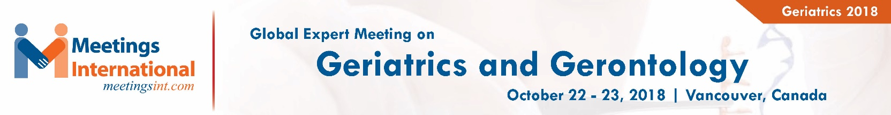

Title: Pseudopheochromocytoma: An uncommon case of paroxysmal hypertension in geriatric female
Zare P1, Domingo A 2
1Department of Internal Medicine, Aventura Hospital and Medical Center, Aventura, Florida
2 Department of Endocrinology, Aventura Hospital and Medical Center, Aventura, Florida

Keywords: Pseudopheochromocytoma, Paroxysmal hypertension, Geriatric

- Abstract:

Introduction: Paroxysmal elevations in blood pressure may trigger evaluation for secondary causes of hypertension including investigation into a catecholamine-secreting pheochromocytoma; however, these tumors are exceptionally rare. A high percentage of cases involving erratic elevations in blood pressure of uncertain etiology may actually qualify for panic disorder, or for a condition known as “Pseudopheochromocytoma”.
Case Report: We present a case of a 65-year-old female that presented with three weeks of episodic palpitation, throat tightness, dyspnea, generalized weakness, occipital headaches and presyncope. Initial evaluation in ED noted a blood pressure 190/102 mmHg with HR 72 bpm. Patient denied any previous history of hypertension, anxiety disorder, trauma, panic attacks or depression. Routine labs (including CBC, CMP, TSH, toxicology screen, troponins) were within normal limits. Imaging studies (CXR, CT scans, echocardiogram), EKG, and exercise stress test were unremarkable. Patient had two witnessed episodes of paroxysms with concurrent spikes in blood pressure despite starting scheduled blood pressure medication. Plasma and 24-hour urine metanephrine/catecholamine studies were normal. Patient’s symptoms and blood pressure stabilized after undergoing treatment with benzodiazepines and antidepressants.
Conclusion: Pseudopheochromocytoma should be considered as a possible cause of paroxysmal hypertension which may respond to psychopharmacological intervention.

Reference:

1. Kuchel O. Pseudopheochromocytoma. Hypertension 1985; 7:151.

- Mann SJ. Severe paroxysmal hypertension (pseudopheochromocytoma): understanding the cause and treatment. Arch Intern Med 1999; 159:670.

Biography:

Pegah Zare has completed her medical in Iran where she received her MD degree from Hormozgan University of Medical Sciences. She is currently an internal medicine resident in Aventura Hospital and Medical Center in Aventura, Florida

Presenting author details



Full Name: Pegah Zare
Contact number: (240)646-2089
Linked In account: Pegah Zare
Session name/ number:
Category: Poster presentation
Passport Number:

Copyright © 2016-2018 Meetings Int PTE Ltd, All Rights Reserved.
Meetings International Pte Ltd
28 MAXWELL ROAD, #03-05 RED DOT Contact Number
TRAFFIC, SINGAPORE (069120) 65-310-80483 (SINGAPORE)
URL:https://www.meetingsint.com/conferences/geriatrics Email Id: geriatrics@annualmeetings.net

