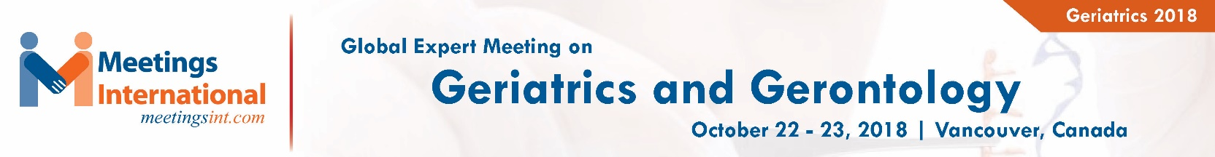

Title: To Survey of Nurses' and Midwives' Knowledge of Osteoporosis Risk Factors in the Iranian Elderly People

Arezoo RAHIMIAN1, Leila HASSANI KHODAJOU², Zahra KESHAVARZ

1 Midwifery Department , Iran University of Medical Sciences, Tehran West Center of Health, Tehran, Iran
2 MSc Candidate, BS, Management office of Nursing, Supervision Department, Atieh Hospital, Tehran, Iran
³Midwifery Department , Iran University of Medical Sciences, Tehran West Center of Health, Tehran, Iran

Keywords: Osteoporosis, Midwives, Elderly

- Abstract Body
Osteoporosis is rapidly assuming epidemic proportions in Iran, as it is in the rest of the developed world. Although osteoporosis prevention has been identified as a critical issue for women and the elderly population, some health professionals still misunderstand osteoporosis. There are emerging studies on the knowledge of osteoporosis among healthcare workers using various assessment tools around the word, and more studies have reported knowledge deficit among this group. For example, in one study in Singapore, it is showed that only 1.8 percent nurses knew that the statement “walking has a great impact on bone health” is false. In another quantitative, descriptive survey in North West of Ireland, midwives were found to have a high knowledge level in comparison to nurses and midwives received their information from media sources, as opposed to a formal education session. According to one study on Public health nurses in Taiwan, it is recommended that continuing education and nursing education about osteoporosis need to be highly valued. Knowledge about osteoporosis among rural Turkish women is low, and majority of women are unaware of the risk factors and consequences of osteoporosis. In one study in Iran, the study findings were consistent with the results of other studies which have reported that the knowledge of osteoporosis among nurses and midwives is less than adequate. The findings showed the requirement to focus on in the osteoporosis educational interventions among nurses and midwives. It is our interested to do survey of nurses' and midwives' knowledge of osteoporosis risk factors in the Iranian elderly people, therefore, we will show our systematic review findings in our presentation.

Image:
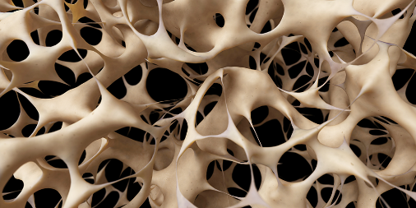
- Reference:

- Hannon C, Murphy K. A survey of nurses’ and midwives’ knowledge of risks and lifestyle factors associated with osteoporosis. Journal of Orthopaedic Nursing. 2007 Feb 1;11(1):30-7.
- Chen IJ, Yu S, Wang TF, Cheng SP, Huang LH. Knowledge about osteoporosis and its related factors among public health nurses in Taiwan. Osteoporosis International. 2005 Dec 1;16(12):2142-8.
- Mokhtari P, Shiri P, Ahmadnia E, Khooshehchin T. Knowledge of Nurses and Midwives on Risk Factors Associated with Osteoporosis. Preventive Care in Nursing & Midwifery Journal. 2011 Sep 15;1(1):37-42.
- Zhang RF, Chandran M. Knowledge of osteoporosis and its related risk factors among nursing professionals. Singapore medical journal. 2011 Mar 1;52(3):158-62.

Biography:
Arezoo RAHIMIAN has completed his MSc. at the age of 28 years from Ghazvin University of Medical sciences, Ghazvin, Iran. She is the Director of Midwifery Department , Iran University of Medical Sciences, Tehran West Center of Health, Tehran, Iran, She has published some papers in reputed scientific butane and has been serving as an educational board member of her center.

Presenting author details

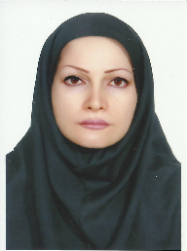

Full Name: Arezoo RAHIMIAN Contact number:
Category: Oral presentation
Phone: +989372333599
Passport Number: T36334934

Copyright © 2016-2018 Meetings Int PTE Ltd, All Rights Reserved.
Meetings International Pte Ltd
28 MAXWELL ROAD, #03-05 RED DOT Contact Number
TRAFFIC, SINGAPORE (069120) 65-310-80483 (SINGAPORE)
URL:https://www.meetingsint.com/conferences/geriatrics Email Id: geriatrics@annualmeetings.net

