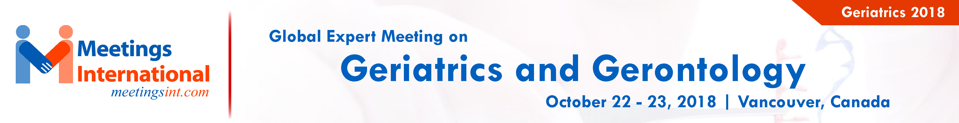

Effects of concurrent training on muscle strength in older adults with metabolic syndrome: A randomized controlled clinical trial.

AGNER VFC¹, GARCIA MC², TAFFAREL AA¹, MOURÃO CB¹, DA SILVA IP⁴, DA SILVA SP¹, PECCIN MS³, LOMBARDI JR. I³.

¹Interdisciplinary Postgraduate Program in Health Sciences, Federal University of São Paulo, Baixada Santista Campus, SP, Brazil
²Department of Biosciences, Federal University of São Paulo, Baixada Santista Campus, SP, Brazil
³Department of Human Movement Sciences, Federal University of São Paulo, Baixada Santista Campus, SP, Brazil
⁴Santos City Hall, SP, Brazil

Keywords: Older adults; Metabolic syndrome; Physical exercise; Muscle strength; Physical endurance; Quality of life

I. Abstract:

Metabolic syndrome is highly prevalent among older adults. Concurrent training comprises muscle strengthening and aerobic exercise. Determine the effects of a concurrent training program on muscle strength, walking function, metabolic profile, cardiovascular risk, use of medications and quality of life among older adults with metabolic syndrome.A randomised, controlled, blind, clinical trial was conducted in the city of Santos, state of São Paulo, Brazil, involving 41 male and female older adults. The participants were randomly allocated to a control group (n = 18) and intervention group (n = 23) and were submitted to the following evaluations: strength - 1 maximum repetition (1MR) for 12 muscle groups; the Six-Minute Walk Test (6MWT); blood concentrations of cholesterol and glucose; the use of medications; and the administration of the SF-36 questionnaire. The intervention was conducted twice a week over a total of 24 sessions of concurrent training: 50 min of strength exercises (40-70% 1MR) and 40 min of walking exercises (70-85% maximum heart rate).Increases in muscle strength were found in the upper and lower limbs in the inter-group analysis and a greater distance travelled on the 6MWT was found in the intervention group (p = 0.001). The intervention group demonstrated a reduction in the consumption of biguanides (p = 0.002). No changes were found regarding metabolic profile, cardiovascular risk or self-perceived quality of life.The findings of this clinical trial can be used for the prescription of concurrent training for older adults with metabolic syndrome for gains in muscle strength and walking distance as well as a reduction in the use of biguanides.

II. Image:
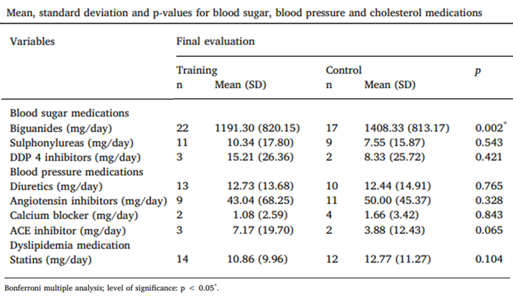

III. References:

1. Cadore, E. L., Pinto, R. S., Lhullier, F. L. R., Correa, C. S., Alberton, C. L., Pinto, S. S., et al, 2010. Physiological effects of concurrent training in elderly men. Train Testing, 31(10), 689–697.

2. Yang, Z., Scott, C. A., Mao, C., Tang, J., & Farmer, A. J, 2014. Resistance exercise versus aerobic exercise for type 2 diabetes: A systematic review and meta-analysis. Sports Medicine, 44(4), 487–499.

3. Vinet, A., Obert, P., Dutheil, F., Diagne, L., Chapier, R., Lesourd, B., et al, 2015. Impact of a lifestyle program on vascular insulin resistance in metabolic syndrome subjects: The RESOLVE study. Journal of Clinical Endocrinology and Metabolism, 100(2), 442–450.

IV. Biography:

Physiotherapist, Graduate in Geriatrics, Federal University of São Carlos and Master in Interdisciplinary Program in Health Sciences, Federal University of São Paulo - Brazil. Conducts research in the area of exercise prescription in elderly people with metabolic syndrome, since 2010.


V. Presenting author details

Full Name: Vania Fernanda Clemente Agner
Contact number: +55(11) 981161786
Session name: Chronic Disease in Elderly
Category: Oral presentation

Federal University of São Paulo
Baixada Santista campus, Department of Human Sciences. Central Building - Rua Silva Jardim, nº 136 - Santos - SP - CEP: 11015-020
Contact: +55 (13) 3229-0100
ULR: http: //www.unifesp.br/campus/san7/
Email Id: geriatricsconference@meetingseries.org
agner.vania@gmail.com

