

Abstract Template

Title: Relationship between Executive Function and Dual Task Physical Performance among Older Adults-A Cross Sectional Study

Hardik Sunil kumar Parikh¹, and Chaitali Shah²
¹Vraj Physiotherapy Center, Vadodara, Gujarat, India
²Department of physiotherapy, Parul Institute of Physiotherapy, Gujarat, India

Keywords: Executive function; Dual-task physical performance; Older adults

- Abstract Body (up to 250words)

Background: Older adults with both physical and cognitive impairment are at higher risk for dementia, fall and disability. So, identifying whether physical performance decline is associated with executive dysfunction is important for developing physical therapy early intervention strategies for older adults.
Purpose: (1) To examine the relationship between executive functions and dual-task physical performances among older adults, (2) To confirm executive function as a useful predictor for functional limitation or disability process in older adults.
Methodology: To measure physical performance, first, reference gait speed on 10 m path was measured. Secondly, dual task gait speed was calculated from 20 m rectangular path with obstruction and picking up an object from it while walking at their comfortable pace. Participants had to cross the obstacles simultaneously picking the ball from bucket. The time to finish the task was measured and from that gait speed during dual task was calculated. The TMT-B test was used to evaluate the components of executive function. To complete this test, participant was asked to use a pencil to connect 25 encircled numbers and letters in numerical and alphabetical order, alternating between numbers and letters. Time to finish this test was recorded.
Results: After analyzing data, for dual task gait speed and TMT-B, we got the value of Spearman’s correlation coefficient(r) is 0.698 and level of significance (p<0.05). For reference gait speed and TMT-B, we got the value of Spearman’s correlation coefficient(r) is 0.600 and level of significance (p<0.05)
Conclusion: This points out that there is statistically significant correlation between executive function and dual task physical performance among older adults.

Image:

All images and graphs kept on last page.

- Reference:

- Montero-Odasso M, Verghese J, Beauchet O, Hausdorff JM (2012), Gait and cognition: A complementary approach to understanding Brain Function and the Risk of Falling. J Am Geriatr Soc 60: 2127-2136.
- Yogev-Seligmann G, Hausdorff JM, Giladi N (2008), The role of executive function and attention in gait. Mov Disord 23: 329-342.
- Chen TY, Peronto CL, Edwards JD (2012) Cognitive function as a prospective predictor of falls. J Gerontol B Psychol Sci Soc Sci 67: 720–728.
- Tinetti ME, Speechley M, Ginter SF (1988) Risk factors for falls among elderly persons living in the community. N Engl J Med 319: 1701-1707.
- van Iersel MB, Kessels RP, Bloem BR, Verbeek AL, Olde RMG (2008) Executive Functions are associated with gait and balance in community living elderly people. J Gerontology: Med Sci 63: 1344-1349.
- Morris JC, Rubin EH, Morris EJ, Mandel SA (1987) Senile dementia of the Alzheimer's type: An important risk factor for serious falls. J Gerontol 42: 412-417.
- Gothe NP, Fanning J, Awick E, Chung D, Wójcicki TR, et al. (2014) Executive Function Processes Predict Mobility Outcomes in Older Adults. J Am Geriatr Soc 62: 285-290.
- Lee Y, Kim JH, Lee KJ, Han G, Kim JL (2005) Association of cognitive status with functional limitation and disability in older adults. Aging Clin Exp Res 17: 20-28.
- McGough EL, Kelly VE, Logsdon RG, McCurry SM, Cochrane BB, et al. (2011) Associations between physical performance and executive function in older adults with mild cognitive impairment: gait speed and the timed “ up & go” test. Phy Ther 91 : 1198-1207.
- Coppin AK, Ferrucci L, Lauretani F, Phillips C, Chang M, et al. (2005) Low Socioeconomic status and disability in old age: Evidence from the Inchianti Study for the mediating role of physiological impairments. J Gerontol Med Sci 61: 86-91.
- Coppin AK, Shumway-Cook A, Saczynski JS, Patel KV, Ble A, et al. (2006) Association of executive function and performance of dual-task physical tests among older adults: Analyses from the in chianti study. Age Ageing 35: 619-624.
- Carlson MC, Fried LP, Xue QL, bandeen-Roche K, Zeger SL, et al. (1999) Association between executive attention and physical functional performance in community dwelling older women. J Gerontol Soc Sci 54: 262-270.
- Bell-McGinty S, Podell K, Franzen M, Baird AD, Williams MJ (2002) Standard measures of executive function in predicting instrumental activities of daily living in older adults. Int J Geriatr Psychiatry 17: 828-834.
- Lezak MD (1995) Neuropsychological Assessment, New York: Oxford University Press.
- Kortte KB, Horner MD, Windham WK (2002) The trail making test, part B: cognitive flexibility or ability to maintain set? Appl Neuropsychol 9: 106-109.
- Hashimoto R, Meguro K, Lee E, Kasai M, Ishii H, et al. (2006) Effect of age and education on the Trail Making Test and determination of normative data for Japanese elderly people: The Tajiri Project. Psychiatry Clin Neurosci 60: 422-428.
- Julene JK, Lui LY, Yaffe K (2007) Executive function, more than global cognition, predicts functional decline and mortality in elderly women. J Gerontol A Biol Sci Med Sci 62: 1134-1141.
- Muir SW, Gopaul K, Montero OMM (2012) The role of cognitive impairment in fall risk among older adults: A systematic review and meta-analysis. Age Ageing 41: 299-308.
- Buracchio T, Dodge HH, Howieson D, Wasserman D, Kaye J (2010) The trajectory of gait speed preceding mild cognitive impairment. Arch Neurol 67: 980-986.
- Verghese J, Lipton RB, Hall CB, Kuslansky G, Katz MJ, et al. (2002) Abnormality of gait as a predictor of non-Alzheimer's dementia. N Engl J Med 347: 1761-1768.
- Kelly VE, Schrager MA, Price R, Ferrucci L, Shumway-Cook A (2008) Age-associated effects of a concurrent cognitive task on gait speed and stability during narrow-base walking. J Gerontol A Biol Sci Med Sci 63: 1329-1334.
- Tangen GG, Engedal K, Bergland A, Moger TA, Mengshoel AM (2014) Relationships between balance and cognition in patients with subjective cognitive impairment, mild cognitive impairment, and alzheimer disease. Phys Ther 94: 1123-1134.

Biography:
Hardik has completed Doctor of Physical Therapy (2018) from National University of Medical Sciences (USA). He has passed Master of Physiotherapy in Neurological disorder (MPT 2014 -2016) from Parul Institute of Physiotherapy, affiliated to Gujarat University, India. He has passed Bachelor of Physiotherapy (BPT 2004 - 2008) from K.J. Pandya College of Physiotherapy, affiliated to Gujarat University, India. He has completed certificate course in Orthopedic Manual Therapy (COMT) based on integrated approach at CHARUSAT Campus, Anand, India from 23rd May to 30th May 2017. He has completed Yoga Teacher’s Training Course (YTTC) during October 2016 to March 2017 from “YOGNIKETAN” Sir Sayaji Rao Institute of Research in Yoga, Ayurveda, Naturopathy, Music & Allied sciences, Near Fatehgunj Post Office, Vadodara-390002, india. He has wide variety of experience in physical therapy and rehabilitation for neurological, musculo-skeletal, cardio-pulmonary, and other systemic conditions. He is the director of Vraj Physiotherapy center located in Vadodara, india.

Presenting author details


Full Name: Hardik Sunilkumar Parikh
Contact number: 9898673154
Twitter account:
Linked In account:
Session name/ number:
Category: (Oral presentation/ Poster presentation)
Passport Number: H2486837

Copyright © 2016-2018 Meetings Int PTE Ltd, All Rights Reserved.
Meetings International Pte Ltd
28 MAXWELL ROAD, #03-05 RED DOT Contact Number
TRAFFIC, SINGAPORE (069120) 65-310-80483 (SINGAPORE)
URL:https://www.meetingsint.com/conferences/geriatrics Email Id: geriatricsconference@meetingseries.org

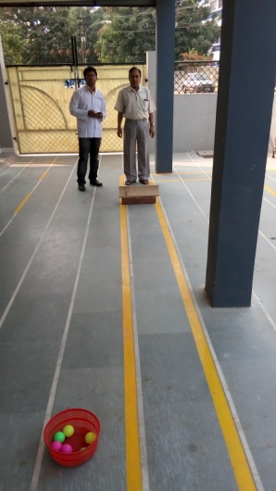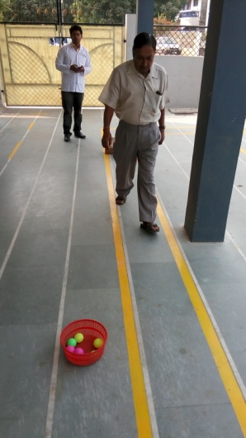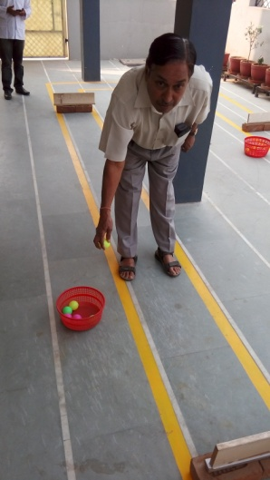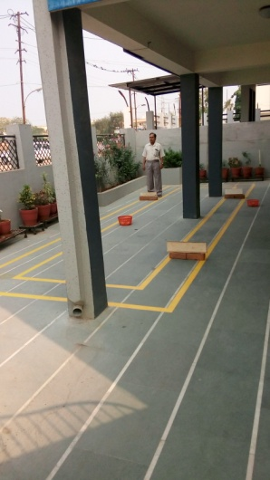

[Fig 1: Measuring of dual task physical performance over 20 meter rectangular path with obstruction and
picking up object from floor.]


[Fig 2: Measuring of Executive function by Trail making test (TMT-B).]

[Graph 1: Showing correlation of Reference gait speed and TMT-B scores.] [Graph 2: showing correlation of Dual Task gait speed and TMT-B scores.]

