Title: Maintain & Promote Lifelong Brain Health
Author: Jennie Ann Freiman MD
Keywords: prevent dementia, slow dementia, reverse early dementia
Abstract:
The SEEDS Plan is for you if you’re tired of stock answers and worn explanations for the inevitability and hopelessness of mental decline. Alzheimer’s disease and other forms of cognitive impairment are preventable, and in the early stages, reversible, and those facts are based on overwhelming scientific evidence.
The SEEDS Plan is the most current, comprehensive resource of everything worth knowing about Alzheimer’s prevention and early stage reversal that’s known right now. It organizes the five essential, modifiable pillars of lifelong brain health into a practical lifestyle program that can be personalized to your preferences, needs and habits. Own your future by adapting the plan in a way that works best for you.
Alzheimer’s roots are set decades before the disease becomes apparent, so it’s never too early to protect brain health. Different forms of cognitive impairment (brain fog, chemo brain, fibro fog, etc.) also benefit from this program because they share similar brain pathology with Alzheimer’s and other dementias. For those with a healthy mind, SEEDS can help keep the brain robust and optimize its function.
It is possible to defy the odds. Get busy with The SEEDS Plan and claim your healthy brain.

Image:
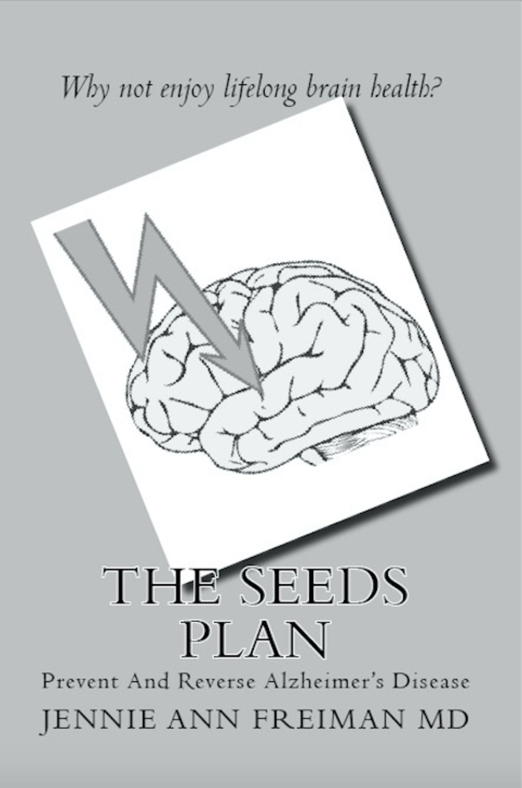
References: over 1000 from PUBMED database (see end of book)
Biography: Jennie Ann Freiman MD is a physician, author, blogger, and founder of Oobroo Inc, a wellness company. She attended Barnard College and the Mount Sinai School Of Medicine, and after medical school, trained in Los Angeles and New York City. She spent the early part of her medical career on the teaching faculty of the New York Hospital-Cornell University Medical Center, followed by private practice. The SEEDS Plan is the culmination of a lifetime interest in preserving and maximizing cognition.

Full name: Jennie Ann Freiman MD
Contact #: 505 309 5340
Linked In: https://www.linkedin.com/in/jennie-ann-freiman-md-33573686/
Session Name/ Number: Track 19 Aging & Rejuvenation
Category: workshop
USA passport

