

Abstract Template

Title: Management of Late Life Depression

J. Craig Nelson1
1Department of Psychiatry, University of California San Francisco, San Francisco CA, USA

Keywords: Geriatric, Depression, Treatment

- Abstract Body (up to 250 words)
Major Depression is common in late life. It not only causes suffering but it contributes to disability, aggravates the course of medical illness and increases mortality. Both psychotherapy and antidepressants are effective in late life depression. In a systematic review of older depressed adults we found 27 trials of psychotherapy with 37 comparisons and 2,245 subjects.¹ Psychotherapy was more effective than the control condition but the effect size varied greatly with the type of control. Trials with waitlist controls showed a large effect size while those with a supportive therapy control had a smaller effect similar to that of antidepressant treatment. Problem Solving Therapy had the best evidence for efficacy. We conducted a systematic review of second generation antidepressants in community dwelling adults 60 years and older with Major Depression.² 10 trials with 4,165 subjects demonstrated antidepressants were more effective than placebo but the effect size was small resulting in a number-needed-to-treat of 11. We were able to obtain individual patient data from the sponsors of each of the 10 studies with which we performed a patient level analysis of moderators of antidepressant response.³ Interestingly age was not a significant moderator. The primary moderator was the lifetime duration of Major Depression. The longer the duration, the lower the placebo response and the greater the drug placebo difference. The finding was replicated in a mixed age sample.⁴

Image:

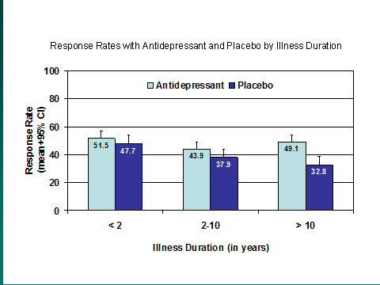

- References:

- Huang AX, Delucchi K, Dunn LB, Nelson JC. A systematic review and meta-analysis of psychotherapy for late-life depression. Am J Geriatr Psychiatry. 2015;23:261-73.
- Nelson JC, Delucchi K, Schneider LS. The efficacy of second generation antidepressants in late life depression: a meta-analysis. Am J Geriatric Psychiatry, 2008;16:558-567.
- Nelson JC, Delucchi K, Schneider LS. Moderators of outcome in late life depression: A patient-level meta-analysis, Am J Psychiatry, 2013; 170:651–659.
- Montgomery SA, Gommoll CP, Chen C, Greenberg WM. Efficacy of levomilnacipran extended-release in major depressive disorder: pooled analysis of 5 double-blind, placebo-controlled trials. CNS Spectr. 2015;20(2):148-56.

Biography:

Dr. Nelson is Professor of Psychiatry at the University of California-San Francisco. He holds the Leon J Epstein M.D. Chair in Geriatric Psychiatry and is Director of Geriatric Psychiatry at UCSF. Dr. has published over 200 articles, books and chapters including the text, Geriatric Psychopharmacology. Dr. Nelson is a member of several professional organizations. He was one of the founding members of the American Society of Clinical Psychopharmacology and served as its President from 1999 to 2003. He served as the editor of the ASCP Corner in the Journal of Clinical Psychiatry until 2017.

Presenting author details

Full Name: J. Craig Nelson MD
Contact number: 415-476-7405
Session name/ number:
Category: (Oral presentation/ Poster presentation) Passport Number:

Copyright © 2016-2018 Meetings Int PTE Ltd, All Rights Reserved.
Meetings International Pte Ltd
28 MAXWELL ROAD, #03-05 RED DOT Contact Number
TRAFFIC, SINGAPORE (069120) 65-310-80483 (SINGAPORE)
URL:https://www.meetingsint.com/conferences/geriatrics Email Id: geriatricsconference@meetingseries.org

