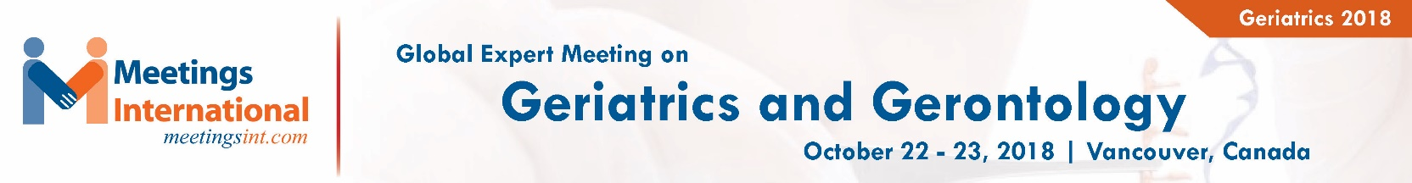

Abstract Template

Title: Initiatives of a Corporate Health Provider in India to improve Quality Care

Sharma O P
1Department of Geriatric Medicine – Indraprastha Apollo Hospitals

Keywords: Elderly Care, Corporate, Preventive

- Abstract Body (up to 250 words)
The World Health Organization’s (WHO) holistic definition of Health as “a state of complete physical, mental and social well-being and not merely the absence of disease or infirmity” has been widely accepted as being more appropriate, when ascribed to older people. When we talk of older persons, the attention is focused towards ageing which is a progressive, generalized impairment of functions resulting in loss of adaptive response to stress and increased risk of age-related diseases and disabilities.¹ At the time of Independence of the country, life expectancy at birth was 37 years which has risen to 68 years currently & currently absolute number is 112 Million. Indian Council of Medical Research has published chronic morbidity profile in the elderly in rural & urban areas. Currently we have more than 25 thousand PHCs, 900 District Hospitals, Govt. Tertiary Care Hospitals, 460 Medical Colleges Hospitals, PSU Hospitals, Military Hospitals, 1.3 Lakhs Private Practitioners besides other systems of medical treatment like Ayurveda, Unani, Homoeopathy, Naturopathy etc. for our entire population of 1.33 billion. We have Geriatric Clinics & wards at many places in India. The Government² & Apollo Group of Hospitals³ which is a leading corporate health provider has facilities for elderly care.
Apollo focuses not only on care but also on preventive health checkups thereby early diagnosis of diseases contributing to positive health.

Image:
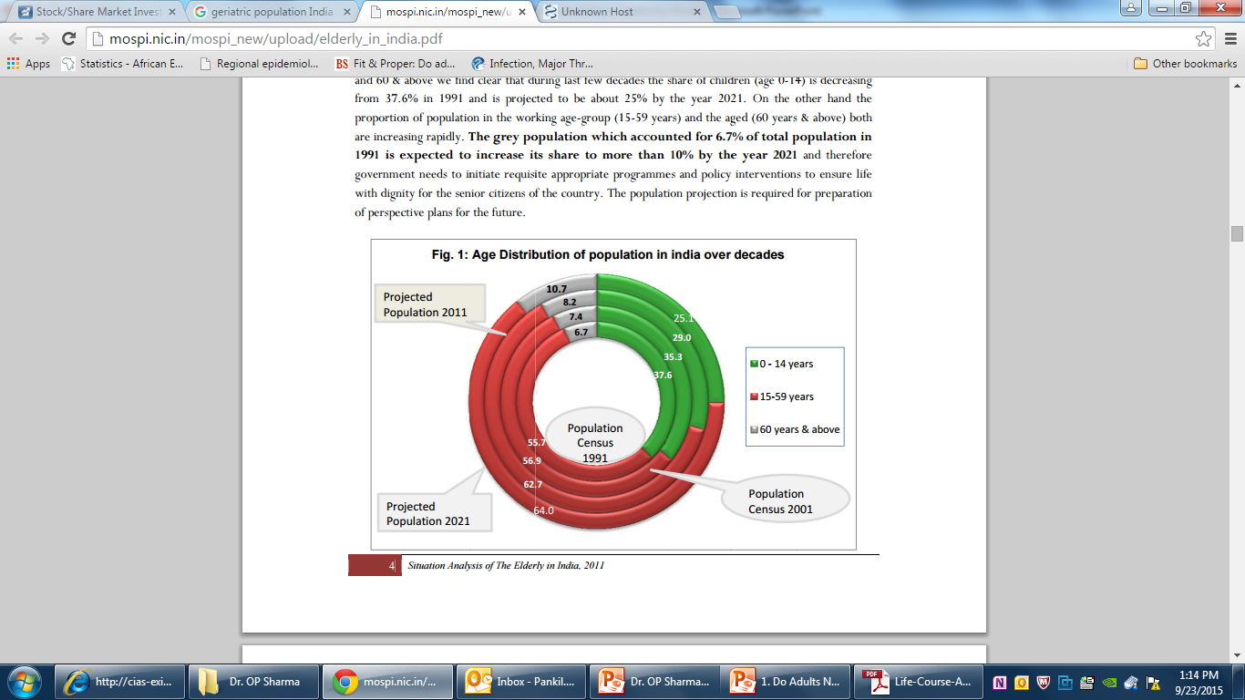
- Reference:

- Sharma O. P., Introduction, Principles & Practice of Geriatric Medicine, 1-6, 2015, Viva Books, New Delhi
- Government of India, Ministry of Health and Family Welfare, Directorate General of Health services. National Programme for Health care of the Elderly; Operational Guidelines:1-53,2011.
- Personal communication Clinical Pharmacology, Indraprastha Apollo Hospitals, New Delhi

Biography:
Dr. O. P. Sharma; National Prof. Geriatrics is a Sr. Consultant Geriatric Medicine - Indraprastha Apollo Hospitals, New Delhi. He is Editor in Chief: Indian Journal of Geriatric Care, Editor in Chief: Principles & Practice of Geriatric Medicine 2015, Editor: Indian Recommendations for Vaccination in Older Adults 2015 Editor cum Course Director: IMA AKN Sinha Institute & Gen. Sec: Geriatric Society of India. He has published several papers & has been an invited speaker in Nepal, Malaysia, Indonesia, Dubai, Turkey, England & USA.

Presenting author details
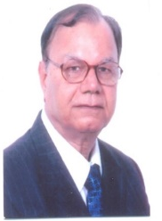
Full Name: Dr. O. P. Sharma Contact number: +91-9810627346 Twitter account: Linked In account:
Session name/ number:
Category: Oral presentation
Passport Number:

Copyright © 2016-2018 Meetings Int PTE Ltd, All Rights Reserved.
Meetings International Pte Ltd
28 MAXWELL ROAD, #03-05 RED DOT Contact Number
TRAFFIC, SINGAPORE (069120) 65-310-80483 (SINGAPORE)
URL:https://www.meetingsint.com/conferences/geriatrics Email Id: geriatricsconference@meetingseries.org

