

Abstract

Title: Dynamic and static impact to the brain unfolds proteins resulting in cytotoxic brain tissue edema.

Hans von Holst ^{1, 2}
1Div of Neurosurgery, Karolinska Univ. Hospital, Stockholm, Sweden
2Div of Cenesy and MIPS R&D, Stockholm, Sweden

Keywords: Traumatic Brain Injury, Stroke, Protein unfolding Protective devices.

I. Abstract Body
Recently a hypothesis to the nervous tissue edema was presented suggesting that external dynamic and internal mechanical static impact forces caused protein unfolding resulting in an increased brain tissue water content and what happens with the metabolism in the long run. The hypothesis was confirmed by computer simulation tests. In this laboratory study we further evaluated the hypothesis by using the mature protein laminin LN521 upon the effects of both dynamic as well as static impact forces, respectively. The treated laminin solutions were then analyzed with denatured electrophoresis and Electron Microscopy showing aggregation and fragmentation of the laminin structures. The present laboratory results confirm earlier hypothesis and computer simulation suggesting for the first time that dynamic impact force in an accident and increased mechanical static force in stroke unfold mature proteins having the potential to increase the intracellular water content defined as cytotoxic brain tissue edema. The clinical condition resembles the phenomenon when elasmobranchs including white sharks prevent their cells from too high hydrostatic pressure in the deep sea. Thus, the present laboratory study results and knowledge from marine physics may be considered to improve the clinical treatment and outcome of TBI and stroke patients. However, the most optimal thing to avoid injuries after traumatic brain injury and stroke is to fully prevent them and this opens up for a number of innovative products for primary prevention.

II Image:

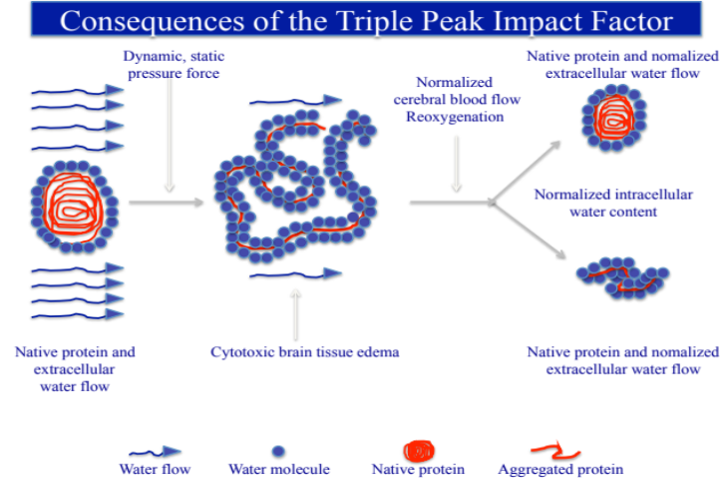

III. Reference:
1 von Holst, H, and Li, X. The dynamic triple peak impact factor in traumatic brain injury influences native protein structures in gray and white matter as measured with computational simulation. Neurol Res 35: 782–789. (2013).

2. von Holst H,. and Li, X. Numerical impact simulation of gradually increased kinetic energy transfer has the potential to break up folded protein structures resulting in cytotoxic brain tissue edema. J Neurotrauma 30:1192–1199. (2013).

3. von Holst H,. and Li, X. Higher impact energy in traumatic brain injury interferes with noncovalent and covalent bonds resulting in cytotoxic brain tissue edema as measured with computational simulation. Acta Neurochir. 157:639–648. (2015).

IV. Biography:
Hans von Holst received his MD´s degree in 1976 and specialist in Neurosurgery 1982, Karolinska University Hospital. In 1985 he earned his PhD and Associate Professorship in Neurosurgery, Clinical Neuroscience, Karolinska Institutet and appointed as senior neurosurgeon 1988 - 2015. During 1991-1996 he was Chairman of the Dept of Neurosurgery and Division Manager of the Neuroclinics at Karolinska University Hospital, respectively. Between 1994-2014 he was appointed as Professor in Neuroengineering, KTH Royal Institute of Technology and visiting Professor at Karolinska Institutet 2006-2012, He has published over 150 original papers in reputed journals, reviews and books including editorial board member in several journals.

V. Presenting author details

Full Name: Hans von Holst Contact number: +46702390067
hvh@cenesy.com
Category: Oral presentation

Copyright © 2016-2018 Meetings Int PTE Ltd, All Rights Reserved.
Meetings International Pte Ltd
28 MAXWELL ROAD, #03-05 RED DOT Contact Number
TRAFFIC, SINGAPORE (069120) 65-310-80483 (SINGAPORE)
URL:https://www.meetingsint.com/conferences/geriatrics Email Id: geriatricsconference@meetingseries.org

