Two ways to control CjCas9 expression in the deletion of pathogenic GAA repeat in frataxin gene
Pouiré Yaméogo¹, Nathalie Majeau¹ and Jacques P. Tremblay¹

¹ Centre de Recherche du Centre Hospitalier Universitaire de Québec and Département de Médecine Moléculaire, Faculté de Médecine, Université Laval

Most Friedrich Ataxia cases are caused by an insertion of a GAA repeat sequence (GAAr) in the first intron of the frataxin gene leading to a decrease in protein expression. Deletion of this GAAr by CRISPR-Cas9 technology leads to an increase in frataxin expression. Due to the limited size of AAV packaging, GAAr removal by SpCas9 required two Adeno-associated viruses (AAVs). Using 2 AAVs reduces the efficiency of a potential treatment since each cell must be infected by both viruses. We have therefore used CjCas9 because it is small enough to be delivered with two sgRNAs by a single AAV. However, a constitutive expression of the CjCas9 gene delivered by an AAV in vivo may increase off-target mutations and induce an immune response against the Cas9 protein. Temporal expression is important for the CRISPR system. We investigated two approaches to limit the nuclease expression.
First, molecular Hara Kiri, we simultaneously transfected in HeLa cells plasmids encoding CjCas9, two guides (pre and post GAAr) targeting the frataxin gene and two guides targeting the CjCas9 gene. Our results showed that despite the self-destruction of the CjCas9 gene, an effective genome editing of the FXN gene was obtained in vitro.
Second, CRISPR-SCReT (Stop Codon Read Through), we inserted a stop codon (TGA) at the beginning of the CjCas9 gene to repress its expression. Subsequently, we induced the expression of Cas9 by molecules capable to allow translation despite the presence of the premature stop codon. This plasmid was transfected into 293T cells with two sgRNAs (pre and post GAAr). We noted deletion of the GAAr only in cells treated with G418.
These different methods permitted to obtain efficient editing of the frataxin gene while preventing a sustained Cas9 expression. This could reduce the chances of off-target mutations and immune reaction against Cas9 protein.
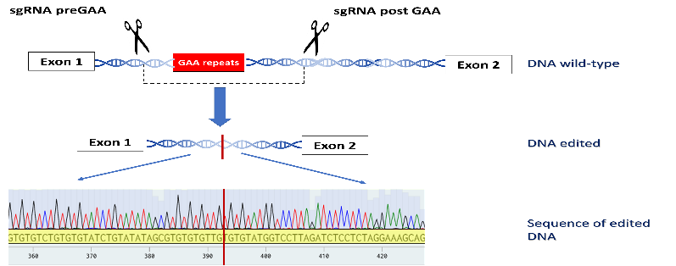
Figure 1: Schematic representation of the human frataxin gene with guides used to delete the GAA repeat by CRIPR-Cas9 technology.
Publications
- Bonkoungou IJO, Ouédraogo N, Tamini L, TegueraRK, Yaméogo P, Drabo MK, Medah I, Barro N, Sharma S, Svensson L, Nordgren J. (2018). Rotavirus and norovirus in children with severe diarrhea in Burkina Faso before rotavirus vaccine introduction.J Med Virol. 90(9): 1453-1460.
- Yameogo N1, Bazie BVEJT, Ouattara AK1, Yameogo P, Compaore TR, Obiri-Yeboah D, Djigma FW1, Karou SD, Simpore J. (2017). Major Polymorphisms of Genes Involved in Homocysteine Metabolism in Malaria Patients in Ouagadougou, Burkina Faso.Malar Res Treat.
- Abdoul Karim Ouattara, Pouiré Yameogo, Lassina Traore, Birama Diarra, Maléki Assih1, Tegwindé Rébéca Compaore, Dorcas Obiri-yeboah, Serge Théophile Soubeiga, Florencia Wendkuuni Djigma and Jacques Simpore. (2017). Prevalence, genetic variants and clinical implications of G-6-PD deficiency in Burkina Faso: a systematic review.BMC Medical Genetics. 18(139): 1-8.
- Ouattara A.K., Yameogo P., Diarra B., Obiri-Yeboah D., Yonli A., Compaore T.R., Soubeiga S.T., Djigma F.W., Simpore J. (2016). Molecular heterogeneity of glucose-6-phosphate dehydrogenase deficiency in Burkina Faso: g-6-pd betica selma and santamaria in people with symptomatic malaria in ouagadougou. Mediterr J Hematol Infect Dis. 8

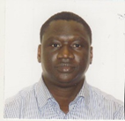
Biography: I am doing my PhD in molecular medicine in Jacques P Tremblay’s laboratory (CHU de Québec, Laval University) since 2018. I have a master's degree in molecular biology. I previously worked in the molecular biology laboratory of the Burkina Faso national public health laboratory. Email: pouire.yameogo.1@ulaval.ca

