The Ledderhose disease : case report

Dr M.Nasr, Dr S.Baya, Dr B.Mderreg, Dr A.Khairi, Pr J.Hafidi, Pr S.Elmazouz, Pr N.Gharib, Pr A.Abbassi
Plastic Reconstructive and Aesthetic Surgery, Hand and Burn Surgery, UH IBN SINA RABAT MOROCCO

Abstract :
Ledderhose disease is a rare condition that causes connective tissue to build up and create hard lumps on the bottoms of the feet. These lumps form along the plantar fascia — the band of tissue that connects your heel bone with your toes. The growths aren’t cancerous, but they can cause pain, especially at walk.
This condition is related to other connective tissue diseases, especially Dupuytren’s contracture. Often these conditions occur together.
Ledderhose disease can start at any age, but it usually affects those who are middle-aged or older. In the surgery called fasciectomy, the surgeon will remove part or all of the thickened tissue from the foot. The surgery can leave scars, and Ledderhose disease can eventually come back. This is about a case of Ledderhose disease treated by surgery in our hospital about a man 50 years old that had this disease in both of the feet.

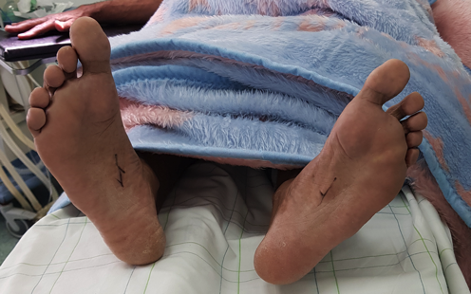 Image A : Before surgery
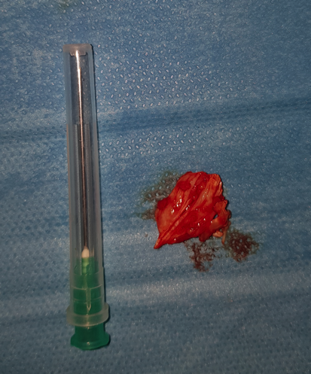Image B : the fasciectomy
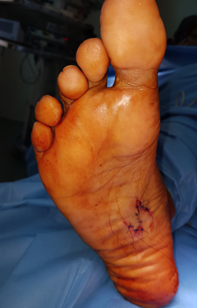Image C : After surgery

DR NASR MOUNIA, Plastic and Aesthetic surgery hand and burn surgery Resident, HU IBN SINA RABAT MOROCCO

