Cutis Verticis Gyrata : case report
Dr M.Nasr, Dr S.Baya, Dr B.Mderreg, Dr A.Khairi, Pr J.Hafidi, Pr S.Elmazouz, Pr N.Gharib, Pr A.Abbassi
Plastic Reconstructive and Aesthetic Surgery, Hand and Burn Surgery, UH IBN SINA RABAT MOROCCO

Abstract :

The cutis verticis gyrata refers to deep folds on the scalp that look similar to the folds of the brain. It occurs more commonly in males, and most commonly develops after puberty, but before age 30. It may occur alone or in association with a variety of underlying conditions or treatments, including neuropsychiatric disorders, eye abnormalities, or inflammatory conditions. While most isolated cases of unknown cause are sporadic, autosomal recessive and autosomal dominant inheritance with varying degrees of severity have been described.
Management may include keeping areas within the folds clean, and/or surgery if requested for psychological or cosmetic reasons. This is a 19-year-old patient who has had this condition since birth, and who has received surgical treatment based on galeotomy and removal of residual tissue.
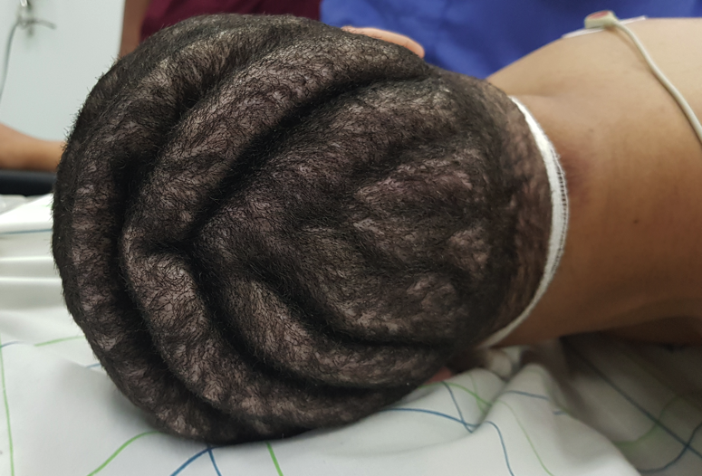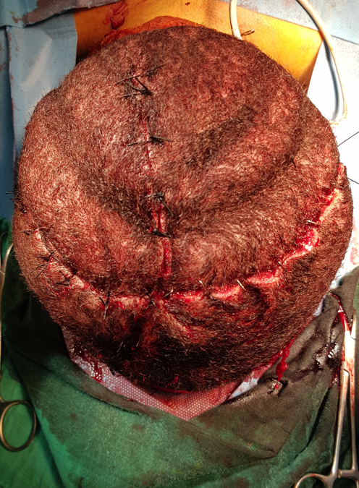
Image A : Before Surgery Image B : After Surgery

DR NASR MOUNIA, Plastic and Aesthetic surgery hand and burn surgery Resident, HU IBN SINA RABAT MOROCCO

