The Zitelli flap in reconstruction of the substance loss of the distal end of the nose : case report

Dr M.Nasr, Dr S.Baya, Dr B.Mderreg, Dr A.Khairi, Pr J.Hafidi, Pr S.Elmazouz, Pr N.Gharib, Pr A.Abbassi
Plastic Reconstructive and Aesthetic Surgery, Hand and Burn Surgery, UH IBN SINA RABAT MOROCCO

Abstract :
Small losses of nose substances secondary to a tumor of the nose at the tip and the nostril are difficult to reconstruct. The bilobed flap of Zitelli is the best indication in these cases.
We will present the case of a 60-year-old man with an infiltrating basal cell carcinoma, poorly limited to 6mm in diameter, straddling the tip of the nose, the right nostril and the right paramedian face.The tumor is removed with 3mm lateral safety margins, the reconstruction of the loss of substance is made with Zitelli's improved bilobed flap allowing coverage of the loss of substance without anatomic and aesthetic modification of the subunits of the nose .
Nasal reconstruction must respect morphological, functional and aesthetic imperatives. Unit repairs offer the advantage of repairing loss of substance with skin of the same quality, matched in texture and color, and they reconstruct aesthetic subunits of the nose while maintaining scars within the unit. . The bilobed flap is a double transposition flap whose overall rotation is 90 °, with a rotation of each lobe of the order of 45 °. It must be dissected sub-muscular to ensure its viability. It is intended for losses of substance less than 20mm in size, paramedianes, low columellar tip or that can border the nostril margin.
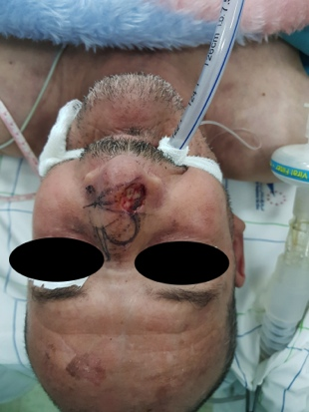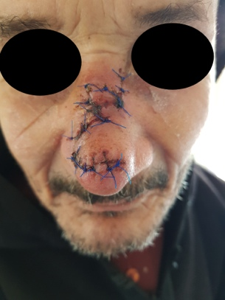
Image A : Pre- Operative Image B : Post- Operative

DR NASR MOUNIA, Plastic and Aesthetic surgery hand and burn surgery Resident, HU IBN SINA RABAT MOROCCO

