Postoperative changes after new surgical method of hernia repair: Sonography and CT in assessment of intervention area
Abatov Nurkassi, FULL professor, PhD, Karaganda Medical University, Karaganda, Kazakhstan
Badyrov Ruslan, Associated professor, PhD, Karaganda Medical University, Karaganda, Kazakhstan
Assamidanov Yerkebulan, Associated professor, PhD, Karaganda Medical University, Karaganda, Kazakhstan
Sapieva Saule, PhD student, Karaganda Medical University, Karaganda, Kazakhstan
Duysenov Galymjan, resident, Karaganda Medical University, Karaganda, Kazakhstan
Shokan Ratbek, resident, Karaganda Medical University, Karaganda, Kazakhstan

Image

Abstract

Statement of the Problem: a new non-mesh tension-free method of inguinal hernia repair is developed. This surgical technique based on displacing of aponeurotic flap from the sheath of rectus abdominis muscle moved on the pedicle for plastics of the posterior wall of the inguinal canal. The aim of study was to evaluate early postoperative changes of intervention area using sonography and computer tomography.
Methodology & Theoretical Orientation: The new method was applied in 15 patients, the control group consisted of 15 studied, operated on Liechtenstein method. All patients were examined by ultrasound of the inguinal-scrotal areas (state of blood flow in the arteries of the spermatic cord) and CT before surgery, 7 days and 1 month after it.
Findings: In the period of 1 month after operation, the improvement in the average value of the blood flow velocity in the artery of the vas deferens was: control - by 1.7±1.6 cm/s; the test group - 1.7±1.1 cm/s; in the testicular artery: control group - by 2.5±1.4 cm/s; the test group is 2.5±1.6 cm/s higher than before the operation. In the control group, an inflammatory process surround of a mesh 6.5±2.5 mm was fixed. These indicators were absent in patients of the test group. According to CT data, in terms of 1 week after surgery, there was a decrease in the density of soft tissues in the test group of 27.5±17.5 HU, at the control group – 25.1±20.9 HU, which confirms the greater severity of inflammation with the presence of a liquid component in the control group.
Conclusion & Significance: The developed a new non-mesh tension-free method of inguinal hernia repair is not inferior to Liechtenstein hernioplasty in restoring blood flow in the early postoperative period, but is characterized by a less pronounced of inflammatory response.

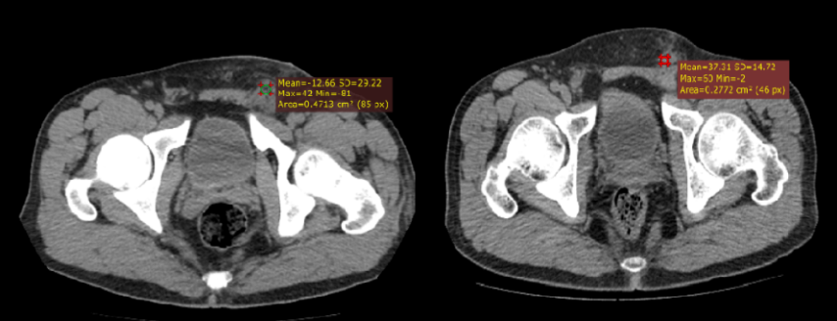

Figure 1: CT sagittal sections at 7 days after surgery. On the left - a patient who underwent hernioplasty by the method of Linchtenstein soft tissue density - (-12.6) HU. On the right is a patient who has undergone a new non-mesh tension-free method - 37.3 HU.

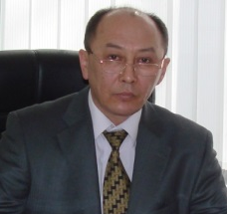Biography
Abatov Nurkassi deals with the scientific problem of comparative study of the effectiveness of traditional and laparoscopic operations in various pathologies of the abdominal cavity organs. The well-known and developed original methods of surgical interventions on the abdominal organs, retroperitoneal space and the anterior abdominal wall have been mastered. Direction of scientific interests: surgery, urology, endovideosurgery, the introduction of new technologies of surgery in clinical practice, biomaterials, information technologies in medicine, innovative teaching methods in medical education.

Email: Abatov@qmu.kz

