Inguinal hernia: a new non-mesh tension-free method of surgical treatment
Abatov Nurkassi, FULL professor, PhD, Karaganda Medical University, Karaganda, Kazakhstan
Badyrov Ruslan, Associated professor, PhD, Karaganda Medical University, Karaganda, Kazakhstan
Abatova Aigerim, PhD, Karaganda Medical University, Karaganda, Kazakhstan
Sapieva Saule, PhD student, Karaganda Medical University, Karaganda, Kazakhstan
Troshin Vadim, resident, Karaganda Medical University, Karaganda, Kazakhstan
Badyrova Elena, intern, Karaganda Medical University, Karaganda, Kazakhstan

Abstract
Statement of the Problem: Recurrences have been a significant problem following hernia repair. Prosthetic materials have been increasingly used in hernia repair to prevent recurrences. However, synthetic endoprostheses have disadvantages, which include: aseptic inflammation in the surrounding tissues with the formation of a pronounced connective tissue scar; low resistance to the infection; high risk of adhesions between the abdominal organs and the mesh. The aim of study was to create a new method of inguinal hernia repair, not using synthetic mesh.
Methodology & Theoretical Orientation: Our new method of autoplasty of the posterior wall of the inguinal canal based on cutting out the aponeurotic flap from the sheath of rectus abdominis muscle, and moving it on the under spermatic cord, followed by fixing it to the pubic tubercle, inguinal ligament, medial – rectus, internal oblique and transverse muscles of the abdomen (figure 1). In this study, 15 new non-mesh tension-free inguinal hernia repairs were performed. The main outcome measure was recurrence in the early postoperative period (before 30 days).
Findings: Inguinal hernia was indirect in 60% of cases (9 patients), direct in 40% (7 patients). Mean patient age was 47.3 years (range, 18 – 75). Follow-up was completed in all 15 patients (100%) by clinical examination or phone call. Small seroma formation in 1 patient was observed in 5th day, but not requiring drainage. We have not observed acute infection, hematoma formation or functional or organic changes in the spermatic cord related to the new technique of hernia repair.
Conclusion & Significance: The above-described method ensures the proper strength of the posterior wall of the inguinal canal, preserves the physiological function of it after operation. The use of this technique has a big potential in the inguinal hernia repair, since it can eliminate all complications associated with the use of synthetic material.

Image
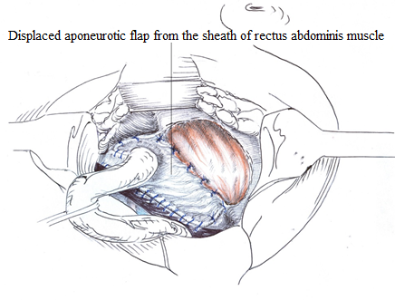
Figure 1: Autoplasty of the posterior wall of the inguinal canal. Aponeurotic flap from the sheath of rectus abdominis muscle moved on the pedicle for plastics of the posterior wall of the inguinal canal and fixed.

 Biography

Badyrov Ruslan has experience in the treatment of surgical diseases of the abdominal cavity and the anterior abdominal wall. For 5 years, he has been actively studying modern methods of abdominal wall reconstruction, as well as introducing new ones. He is a co-author of the invention - a new biological implant based on the extracellular bovine-derived peritoneum matrix for abdominal wall defects repair (Patent of the Republic of Kazakhstan), is actively working on the use of biological implants for abdominal wall reconstruction.
Email: badyrov_ruslan@bk.ru

Notes/Comments:

