Locally Advanced Pancreatic Cancer: Resectability After Neoadyvant Therapy
Lucia Moletta, MD, Department of Surgery, Gastroenterology and Oncology, University of Padova, Italy

Abstract

Pancreatic adenocarcinoma (PDAC) represents the fourth cause of death-related mortality in Italy. Only 20 % of patients have with resectable tumors at diagnosis. The introduction of new chemoterapic regimens (folfirinox (FFN) and gemcitabine-paclitaxel (GEMPAC)) has brought to encouraging improvements in downstaging, conversion to resectability and overall survival. The aim of the study was to evaluate the impact of neoadjuvant therapy (NAT) in “borderline resectable” (BR) and locally advanced pancreatic adenocarcinoma (LAC). We enrolled all patients with BR and LAC PDAC from January 2012 to December 2020. Survival data were estimated with the Kaplan–Meier method and examined using the log-rank test. The most frequent chemoterapic regimens were FFN and GEMPAC, in the 51,06% and 36,17% of cases, respectively. After NAT, 20% of patients were resected with a DSF of 26,43 ± 5,51 months. The OS in the entire cohort was 19,82 ± 2,21 months. The OS of the different groups of patients was: 5,66 ± 1,96 months for patients undergoing to best supportive care; 14,29 ± 2,09 months for patients experiencing progression of disease; 19,82 ± 3,07 months for patients undergoing surgical exploration but not resection and 40,44 ± 4,27 months for resected patients. The use of chemoterapic regimens other than FFN and GEMPAC was associated to progression of disease and a poor OS (p<0,05). The multivariate analysis of risk factors influencing OS showed that lymph-node involvement and an increased CA 19.9 after NAT were associated to a poor OS (p<0,05). Data reported in the Literature suggest that the use of FFN and GEMPAC represents a key point in the treatment of BR and LAC PDAC. However, the response rates are variable and they do not always correlate with the surgical resectability., New randomized clinical trails are necessary to establish the role of the different therapies available.
Image
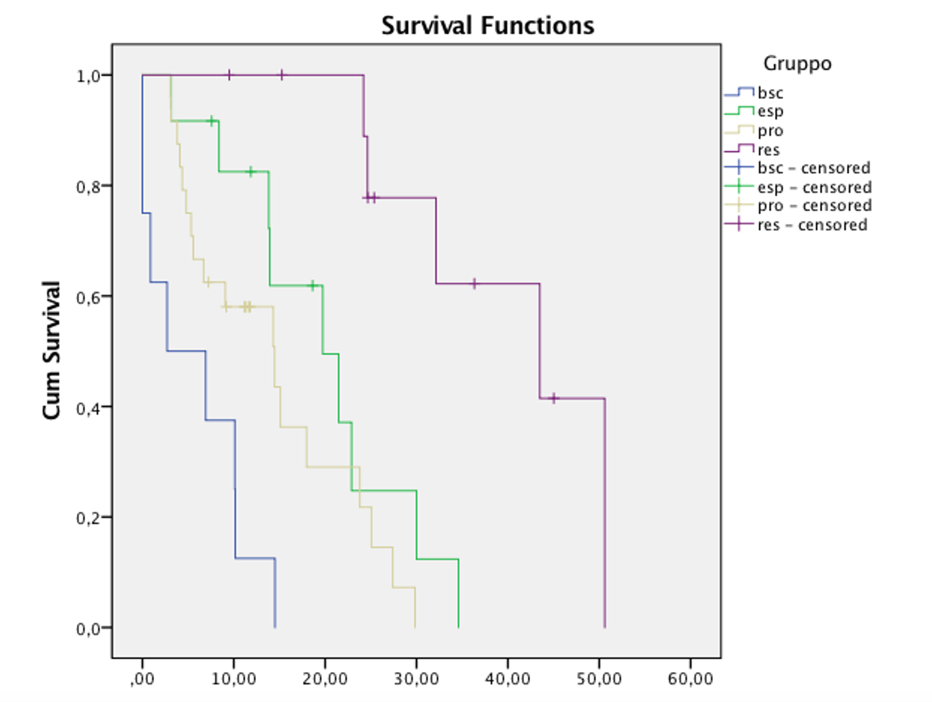
Survival of patients according to the different clinical response to NAT for PDAC. BSC: best supportive care; ESP: patients undergoing surgical exploration but not resection; PRO: patients experiencing progression of disease; RES: patients resected.
Recent Publications (minimum 5)
- Serafini S, Sperti C, Friziero A, Brazzale AR, Buratin A, Ponzoni A, Moletta L. Systematic Review and Meta-Analysis of Surgical Treatment for Isolated Local Recurrence of Pancreatic Cancer. Cancers (Basel). 2021 Mar 13;13(6):1277.
- Sperti C, Friziero A, Serafini S, Bissoli S, Ponzoni A, Grego A, Grego E, Moletta L.
Prognostic Implications of 18-FDG Positron Emission Tomography/Computed Tomography in Resectable Pancreatic Cancer. J Clin Med. 2020 Jul 9;9(7):2169.
- Moletta L, Pierobon ES, Capovilla G, Costantini M, Salvador R, Merigliano S, Valmasoni M. International guidelines and recommendations for surgery during Covid-19 pandemic: A Systematic Review. Int J Surg. 2020 Jul;79:180-188.
- Serafini S, Sperti C, Brazzale AR, Cecchin D, Zucchetta P, Pierobon ES, Ponzoni A, Valmasoni M, Moletta L.
The Role of Positron Emission Tomography in Clinical Management of Intraductal Papillary Mucinous Neoplasms of the Pancreas. Cancers (Basel). 2020 Mar 27;12(4):807.
- Moletta L, Serafini S, Valmasoni M, Pierobon ES, Ponzoni A, Sperti C. Surgery for Recurrent Pancreatic Cancer: Is It Effective? Cancers (Basel). 2019 Jul 16;11(7):991.

Biography
Lucia Moletta graduated in 2008 at University of Padova and got her surgical residency in 2015 at the same University Since 2017, she had been working as research associate at the Department of Surgical, Oncological and Gastroenterological Sciences (DISCOG), Clinica Chirurgica 3, University and Hospital of Padua. She attended in 2015 as a visiting physician the Hepatobiliary and Pancreatic Surgical Unit at the Academisch Medisch Centrum (Amsterdam). Her main interest lies in the oncologic diseases of the pancreas, as far as both the diagnosis and surgical treatment are concerned and in the oncologic diseases of the esophagus and stomach. She carries out research into new treatment methods for pancreatic cancer, minimally invasive pancreatic surgery, and new diagnostic and therapeutic approaches for pancreatic cysts, pancreatic carcinoma, esophageal and gastric tumors.

Email: lucia.moletta@unipd.it

