Pediatric Gastrointestinal Basidiobolomycosis mimicking Malignancy
Zainab Almoosaª, Mohammed Alsuhaibani ^{b} ,Sadeq AlDandan^{c},Dayel Alshahrani^{d*}
ªPediatric Infectious Diseases Section, King Abdulaziz Hospital Al-Ahsa, 2477, Saudi Arabia.
^{b}Pediatric department, college of medicine, Qassim University, Qassim, 51431 Saudi Arabia.
^{c}Pathology department, King Fahad Medical City, Riyadh,11564 Saudi Arabia.
^{d}Pediatric Infectious Diseases Section, Children Specialized Hospital, King Fahad Medical City, Riyadh,11564, Saudi Arabia

Abstract (300 word limit)

Basidiobolomycosis is a rare fungal infection with high prevalence in southwestern province of Saudi Arabia (Tohama region); it mainly causes subcutaneous infections and rarely gastrointestinal disease. Because of its indolent presentation, it is often misdiagnosed as IBD, tuberculosis or Malignancy.

We are reporting a 7 year old Saudi girl with abdominal mass, fever and eosinophilia resembling malignancy on radiological and pathological picture fully recovered with only medical therapy in the form of oral Voriconazole

Image

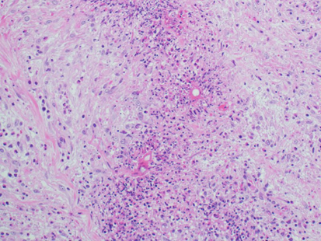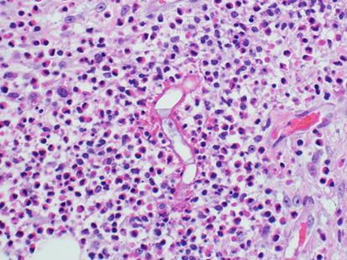

Figure (A) and (B)
Mesenteric fat and connective tissue with heavy infiltration by lymphocytes, histiocytes, plasma cells and eosinophils. Large and wide septated fungal hyphae are seen in association with nucleated basidiospores. Eosinophilic cell aggregates condense around the fungal hyphae forming Splendore-Hoeppli phenomenon.

Figure (A) and (B)
Mesenteric fat and connective tissue with heavy infiltration by lymphocytes, histiocytes, plasma cells and eosinophils. Large and wide septated fungal hyphae are seen in association with nucleated basidiospores. Eosinophilic cell aggregates condense around the fungal hyphae forming Splendore-Hoeppli phenomenon.
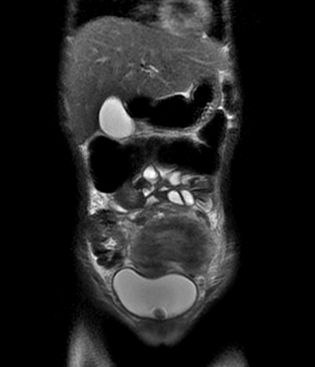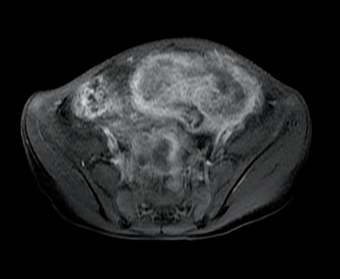

Image (A) and (B)
There is a large pelvic mass extending from the anterior abdominal wall to the right side of the pelvis posteriorly it is surrounding the sigmoid which is seen passing through the mass with no signs of obstruction however the mass is causing significant mass effect on the rectum and right-sided vesicouretric junction causing right side hydrouretronephrosis.

Recent Publications (minimum 5)

- Almoosa ZA, Alsuhaibani M, AlDandan S,AlShahrani D Pediatric Gastrointestinal Basidiobolomycosis mimicking Malignancy.Medical Mycology Case reports. 2017; 08: 002.

- Almoosa ZA, AlFawaz T,AlFawaz F. Pott’s puffy tumor due to Aspergillus fumigatus: A case report and review. IJPAM. 2016; 08: 005.

- Almoosa ZA , AlShahrani D . Invasive Candidiasis in Pediatric Patients at King Fahad Medical City in Riyadh, Saudi Arabia: A 5-year Retrospective Study. SMJ.2017.

- Aljughaiman A, ALrasheedi J, AlAbdulagader M, Almoosa ZA. Pneumonia complicated by transient encephalopathy: unusual presentation of adenovirus.. Virology & Mycology.2017.

Biography (150 word limit)

- Consultant Pediatric Infectious Diseases at King Abdulaziz Hospital (KAH) for National Guard, Al-Ahsa, KSA.
- MBBS from King Faisal University, Dammam in 2007.
- Saudi a board in Pediatrics(SSCP).
- Arab board in pediatrics (CABP)
- Clinical fellowship in Pediatric Infectious Diseases (SF-PED ID).
- program director of pediatric residency program at KAH.
- Chair of antimicrobial stewardship team in almoosa specialist hospital.
- Member of infection control committee in KAH.
- Member of Infectious diseases society of America (IDSA).
- Member of Saudi society of pediatric infectious diseases.
- Active full member of APIC Association for professionals in infection control and epidemiology(APIC).
- Published several national and international articles in infectious diseases.

Notes/Comments:

