The redefinition of Helicobacter pylori lipopolysaccharide O-antigen and coreoligosaccharide domains
Hong Li, PhD, West China Marshall Research Center for Infectious Diseases, Center of Infectious Diseases, West China Hospital of Sichuan University

Abstract (300 word limit)

Helicobacter pylori lipopolysaccharide promotes chronic gastric colonisation through O-antigen host mimicry and resistance to mucosal antimicrobial peptides mediated primarily by modifications of the lipid A. The structural organisation of the core and O-antigen domains of H. pylori lipopolysaccharide remains unclear, as the O-antigen attachment site has still to be identified experimentally. Here, structural investigations of lipopolysaccharides purified from two wild-type strains and the O-antigen ligase mutant revealed that the H. pylori core-oligosaccharide domain is a short conserved hexasaccharide (Glc-Gal-DD-Hep-LD-Hep-LD-Hep-KDO) decorated with the O-antigen domain encompassing a conserved trisaccharide (-DD-Hep-Fuc-GlcNAc-) and variable glucan, heptan and Lewis antigens. Furthermore, the putative heptosyltransferase HP1284 was found to be required for the transfer of the third heptose residue to the core-oligosaccharide. Interestingly, mutation of HP1284 did not affect the ligation of the O-antigen and resulted in the attachment of the O-antigen onto an incomplete core-oligosaccharide missing the third heptose and the adjoining Glc-Gal residues. Mutants deficient in either HP1284 or O-antigen ligase displayed a moderate increase in susceptibility to polymyxin B but were unable to colonise the mouse gastric mucosa. Finally, mapping mutagenesis and colonisation data of previous studies onto the redefined organisation of H. pylori lipopolysaccharide revealed that only the conserved motifs were essential for colonisation.

In conclusion, H. pylori lipopolysaccharide is missing the canonical inner and outer core organisation. Instead it displays a short core and a longer O-antigen encompassing residues previously assigned as the outer core domain.

Image
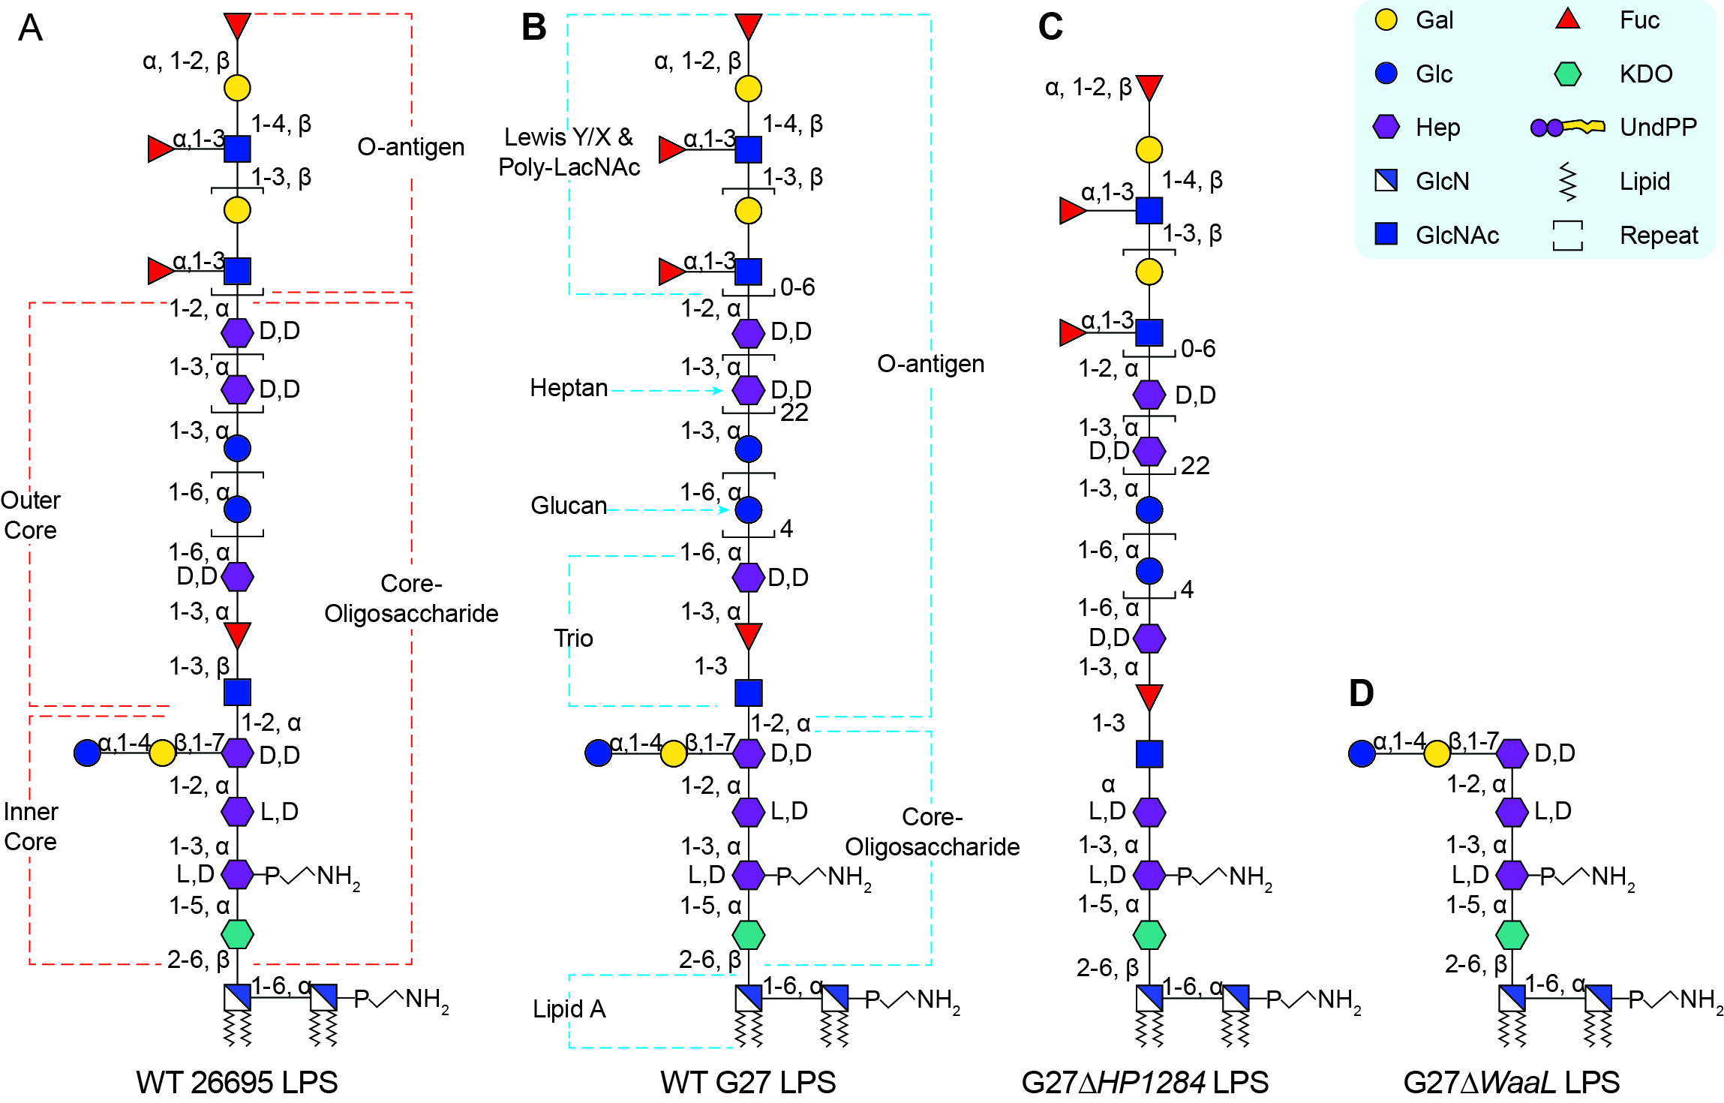
Fig 1. Previously proposed and the redefined LPS structure in H. pylori.
The previously proposed LPS structure in strain 26695 wild-type (A), the redefined LPS structures of the G27 wild-type (B), G27ΔHP1284 (C) and G27ΔwaaL (D). The nomination of different domains of the LPS is annotated.
Recent Publications (minimum 5)
- Li H, Yang T, Liao T, Debowski AW, Nilsson HO, et al. (2017) The redefinition of Helicobacter pylori lipopolysaccharide O-antigen and core-oligosaccharide domains. PLoS Pathog 13: e1006280.
- Li H, Liao T, Debowski AW, Tang H, Nilsson HO, et al. (2016) Lipopolysaccharide structure and biosynthesis in Helicobacter pylori. Helicobacter 21: 445-461.
- Li H, Debowski AW, Liao T, Tang H, Nilsson HO, et al. (2017) Understanding protein glycosylation pathways in bacteria. Future Microbiol 12: 59-72.
- Li H, Yang T, Liao T, Debowski AW, Nilsson HO, et al. (2017) Insights from the redefinition of Helicobacter pylori lipopolysaccharide O-antigen and core-oligosaccharide domains. Microbial Cell.
- Tang X, Li H, Yan L, Zhou L, et al. (2017) Diagnostic value of PIVKA-II in detectinghepatocellular carcinoma in Chinese patients with hepatitis B virus infection. Future Virol.
- Lei L, Yang Y, Mao M, Li H, et al. (2015) Modulation of biofilm exopolysaccharides by the Streptococcus mutans vicX gene. Front. Microbiol 6:1432.
- Debowski AW, Gauntlett JC, Li H, et al. (2012) Xer-cise in Helicobacter pylori: one-step transformation for the construction of markerless gene deletions. Helicobacter 17(6):435-43

Biography (150 word limit)
Hong Li obtained his MD degree at North Sichuan Medical College, China in 2006. He then became a registered physician in West China Hospital in 2007. He obtained his Master degree in West China Hospital, Sichuan University 2009 for the study of HBV infection. In October 2009, he was awarded the PhD Full-Scholarship from The University of Western Australia (UWA) under the supervison of Nobel Laurate Professor Barry Marshall, Drs Mohammed Benghezal, Hans-Olof Nilsson and Keith Stubbs from UWA. His study in UWA led to the completion of his PhD thesis titled “Lipopolysaccharide biosynthesis and protein glycosylation in Helicobacter pylori” and the awarding of his PhD degree in Microbology from UWA. In 2015, Hong Li returned back to West China Hospital of Sichuan University and actively promoted the academic collaboration between Sichuan University and UWA with the establishment of the collaboration center---"West China-Marshall Research Center for Infectious Diseases" in Chengdu.

Email: anhong99999@163com
Notes/Comments

