Transcutaneous electroacupuncture alleviates postoperative ileus after gastrectomy: A randomized clinical trial
Kai-Bo Chen M.D. CHINA

Abstract (300 word limit)

AIM

To investigate the efficacy and safety of transcutaneous electroacupuncture (TEA) to alleviate postoperative ileus (POI) after gastrectomy.

METHODS

From April 2014 to February 2017, 63 gastric cancer patients were recruited from the Second Affiliated Hospital of Zhejiang University School of Medicine, Hangzhou, China. After gastrectomy, the patients were randomly allocated to the TEA (n = 33) or control (n = 30) group. The patients in the TEA group received 1 h TEA on Neiguan (ST36) and Zusanli (PC6) twice daily in the morning and afternoon until they passed flatus. The main outcomes were hours to the first flatus or bowel movement, time to nasogastric tube removal, time to liquid and semi-liquid diet, and hospital stay. The secondary outcomes included postoperative symptom assessment and complications.

RESULTS

Time to first flatus in the TEA group was significantly shorter than in the control group (73.19 ± 15.61 vs 82.82 ± 20.25 h, P = 0.038), especially for open gastrectomy (76.53 ± 14.29 vs 87.23 ± 20.75 h, P = 0.048). Bowel sounds on day 2 in the TEA group were significantly greater than in the control group (2.30 ± 2.61/min vs 1.05 ± 1.26/min, P = 0.017). Time to nasogastric tube removal in the TEA group was earlier than in the control group (4.22 ± 1.01 vs 4.97 ± 1.67 d, P = 0.049), as well as the time to liquid diet (5.0 ± 1.34 vs 5.83 ± 2.10 d, P = 0.039). Hospital stay in the TEA group was significantly shorter than in the control group (8.06 ± 1.75 vs 9.40 ± 3.09 d, P = 0.041). No significant differences in postoperative symptom assessment and complications were found between the groups. There were no severe adverse events related to TEA.

CONCLUSION

TEA accelerated bowel movements and alleviated POI after open gastrectomy and shortened hospital stay.

Image
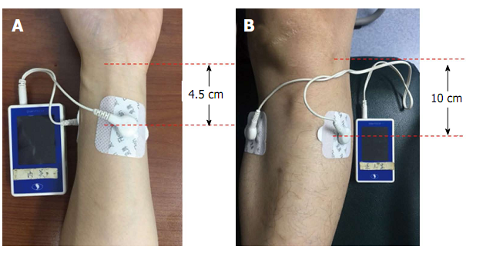
Transcutaneous electroacupuncture sites used in this study. A: Neiguan (ST36): two electrodes were oppositely attached on the skin approximately 4.5 cm below the wrist wrinkle; B: Zusanli (PC6): two electrodes were oppositely attached on the skin 10 cm below the lateral patella pit
Recent Publications (minimum 5)
Kai-Bo Chen(#); Yi-Qiao Lu(#) ; Jian-De Chen; Di-Ke Shi; Zhi-Hui Huang; Yi-Xiong Zheng; Xiao-Li Jin; Zhe-Fang Wang; Wei-Dong Zhang; Yi Huang; Zhi-Wei, Wu; Guo-Ping Zhang; Hang Zhang; Ying-Hao Jiang; Li Chen(*) Transcutaneous electroacupuncture alleviates postoperative ileus after gastrectomy: A randomized clinical trial World Journal of Gastroenterology Surgery 2018.2.27 10(2) : 13~20

Biography (150 word limit) 

Email: live4love@zju.edu.cn

Notes/Comments:

Kai-Bo Chen is a general surgeon, working in the Second Affiliated Hospital of Zhejiang University, College of Medicine, Hangzhou, who has graduated from the Zhejiang University with Bachelor degree of Life Science and MD degree in the year of 2014. He is now a fellow doctor, well trained in general surgery, especially in open or laparoscopic gastrectomy as well as thyroidectomy.
He also does some clinical and laboratory researches about gastric cancer, especially the metastatic mechanism of gastric cancer, such as peritoneal metastasis.

