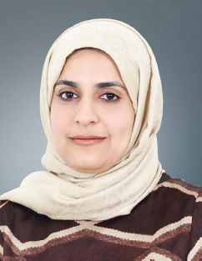

Biography
Dr Maheeba Abdulla
Dr Maheeba Abdulla is Consultant Gastroenterologist and Hepatologist at Salmaniya Medical Complex, Bahrain. After gaining her medical degree, she completed her residency and subsequently undertook an international fellowship in gastroenterology and Hepatology at king Faisal Specialist Hospital in Riyadh, Saudi Arabia followed by two fellowships in liver transplantation and advanced therapeutic endoscopy at King’s College London and Queen Alexandra Hospital, Portsmouth, both in the UK. She has published several original articles and presented posters at international meetings. At present her research interests focus on hepatitis C virus infection, Hepatitis B virus infection and inflammatory bowel disease.

