Title: ‘’Gastroeneterology,hepatology complications during COVID-19 pandemic with endoscopy planning –the dilemna’’

Kulvinder Kochar Kaur¹, Gautam Allahbadia², Mandeep Singh³

- Dr Kulvinder Kaur Centre For Human Reproduction,Jalandhar ,Punjab ,India
- Ex-Rotunda-A Centre for Human Reproduction,Mumbai,Maharashtra ,India
- Swami Satyanand Hospital, Jalandhar ,Punjab ,India

Abstract

Digestive symptoms including anorexia, nausea, vomiting, diarrhea (N,V,D)- frequently reported in patients withCOVID-19-disease[CD]) .SARS-CoV-2 RNA was first detected in stool of the 1st reported CD-19 case in the USA, who also presented with the digestive symptoms of (N.V,D). In the biggest cohort -1099 patients with laboratory-confirmed CD-19 from 552 hospitals in China in Jan 2020,N,V,D were reported in55(5%) and 42(3.8%) patients, respectively. Of the204 patients with CD-19 and full investigations , 99 (48.5%) presented with digestive symptoms as main complaint. Patients with digestive symptoms had separate manifestations,like anorexia (83.8%),V,D and abdominal pain (0.4%). Digestive symptoms - might be presenting prior to respiratory symptoms, or onlysymptoms of CD-19 The mode for GITinfection of SARSCoV is ACE2 cell receptor.SARS-CoV-2, having genome sequence of SARS-CoV(82%), might use the same ACE2, >strain -SARS-CoV(2003). Xiao et al showed on endoscopic biopsy samples that ACE2 was rarely expressed in esophageal epithelium, but abundantly distributed in cilia of glandular epithelia, while staining of viral nucleocapsid protein was visualized in the cytoplasm of gastric, duodenal, and rectum glandular epithelial cell, but not in esophageal epithelium.as found in another study in the small intestine,The crosstalk amongSARS-CoV-2 -ACE2 might disrupt the function of ACE2 and cause diarrhea.Chances of fecal–oral transmission of SARS-CoV-2 stressed on proper hand hygiene ,stools handling and hospital sewage carefully in pts. SARS-CoV-2 in the GIT,signifies CD-19 infection in patients with preexisting digestive diseases and fecal microbiota transplant donors. To prevent SARS-CoV-2 transmission by fecal microbiota transplantation, more testing needed over current ones.GIT endoscopy departments face marked transmissions risk of virus during endoscopy .Earliest reports of CD-19 , 40/138 showed high risk of infection for healthcare workers of infection.Possible routes of viral transmission onendoscopy examination - person-to-person, respiratory droplets, aerosols formed onendoscopy, and contact with contaminated surroundings, body fluids, and fecal material.Recommendation used-World Endoscopy Organization, ASGE,ESGE on endoscopy during the pandemic.Liver damage was common in the patients infected by the other 2 highly pathogenic coronavirus-SARS-CoV, MERS CoV associated with the severity of diseases. In patients with CD-19, several studies have documented the incidence of liver injury , indicating that 2- 11% of patients with CD-19 had liver comorbidities and 16 -53% cases reported abnormal levels of SGOT /PT.Guan et al and Huang showed that elevated AST levels were observed more in pts with severe disease,. Liver injury might be due to viral infection in liver cells or due to other causes such as drug induced liver injury and systemic inflammation induced by CKSor pneumonia-related hypoxia. SARS virus has been shown to be present in the liver tissue, although the viral titer was relatively low because viral inclusions were not observed.The impact of COVID-19 in patients with preexisting chronic liver diseases, needs evaluation.from Chinese study showed that chronic hepatitis B infection pts didn’t have higher disease severity vs population as did world cases. Major changes to the standard management of GIT diseases, priorities like minimizing viral transmission, preserving PPE, and freeing hospital beds have driven unconventional approaches to managing GI patients. Conversion of endoscopy units to CD units and redeployment of GI fellows and faculty has profoundly changed most GI services.Meanwhile, consult and procedural volumes have reduced drastically..Sethi et al., showed how dealing specific consults and conditions haschanged, the mainfocus is on noninvasive measures and maximizing medical therapies.Endoscopic procedures have been reserved for those timely interventions that are most likely to be therapeutic.The role of multidisciplinary discussion, although important, has become critical now.Advancing a clear vision and a transparent process for how to organize and triage care in the recovery phase will allow for a smooth transition to our new normal. For percutaneous endoscopic gastrostomy(PEG) placements even in this time of pandemic needs to be avoided . Despite the viral effects of the SARS-CoV-2 in the GIT, enteral nutrition is still the preferred method of nutrition therapy for patients with CD-19 because of its multiple benefits in the gut. It supports the structural and functional integrity of the gut, thereby modulating systemic immunity, attenuating disease severity,aiding in good results. However, the presence of GI symptoms such as anorexia, N,V,Din some patients with CD-19complicates this challenge to feed the patient.
For emergency colorectal surgery, like cancer surgery ,queries on operating room (OR) utilization and techniques needed to be addressed. Caregiver safety relating to PPE and OR environment.with,extra PPE may be required on local presence of CD-19 testing plus incidence of known infection there.Besides standard CD-19 PPE precautions, a negative-pressure environment, including an OR, is advocated,mainly for aerosol-generating procedures(AGPs). Hospital spaces from patient wards toORs to endoscopy rooms have been successfullyconverted from standard positive-pressure to negative-pressure spaces.Moreover, minimally invasive surgery with pneumoperitoneum is an AGP and thus must be carefullyconsidered. Present worry is to avoid in patients infected with SARS-CoV-2 or we can dounder precautions with safety measures inplace -minimize exposure to aerosolized virus particles.Significant lessons learned from pressurized intraperitoneal aerosolized chemotherapy procedures are helpful to improve our insight &treat.
Mayo Clinic researchers, used a computer model to compare three strategies for CD-19 testing using PCR for patients scheduled to undergo endoscopic procedures during the CD-19 pandemic:strategy 1: testing all patients within 48 hours,with urgent procedures performed regardless of PCR result using high-risk PPE,and semi-urgent procedures performed with a negative result using low-risk PPE; 2nd: testing for semi-urgent procedures; and 3rdendoscopy for urgent procedures only.
PCR testing wassafe and effective intervention to resume endoscopy in semi-urgent and
elective cases, requiring expendituresUS22- $105 in testing per patient for strategies 2 and 3, respectively. This would allow an increase to 19.4% and 95.3% of baseline endoscopies, respectively. Implementing nationwide PCR testing in the US would require 13 million to$64 million per week for the two strategies, respectivel,with a return of $165 million and $767 million to providers, respectively. Healthcare workers infected in the endoscopy unit weekly were around 65 and 325 for the two strategies, respectively. per Aytin et al.pointsonly life-threatening emergency operations be performed in the stage where the epidemic exceeds the capacity of the hospitals (1ststage),cancer and transplantation surgery should be initiated when the outbreak beginsto be controlled (2ndstage),and surgeryfor elective cases be performed in a controlled manner with suppression of the outbreak (3rd stage).Most cases can be postponed to the 3rd stage of the epidemic.

References
- Kulvinder Kochar Kaur,Allahbadia GN,Singh M. ‘’A Comprehensive review on epidemiology ,aetiopathogenesis ,diagnosis and treatment of the novel corona virus syndrome –COVID-19’’ IBEROAMERICAN JOURNAL OF MEDICINE 2020;2:110-23.
- Kulvinder Kochar Kaur. Editorial –Maximum possible efforts by which we will win over this Deadly Pandemic of COVID-19’’Acta Scientific Microbiology 2020;3(6):01-03.
- Kulvinder Kochar Kaur,Allahbadia GN,Singh M. An Update on COVID19 from Etiopathogenesis ,to role in male infertility ,Pregnancy Lactation ,and Regarding treatment.2020;In press
- Kulvinder Kochar Kaur,Allahbadia GN,Singh M. Editorial-An update on management of severe COVID19presenting with Cytokine Release Syndrome responsible for most mortalities in COVID19. 19’’Acta Scientific Microbiology 2020;in press.
- Kulvinder Kochar Kaur,Allahbadia GN,Singh M.An update on the place of ART with SARS CoV2-around and influence on Both Reproduction ,transmission possibilities to ,Progeny,Partners And Staff –What is the Answer’’-Under review with Longdom Publishers.

.


Biography:(100 -200 words)
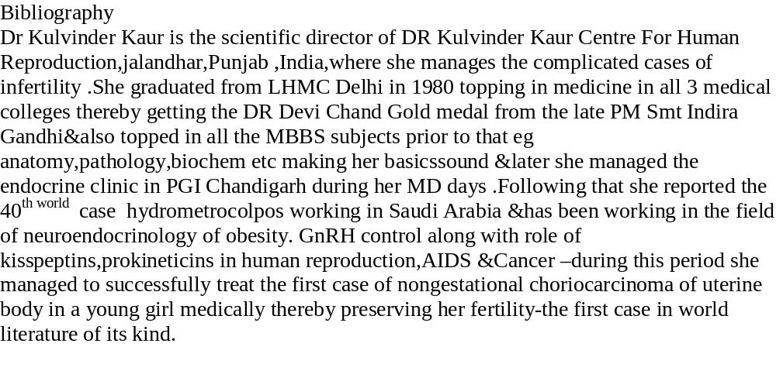

• Full Name: Kulvinder Kochar Kaur

• Personal Email: kulvinder.dr@gmail.com
• Mobile Number: +919501358180
• Category: (Oral presentation)
• Date of Birth: 18/6/1959
• Postal Address: Dr Kulvinder KaurCenter for Human Reproduction

Email: kulvinder.dr@gmail.com

