HABEN TSEHAYE
KAMPALA UGANDA
CASE PRESENTATION; PANCREATIC PSEUDOCYST
ABSTRACT;
Pancreatic pseudocyst is an encapsulated collection of fluid with a well defined inflammatory wall usually outside the pancreas with minimal or no necrosis.
It occurs 4 weeks following the incidence of acute pancreatitis.its caused by pancreatic duct obstruction due to stenosis fibrosis or stones or following acute pancreatitis.
Clinical presentation varies from asymptomatic to abdominal pain with vomiting low grade fever to serious peritonitis or pancreatic abscess and haemorrhage
Here we present a case of 50 year old male with history of acute pancreatitis 4 months ago due to blunt abdominal trauma.4 months after acute pancreatitis patient began to experience severe abdominal pain and vomiting.
On physical exam
Patient was on sever pain but conscious and oriented
Vital signs...BP 110/70 mmhg PR =80/min RR=18/min temp 36.5
Abdomen .....epigastric and upper abdomen tenderness.
Abdominal ultrasound revealed huge pancreastic pseudocyst in the body of the pancreas.
Pancreatic pseudocyst size of 10.55 cm
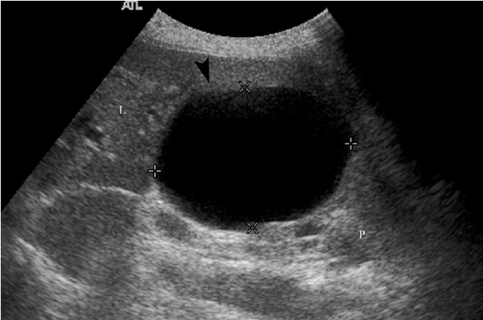

ENDOSCOPIC ULTRASOUND
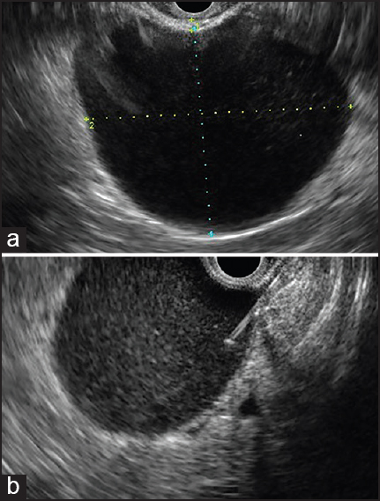
CT PANCREATIC PSUEDOCYST
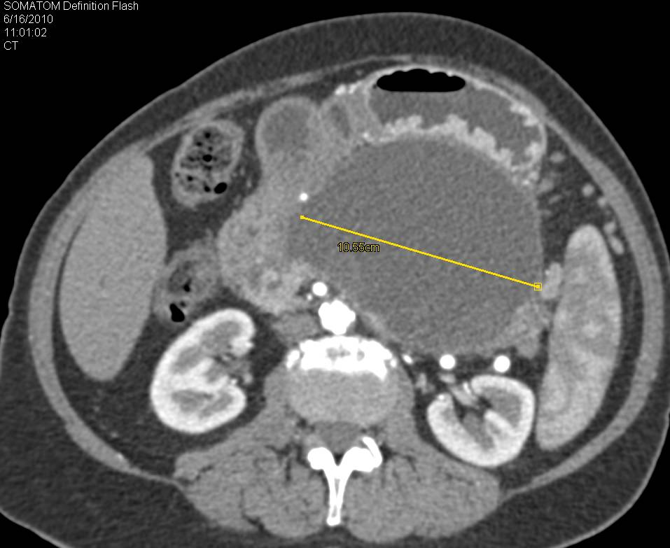
SURGICAL MANAGEMENT
Patient underwent open abdominal surgery and then cyst gastrostomy procedure was done.
Patient improved markedly without any complication and was discharged on 9th post operative day.
REFERENCES;
1.S.Habashi and PV Draganov ,pancreatic pseudocyst ,world journal of gastroenterology ,vol.15 pp 38-47 ,2009
2.D .Singhal,R.SUD AND Achaudhary ,issues in management of pancreatic pseudocyst ,journal of pancreas,vol 7,no 5 pp 502-507,2006.
3.lerch M,StierA,Wahnschaffe U,Mayerle J.Pancreas pseudocyst 2009,106;614-21.
BIOGRAPHY
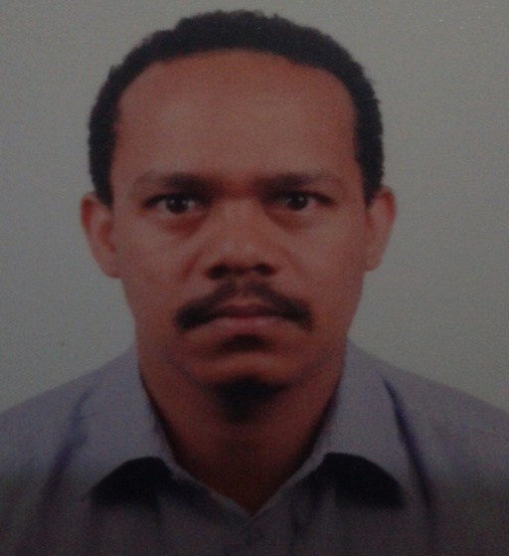
Haben Tsehaye is a medical doctor who has been practising in internal medicine and gastroenterology for the last 6 years. He holds his degrees from orotta school of medicine. he is very vigilant and hardworking.
He has worked in different hospitals. His passion for Gastroenterology has enabled him to work more on this field and take care of patients with gastroenterology diseases.
He has presented many gastroenterology and internal medicine cases in different occasions.
His interest in publishing and research is enormous.
Email....tghaben@yahoo.com
Tele....+256758248451.

