HABEN TSEHAYE
KAMPALA UGANDA
ISCHEMIC COLITIS ;CASE PRESENTATION
ABSTRACT
Ischemic colitis makes 1% of all the causes of acute abdominal pain.its a common disease in elderly males and the affected watershed blood supply are the splenic flexure and rectosigmoid parts of the colon.over 90% cases of ischemic colitis are over the age of 60.most of them have underlying atherosclerotic risk factors and diseases.
Most patients present with sudden crampy severe lower left quadrant abdominal pain and rectal bleeding.
Here we present a 72 year old male patient with history of hypertension, diabetes, acute coronary syndrome 2 years ago and history of abdominal aortic aneurysm with EVAR and heart failure who present to emergency department with acute onset severe abdominal pain and bloody diarrhea of one day duration.
Vitals signs ;bp 130/70, temp 37 pulse rate 96/min RR 18/min.
Conscious oriented patient with severe pain
Chest is clear ,CVS s4 gallop and pitting edema +1
Abdomen ....mildly distended with tenderness and guarding in the left lower quadrant
Per rectum..blood in glove but no mass palpated
LABS....WBC slightly raised with left shift but other electrolytes and chemistries and clotting panel are normal.Different imaging modalities were done for him as follows .ERECT ABDOMINAL FILM.....THUMB PRINT SIGN
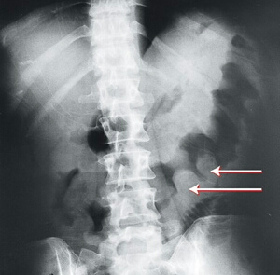
MESENTERIC ANGIOGRAPHY SHOWING.... SMA 90% stenosis with EVAR for aortic aneurysm
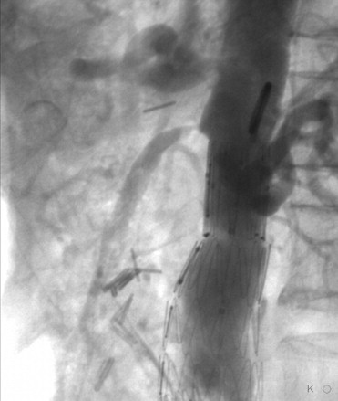

RECTOSIGMOIDSOCOPY SHOWING..... Ischemic colitis ulcerations.
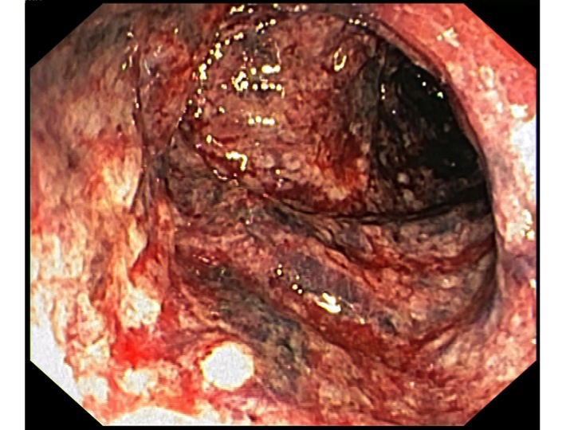
Considering his age and all the risk factors he has then stenting of the SMA was the best choice of treatment .patient underwent stenting and digoxin was discontinued due to its mesenteric vasconstrictive effect.he was followed with CBC Electrolytes and fluid balance and abdominal pain diarrhea and tenderness stopped 72 hours after stenting.patient did well and discharged in 7 th post stenting days and followed as outpatient with no complications thereafter.
SMA DURING STENTING/ANGIOPLASTY PROCDURE
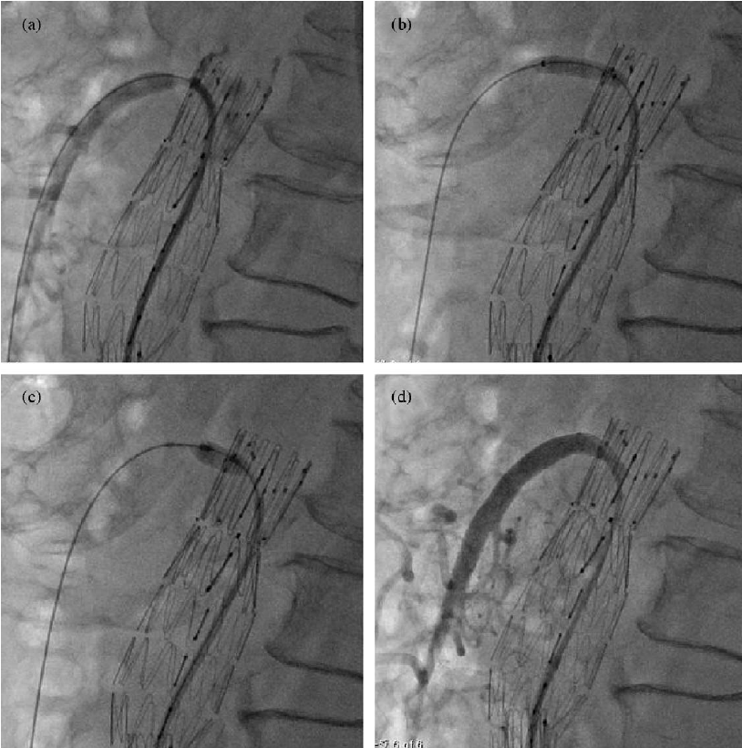

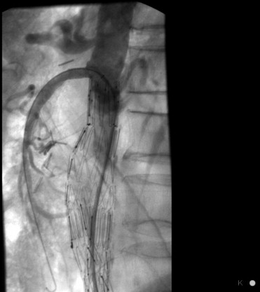
REFERENCES;
1.Fraboni 2012 board review express san jose
2.Birnbaumer 2013 CMEA medicine,sandiego
3.Harward 2013 J VASCULAR SURGERY 9(2)
4.BARCEWITZ PA,Welch jp ;ischemic colitis in adult patients dis colon rectum 123;109
BIOGRAPHY
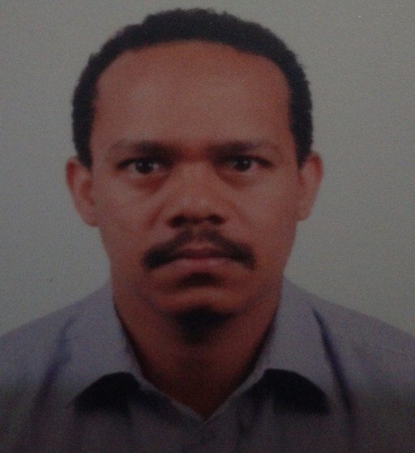
Haben Tsehaye is a medical doctor who has been practising in internal medicine and gastroenterology for the last 6 years. He holds his degrees from Orotta School of medicine. He is very vigilant and hardworking.
He has worked in different hospitals. His passion for Gastroenterology has enabled him to work more on this field and take care of patients with gastroenterology diseases.
He has presented many gastroenterology and internal medicine cases in different occasions.
His interest in publishing and research is enormous.
Email....tghaben@yahoo.com
Tele....+256758248451.

