The Short-term Effect Analysis of Delta-shaped Anastomosis in Totally Laparoscopic Right Hemicolectomy
Hao Su, RD MD, National Cancer Center/Cancer Hospital, CAMS&PUMC, CHN
Haitao Zhou, RD MD, National Cancer Center/Cancer Hospital, CAMS&PUMC, CHN

Abstract (300 word limit)
Background: Delta-shaped anastomosis was carried out in totally laparoscopic gastrectomy widely. We have applied the technique of delta-shaped anastomosis in totally laparoscopic colonic cancer surgery since 2016. This study aims to explore the clinical safety and feasibility of delta-shaped anastomosis in totally laparoscopic right hemicolectomy. Study Design: From January 1, 2016 to October 1, 2016, 11 patients who were diagnosed with right colon cancer and underwent totally laparoscopic right hemicolectomy with delta-shaped anastomosis in Cancer Hospital, Chinese Academy of Medical Sciences and Peking Union Medical College were retrospectively enrolled in this study. The data of clinicopathologic characteristics, surgical and postoperative outcomes, and follow-up findings were collected and analyzed. Results: All patients underwent totally laparoscopic right hemicolectomy with delta-shaped anastomosis successfully. The mean operation time was 144.8±34.1 minutes and intraoperative blood loss was 51.3±32.3 ml. The mean time for anastomosis was 14.9±2.9 minutes. The number of lymph nodes retrieved was 32.6±13.9 per patient. The lengths of upper and lower segment of resection from colon cancer were 11.4±3.8 cm and 8.4±3.6 cm. The average time to ground activities, time to flatus, time to fluid diet and length of hospital stay were 2.3±0.5 days, 3.3±0.9 days, 4.3±0.9 days, and 8.1±0.8 days, respectively. Only one patient suffered from pulmonary infection during his hospitalization due to preoperative long-term smoking history. No mobility related to the anastomosis such as anastomotic bleeding, stenosis, obstruction and leakage occurred in all the patients. Conclusions: Totally laparoscopic right hemicolectomy with delta-shaped anastomosis is a safe and feasible procedure and the short-term effect is satisfactory.

Image
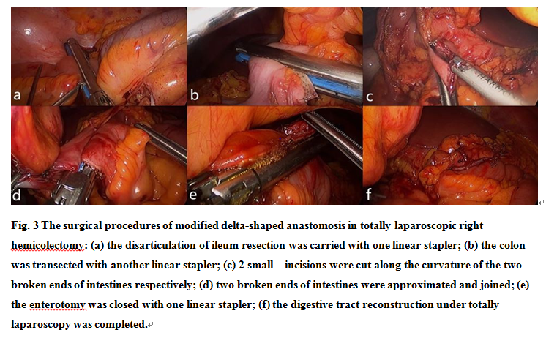
Recent Publications (minimum 5)
- Kanaya S, Kawamura Y, Kawada H（2011）The delta-shaped anastomosis in laparoscopic distal gastrectomy: analysis of the initial 100 consecutive procedures of intracorporeal gastroduodenostomy. GASTRIC CANCER 14: 365-371.
- Okabe H, Obama K, Tsunoda S（2014）Advantage of completely laparoscopic gastrectomy with linear stapled reconstruction: a long-term follow-up study. ANN SURG 259: 109-116.
- Kinoshita T, Shibasaki H, Oshiro T（2011）Comparison of laparoscopy-assisted and total laparoscopic Billroth-I gastrectomy for gastric cancer: a report of short-term outcomes. Surgical Endoscopy 25: 1395-1401.
- Kim BS, Yook JH, Choi YB（2011）Comparison of Early Outcomes of Intracorporeal and Extracorporeal Gastroduodenostomy After Laparoscopic Distal Gastrectomy for Gastric Cancer. J LAPAROENDOSC ADV S 21: 387-391.
- Kim J, Song KY, Chin HM（2008）Totally laparoscopic gastrectomy with various types of intracorporeal anastomosis using laparoscopic linear staplers: preliminary experience. Surgical Endoscopy 22: 436-442.

 Biography (150 word limit)
Haitao Zhou has his expertise in the surgical treatment of colorectal cancer. He completed about 350 laparoscopic surgeries for colorectal cancer every year and has his own understanding and experiences in the laparoscopic surgery. He also has completed several surgeries of transanal or transvaginal specimen extraction in laparoscopic rectectomy without abdominal incision. He first reports the application of delta-shaped anastomosis in totally laparoscopic surgery for right colon cancer worldwide in this study.
Email: zhouhaitao01745@163.com

Notes/Comments: This study first reports the application of delta-shaped anastomosis in totally laparoscopic surgery for right colon cancer and confirms that it is safe and feasible.

