Webinar on Forensic Toxicology
November 18, 2020

Special Forensic Cases and Ways to approach Conclusion by New Techniques GC-MS-MS, LC-MS-MS, EDX-8000, Ion-Chromatography, ICP-MS, UV-Visible Spectrometry. An Indian Scenario
Dr. Rakhi Khanna, Deputy Director Training & Expert Forensic Scientist & Toxicologist , Forensic Training and Research Institute, Forensic Science Laboratory, Jaipur, Rajasthan, India
Email: rakhi_khanna@yahoo.com
Abstract
In Forensic Laboratory Rajasthan, India different types of cases are received in Toxicology Section where the visceral content comprising of Piece of Stomach, Intestine, Liver, Spleen, Kidney, Lungs, Heart, Brain, Blood sample, Urine Sample, Skin piece (injection site or site of Bite) etc is being received for examination. All types of poisons is grouped into metallic poisons, ethyl - methyl alcohol, cyanide, alkaloids, barbiturates, tranquillizers and insecticides are often checked. By far if we go on to see the statistics data In India most of the poisoning cases found positive for Aluminium phosphide and Insecticides, Some cases are of drugs poisoning where the drugs are being used for suicide, murder purpose or due accidental reasons viz. negligence use of drugs during treatment by medical doctors. A scientist has to think about all related aspect along-with analysis to assist the cases to reach at concrete result that help get justice. The wide range of cases of poisoning specifies from cyanide, nitrite, alcohol, insecticide, carbon-monoxide, phosphine, snake venom, medicinal drugs for different purposes Robbery, Murder, Homicide, Suicide etc are quite common. After performing separation and extraction methodologies separation of organic and inorganic poisons took place. The confirmation of poison was done using GC-MS-MS, LC-MS-MS and UV-Visible Spectrometry for organic poisons. For inorganic poisons the use of Inductively Coupled Plasma with Mass Spectrophotometer and EDX-8000 and Ion chromatography techniques are proved highly significant. EDX-8000 technique is useful in detection of Gun Shot residues in traces. Several cases are sorted out of it and establishing the presence of gunshot residues on the hands of criminals solves typical mysteries. Latest changing scenario of crime needs up-gradation in techniques so that they can be used to establish strong evidences in Court of Law.

Stories and Approaches
1. Toxicological examination in a case of Burnt body samples: Murder of Businessman
Dead body of a businessman aged 35 years was found on a deserted way away from main Road lying outside his car. The body and car was found completely burnt. Crime scene team visited the spot and inferred conclusion that it was a case of accidental spark from AC that gives no time to him to survive. Viscera material when examined found positive for the presence of Organo-chlorine Insecticide i. e Endosulfan insecticide which was confirmed by Gas Chromatography and Mass spectrometry. The presence of this molecule raises several questions and the case need re-examination. For a single case we need to get information of all three sciences. Physical sciences needs examination of condition of car, AC, Production of fire spot, Chemical examination of inflammable material as Kerosene, Petrol, Diesel etc, Biological / Toxicological examination of visceral organs. Hence various clues were explained by us, on basis of which reconstruction of crime scene was done that clear that it was a case of planned murder not a mere accident. This case provides extraordinary vision and purpose of analysis to assist justice in deciding cause of death of an innocent.

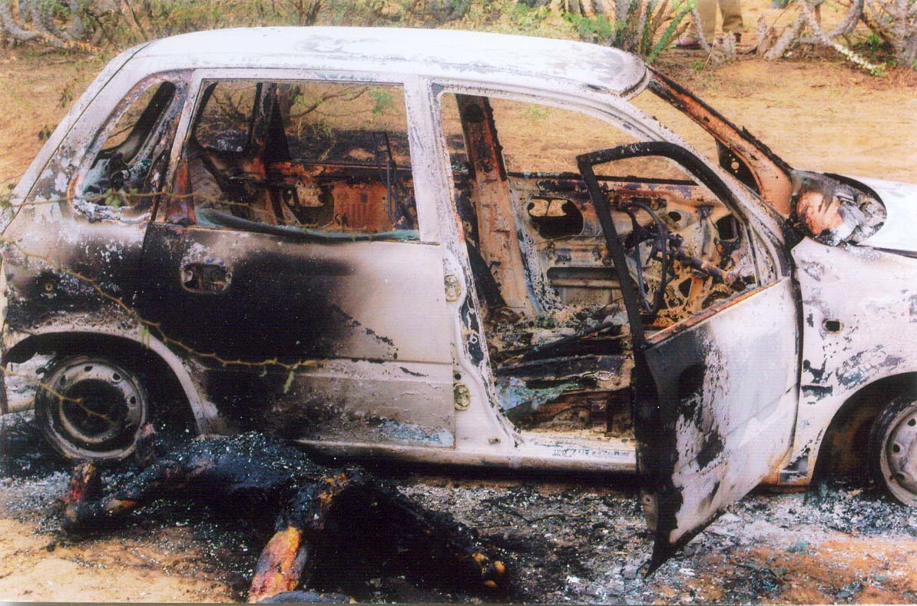
Image.1

Image.2
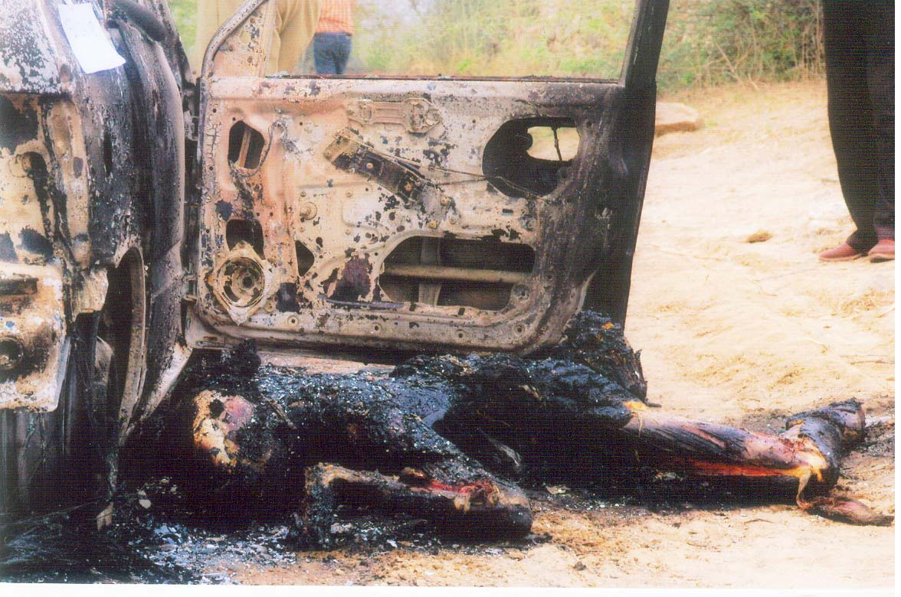

2. Toxicological examination proved presence of unusual drug in samples of blood used in farari of a criminal from Jail. The drug was specifically introduced in food articles to tranquillize/ sedate the police persons. This case study explains how a preplanned master mind was working behind it. Forensic examination was not only concerned with the detection of drug but provides useful direction to trap the culprits and linking the evidences. The possibility of involvement of a person having medical background cannot be overruled. The suspicious and dull role of police persons proved significant indulgence as they not only take the sweets but allowed the use of mobile to the gangster and taking selfies with the ganster. This case explains forensic aspect of identification of an antipsychotropic drug by use of most valid techniques as GC-MS, HPTLC, UV-Visible Spectrophotometry. This case becomes the most important one to open the eyes of our govt. and administrative system towards security and elaborates the issue to think of the poor facilities provided to police personnel’s and their deteriorating moral values in greed towards several items. Authorities and society should remain alert towards the changing scenario of crimes using drugs in high amount.

Image.3

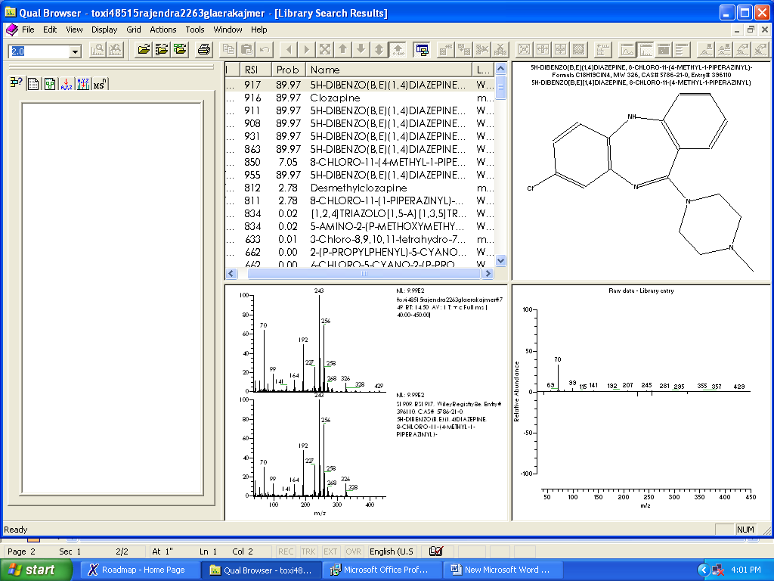

3. We have many cases of Aluminium phosphide poisoning in India different then most of the Western and European countries and as a new approach we have worked on to get presence of metals in blood samples. EDX-8000 which is being utilized for Gunshot residue analysis is being applied for Analysis of Metal poisons in blood samples. The results are quite interesting in positive cases when compared to negative cases.
4. The presence of sodium nitrite, cyanide in poisoning cases related to homicide are analyzed using wider techniques. Sodium nitrite is extensively used in dyeing industries. Its easy availability, mode of administration, high toxicity and solubility in liquor makes it a homicidal weapon in the hands of culprit. Death cases are increasing tremendously in Rajasthan due to nitrite intoxicating liquor. Four persons died instantly and two seriously hospitalized as a result of liquor consumption. It was sensational news and media alleged that Government of Rajasthan has no control on illicit sale of liquor. Autopsy material and other related samples were sent to Forensic Science laboratory for immediate report to decide the cause of death. A standard operating procedure for ethyl-methyl alcohol using Headspace with GC-Mass spectrometry was developed to solve the immediate need of the State Government. Mass fragments of methanol were not observed but Mass fragments for nitro ethanol & other nitro compounds indicate the presence of some nitro or nitrite moiety compounds. Toxicological examination of all the autopsy material and related clue articles concluded that the cause of death was Sodium nitrite mixed in ethanol but not methyl alcohol as it was suspected earlier. These toxicological findings helped the investigating authority to unveil the revengeful love story of an old lady who herself intentionally mixed nitrite in Bermuda xxx Rum to kill her partner. Present paper established the fact that whenever nitrite salts are taken with alcohol, absorption of nitrite is faster in blood, than ethanol, which immediately blocks the cytochrome oxidaze cycle and causes death.

III- BIOGRAPHY
1. Dr Rakhi Khanna is presently as Deputy Director Training at State Forensic Science Laboratory, Jaipur, Rajasthan, India
2. President of Internal Complaint committee of Prevention, Prohibition and Redressal Act Against Sexual Harassment of Women at Workplace, 2013
4. She did her PhD in science specialized in chemistry on Topic “Gas-Chromatography Mass-Spectrometry Studies of some Modern Insecticides in Postmortem Tissues and Body-Fluids, in 2009 from Department of Chemistry, University Of Rajasthan, Jaipur, India
5. Working experience of 22 years as Forensic Scientist cum Toxicologist from 1998 and have experience of analyses of large number of cases. approx. 20,000 cases and 60000 exhibits are reported. .
She has presented many research papers in many journals and conference proceedings She is an Editorial- member to review papers in many journals of Repute.
She has many awards in her credits.
- Best Scientific Paper Award in All India Forensic Science Conference 2009
- Best Scientific Paper Award in All India Forensic Science Conference, 2005
IV Research Interest
To Design methodologies for analysis of wide range of poisons using newer scientific techniques and to work for creating innovative ways to get maximum information about poisons in visceral organs and blood samples.
Name of poisons analyzed:
Aluminium phosphide, Zinc phosphide, Arsenic Oxide, chlorates, Mercury, Chlorides, Sulphates, Sodium Nitrates, Sodium Nitrites, Methyl Succinate, Sodium hydroxide, Sulphuric acid, Hydrochloric acid, Sodium Cyanide, Potassium Cyanide, Potassium chloride, Carbon monoxide, Sulphur, hydrogen sulphide, Insecticides as malathion, parathiom,baygon,propoxur,chlopyrifos,dimethoate,monocrotophos,endosulfan,DDT, BHC herbicides etc. Volatiles as in Whitener fluid, Ethyl alcohol, Methyl alcohol, chloroform, formaldehyde, acetaldehyde, acetone etc.; Sevofluranes, Isofluranes, Hydrocarbons, etc, Explosive as ammonium nitrate, RDX, PETN, Drugs as Vecuronium, Atracurium, Benzodiazepines, Phenothiazines, Tranquillizers, Anaesthetics, Barbiturates, Ergot Alkaloids, Morphine, Cannabinoids, Chloroquine, Chlorpheniramine, and many others as specificified alongwith case or not.
Besides She has interested in providing training, writing and creating awareness about Women and Child issues, DNA, Shooter identification, GSR Analysis, Photography and Videography, Crime scene management, SAECK KIT and various crime scene kits.
V-Presenting Author

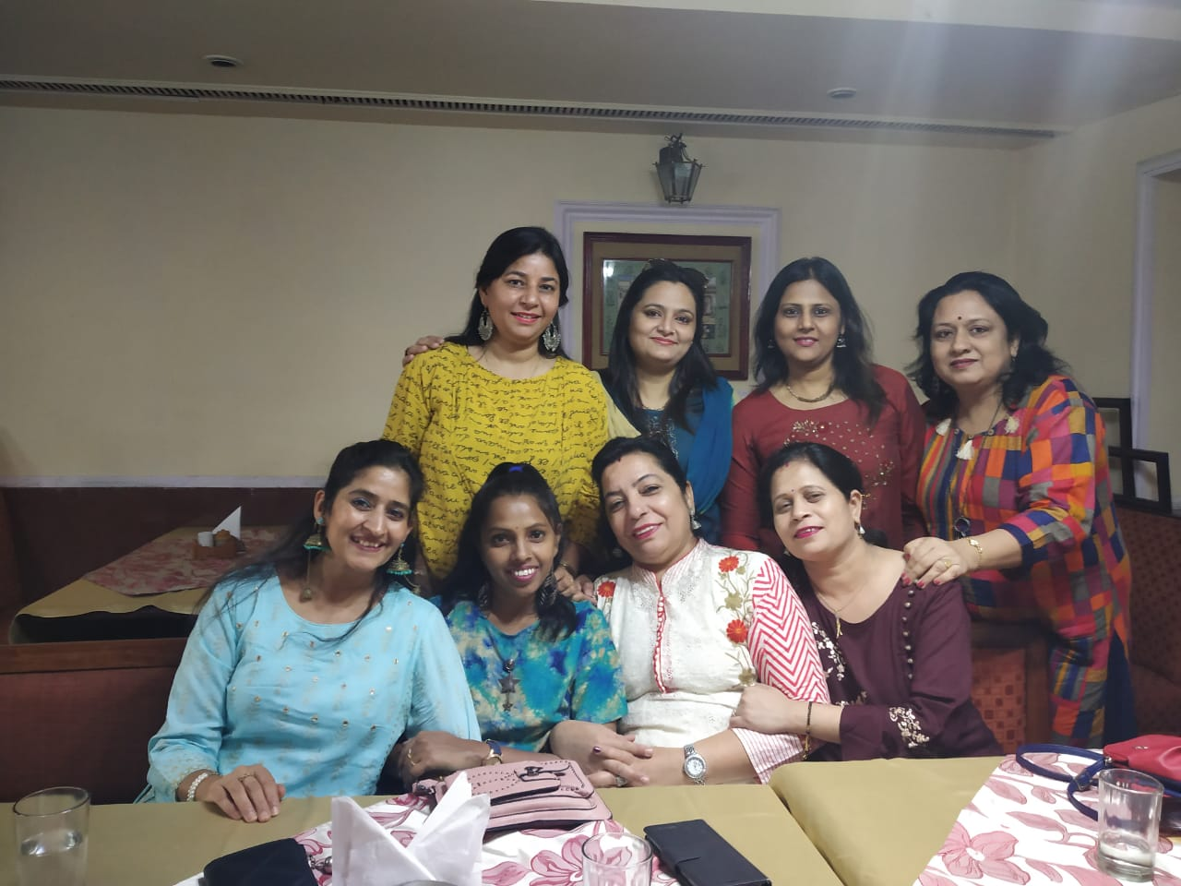
Full Name: Dr. Rakhi Khanna
Contact number: +91-9529791877
Linked In account: www.linkedin.com/in/Dr-Rakhi-Khanna
Session name/ number: Forensic Chemistry and Toxicology
Category: Speaker
Passport Number: S 5570644

