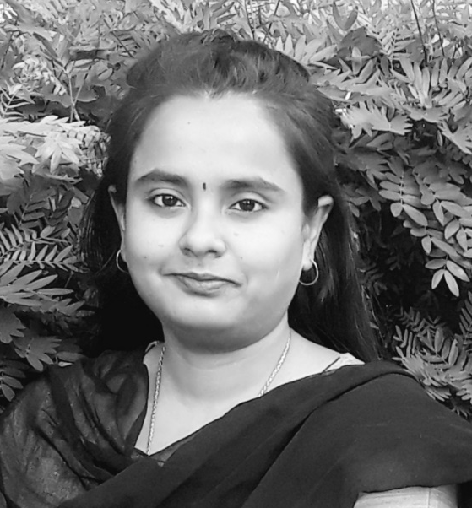

Name : Dr. Pooja Chakraborty, BDS, M.Sc Forensic Odontology India
Title of the Session: Forensic Odontology: Scope and Future
Abstract
The field of forensic comprises multiple branches, namely forensic medicine, toxicology, physics and many more. Forensic odontology is also a branch of forensic, though small and underrated subject but nevertheless less impactful. This subject is equally scientific and a strong evidence for achieving convictions. Like the vast clinical dentistry, forensic dentistry is also useful in Human Identification, in cases where Fingerprints and DNA fails. This subject largely depends on the availability of dental records for its successful completion. It has various components, the study of lip prints, rugae patterns, bite marks and also Age estimation. Forensic odontology works in the interest of justice. This subject is growing faster than expected and is even providing important convictions based on dental evidences. The session will be oriented towards the overview of the subject, with its application and scope.This session will also aim at highlighting the role of a forensic odontologist in Disaster Victim Identification.

Biography
Dr. Pooja Chakraborty is a Forensic Odontologist by profession. She completed her bachelors of dental surgery in 2018 with outstanding marks. On her quest to do something different, she went on to pursue her masters in Forensic Odontology thereafter. To her credit she has numerous International and national Paper and Poster Presentations and also bagged few awards for the same. She has contributed articles in both national and international journals and has even co-authored a chapter on ‘Recent advances in Forensic Odontology’. She is trained in performing dental autopsies. She has keen interest for forensic archaeology and forensic facial reconstructions. She is actively involved in the field of forensics and has addressed various talks for the graduates, post graduates as well as security professionals. She has been invited as speaker on various platforms. She is actively involved with International agencies dealing with DVI Operations.

